FOR IMMEDIATE RELEASE
FEBRUARY 18, 2022

ENISA UNVEILS FAKE LOVE

EAGERLY AWAITED EP HIGHLIGHTED BY WORLDWIDE HITS
“TEARS HIT THE GROUND” AND “ONE THING”

NEW SINGLE, “GET THAT MONEY,” PREMIERES TODAY
ALONGSIDE OFFICIAL MUSIC VIDEO

FAKE LOVE AVAILABLE NOW VIA HIGHBRIDGE THE LABEL/ATLANTIC RECORDS

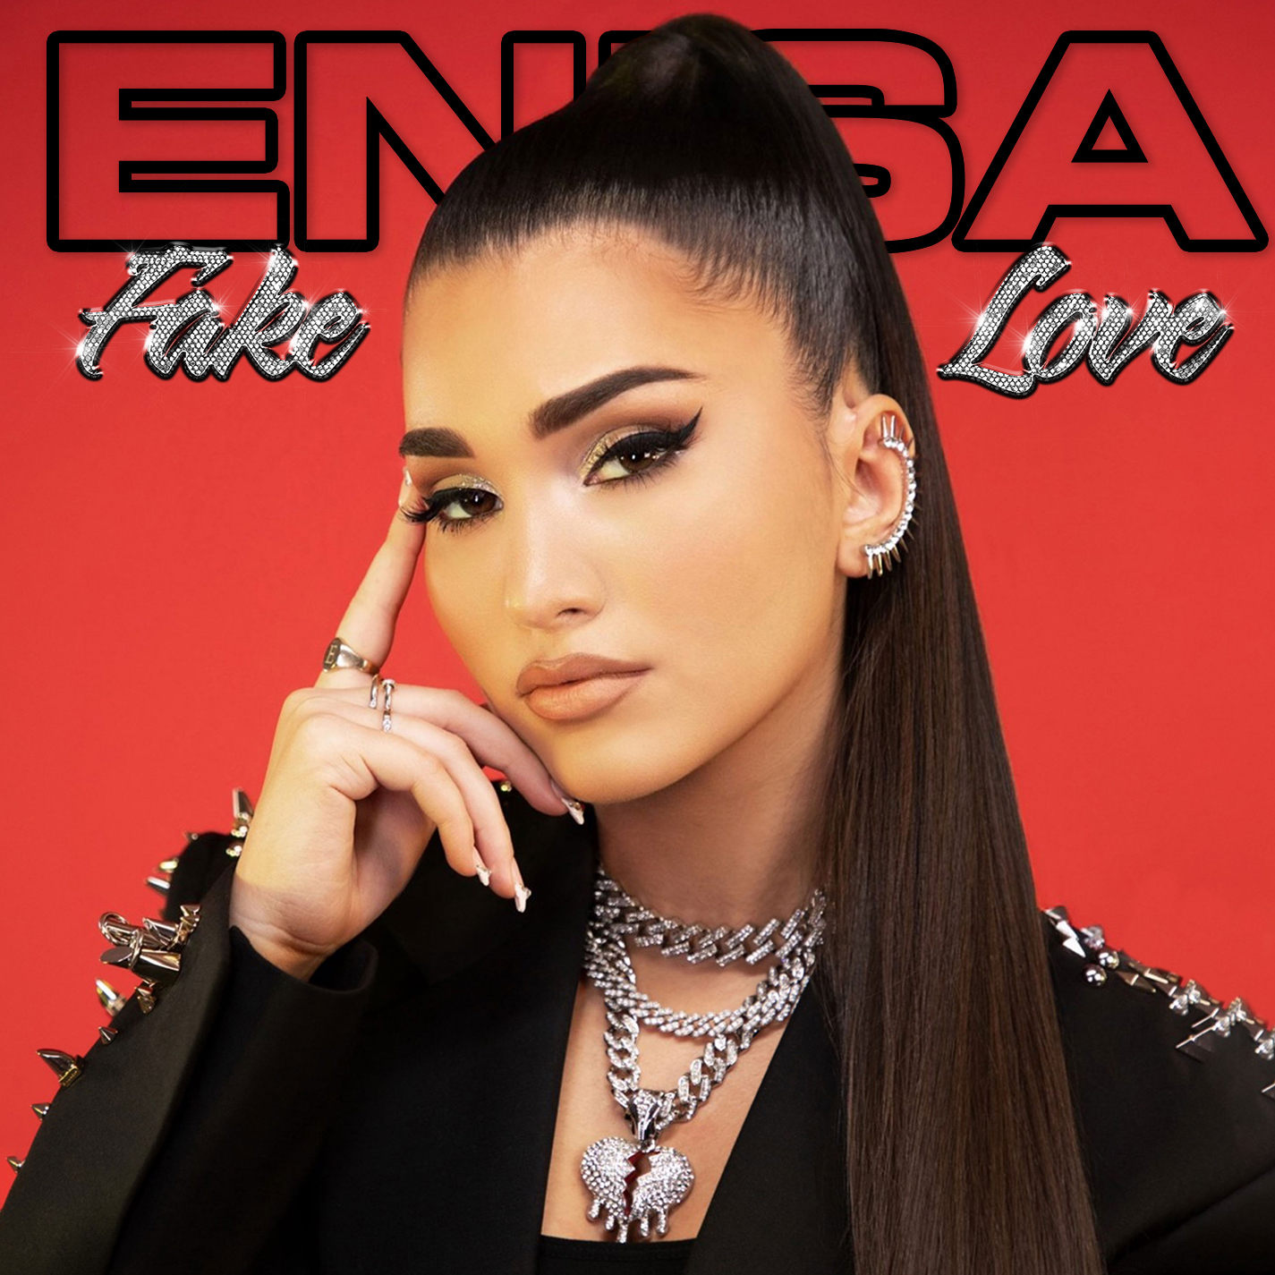
(DOWNLOAD HI-RES ARTWORK)

“Enisa spikes pop with raw soul and endless attitude…with millions of streams under her latest releases, the New York-born Albanian singer and songwriter is taking over the pop music scene.”
– OUT NOW

Brooklyn-based songstress Enisa has shared her eagerly anticipated new EP, FAKE LOVE, available now via Highbridge The Label/Atlantic Records at all DSPs and streaming services HERE.

Co-written by Enisa alongside top songwriters including Julie Hardy, Dimitri Erlich, Andrea Martin, FAKE LOVE includes the worldwide hit tracks, “Tears Hit The Ground” and “One Thing,” as well as the insatiable new single, “Get That Money,” available now for streaming and download; an official music video – directed by award-winning filmmaker/photographer/art director Genevieve Andrews (Billie Eilish, Hannah Hooper, VFILES Runway) – premieres today at YouTube.

“This EP is about all the emotions I’ve been through since I started my musical journey,” Enisa says. “Anyone and everyone will find a song on FAKE LOVE that they can relate to, because I hit every emotion on the spectrum of human emotions. It's a very empowering piece of work!”

With over 28M worldwide streams and more than 104M total video views, Enisa has proven a truly global favorite, earning chart-topping success in Nigeria, Gambia, Portugal, Algeria, Tunisia, Morocco, Sri Lanka, and India, to name a few. “Get That Money” marks the latest in a continuing series of increasingly popular releases from the First Lady of Highbridge The Label, following “Tears Hit The Ground” (2.5M views), “Love Cycle” (14.5M views), “Dumb Boy” (13M views), and the smash hit, “Count My Blessings” (36M views).

Enisa has spent her whole life preparing for this journey as a first-generation American born to Albanian immigrant parents. Following her graduation from Brooklyn’s esteemed Edward R. Murrow High School, she attended Brooklyn College where she continued to develop her unique musical vision. A series of distinctive cover versions exploded across social media, earning her millions of views and critical acclaim from the likes of Complex, XXL, ThisSongIsSick, and more. With the wind at her back, Enisa continued to hone her diverse musical approach, infusing contemporary soul pop with Middle Eastern flourishes inspired by her own Muslim heritage. Track releases like Scridge and Genda’s viral smash “Karma (Remix)” and such solo singles as “Burn This Bridge” and “Wait for Love” showcased a spectacular knack for raw soul and endless attitude, earning her more than 16M views and over 3M global streams as an independent artist.

2021 proved a milestone year for Enisa, highlighted by a cover appearance in Out Now, debut live performances at NYC’s legendary SOB’s and Sacramento, CA’s Lost In Riddim festival, and a social media explosion that now sees close to 6M total followers around the world, including 2.5M on TikTok alone.

CONNECT WITH ENISA
OFFICIAL | INSTAGRAM | FACEBOOK | TWITTER | TIKTOK | YOUTUBE

PRESS CONTACT
SELAM BELAY | SELAM.BELAY@ATLANTICRECORDS.COM

