FOR IMMEDIATE RELEASE
JANUARY 28, 2022

ENISA RETURNS WITH “ONE THING”

OFFICIAL MUSIC VIDEO PREMIERES TODAY

NEW EP, FAKE LOVE, ARRIVES FRIDAY, FEBRUARY 18TH

“ONE THING” AVAILABLE NOW VIA HIGHBRIDGE THE LABEL/ATLANTIC RECORDS

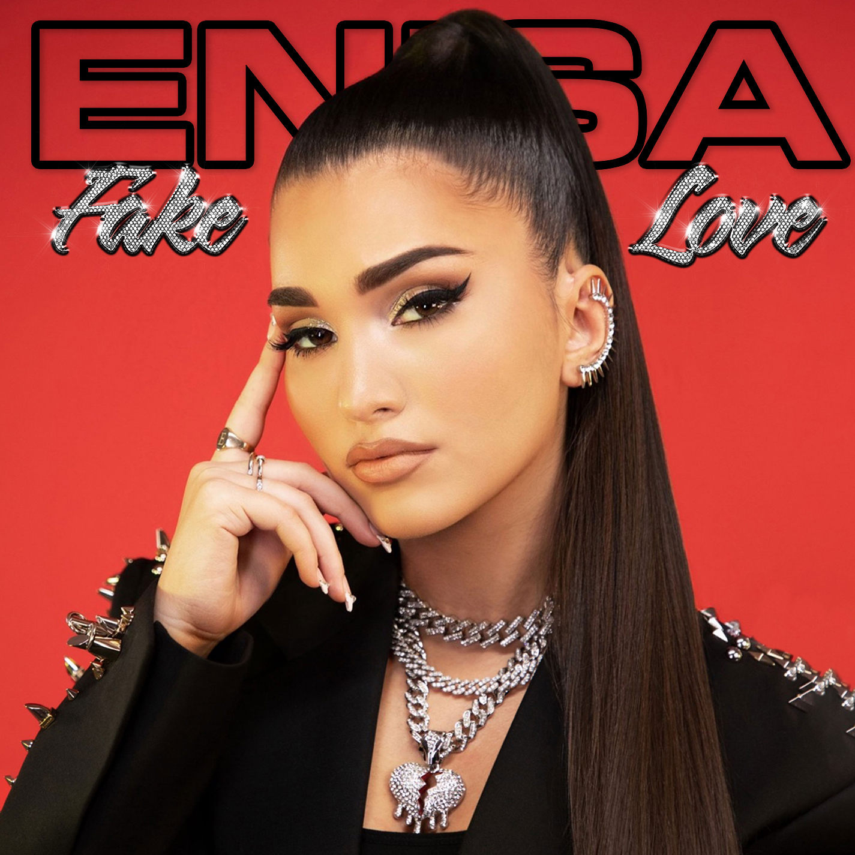
(DOWNLOAD HI-RES ARTWORK)

Brooklyn-based songstress Enisa has shared her long-awaited new single. “One Thing” is available now via Highbridge The Label/Atlantic Records at all DSPs and streaming services; an official music video – directed by award-winning filmmaker/photographer/art director Genevieve Andrews (Billie Eilish, Hannah Hooper, VFILES Runway) – premieres today.

STREAM/DOWNLOAD “ONE THING”
WATCH OFFICIAL MUSIC VIDEO

“One Thing” marks the first single from Enisa’s eagerly anticipated new EP, FAKE LOVE, due to arrive everywhere on Friday, February 18th. Co-written by Enisa, Julie Hardy, and Mike MacAllister and produced by MacAllister at Brooklyn, NY’s Creekside Sound – the very same studio where Enisa recorded her first-ever demo and received her first vocal lesson – the track was born out of a long-standing lyrical idea about the conflict between romantic and physical aspects of modern dating.

“It seems that these days when it comes to dating, guys just want a quick hook up,” Enisa says. “I’ve never been the type of girl to be ok with that. I’m more traditional, if I’m dating someone it would have to be someone, I can see myself marrying. I say In the song ‘Unless you’re getting down on one knee, boy you’re barking up the wrong tree.’ Many people don’t have that mindset in 2022 – they usually want ‘One Thing’ and it’s usually physical. I hear my friends complain about it all the time so I thought it would make a great song that a lot of people could relate to. I enjoyed writing about the cliché stuff guys do to try and get a girl for the night. It’s a fun, quirky song and one of my favorites to sing live!”

The First Lady of Highbridge The Label, Enisa has proven a truly global favorite, earning chart-topping success in Nigeria, Gambia, Portugal, Algeria, Tunisia, Morocco, Sri Lanka, and India, to name a few. “One Thing” marks the latest in a series of increasingly popular releases from the gifted young artist, following after “Tears Hit The Ground” (2.4M views), “Love Cycle” (14M views), “Dumb Boy” (13M views), and “Count My Blessings” (34M views).

Enisa has spent her whole life preparing for this journey as a first-generation American born to Albanian immigrant parents. Following her graduation from Brooklyn’s esteemed Edward R. Murrow High School, she attended Brooklyn College where she continued to develop her unique musical vision. A series of distinctive cover versions exploded across social media, earning her millions of views and critical acclaim from the likes of Complex, XXL, ThisSongIsSick, and more. With the wind at her back, Enisa continued to hone her diverse musical approach, infusing contemporary soul pop with Middle Eastern flourishes inspired by her own Muslim heritage. Track releases like Scridge and Genda’s viral smash “Karma (Remix)” and such solo singles as “Burn This Bridge” and “Wait for Love” showcased a spectacular knack for raw soul and endless attitude, earning her more than 16M views and over 3M global streams as an independent artist.

“When you hear me, I want you to walk away empowered,” Enisa says. “I know firsthand you can come out of every situation stronger. I hope you hear a song, apply it to your life, and feel like you can overcome anything. My music is all about embracing this confidence.”

CONNECT WITH ENISA
OFFICIAL | INSTAGRAM | FACEBOOK | TWITTER | SOUNDCLOUD | YOUTUBE

PRESS CONTACT
SELAM BELAY | SELAM.BELAY@ATLANTICRECORDS.COM

