FOR IMMEDIATE RELEASE
JULY 6, 2021

CHILDISH MAJOR SAYS “F YAH JOB”

SUMMER ANTHEM HERALDS EAGERLY AWAITED NEW PROJECT,
THANK YOU, GOD. FOR IT ALL. ARRIVING JULY 23RD

PRESAVES AVAILABLE BEGINNING TODAY

“F YAH JOB” AVAILABLE NOW AT ALL DSPS AND STREAMING SERVICES

STREAM/DOWNLOAD “F YAH JOB”
WATCH OFFICIAL MUSIC VIDEO
PRE-SAVE THANK YOU GOD, FOR IT ALL

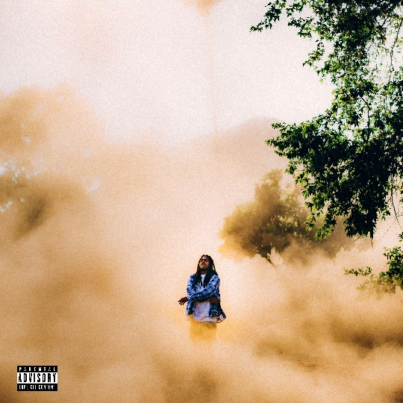

GRAMMY® Award-nominated artist/producer CHILDISH MAJOR is keeping summer hot with today’s premiere of his sizzling new single, “F Yah Job,” available now at all DSPs and streaming services. Written by Childish Major and produced by Hollywood Cole, the track is joined by an official music video available now.

“This will likely be the #MOOD of the summer!” says Childish Major. “It’s a story of a man who meets a girl and he doesn’t want their time together to end. They’re enjoying each other’s company and vibes as they talk, laugh, run around the town, etc. and he doesn’t care if her job calls 30 times. As the saying goes…it’s heavy on the F Yah Job so the fun can continue.”

“F Yah Job” heralds the upcoming release of Childish Major’s eagerly anticipated new EP, THANK YOU, GOD. FOR IT ALL., arriving July 23rd; pre-saves are available now. A powerful expression of intent, confidence, gratitude, and sincerity, the 7-track project sees Childish Major continuing to hone his craft with laser precision.

Born Markus Randle, Childish Major is a GRAMMY® Award-nominated artist and producer based in Atlanta, Georgia. Originally from Edgefield, SC, Childish made his mark on the ATL music scene working with a wide variety of artists including Rocko, Future, SZA, J. Cole, Isaiah Rashad, Pusha T, Fall Out Boy, Young Jeezy, and 6lack.

Major unveiled his own debut project, WOO$AH, in 2017 and has kept moving forward ever since. 2019 saw the release of his second studio project, Dirt Road Diamond, while songs like “Supply Luh” (produced by J.Cole) and “Know Nothing” were featured in the hit HBO series, Insecure. More recently, “Kick It (Feat. Jace)” was included on EA’s Madden NFL 21 soundtrack. Major has also been featured in major brand campaigns including Reebok’s Alter the Icons (with Tayla Parx) and the MCM Autumn/Winter 2019 collection (alongside close friend Billie Eilish). He also appeared with legendary producer Timbaland in an IBM commercial that premiered during Super Bowl LV (streaming HERE).

For more information/the latest on Childish Major please visit https://www.childishmajorofficial.com/.

THANK YOU, GOD. FOR IT ALL
CHILDISH MAJOR

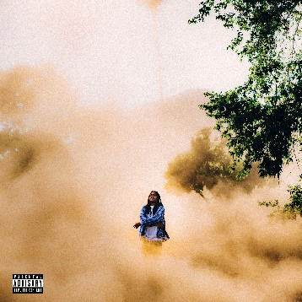

Player’s Prayer
Check
Money Power Respect
Down South
F Yah Job
Disrespectful
Thank You, God. For It All.

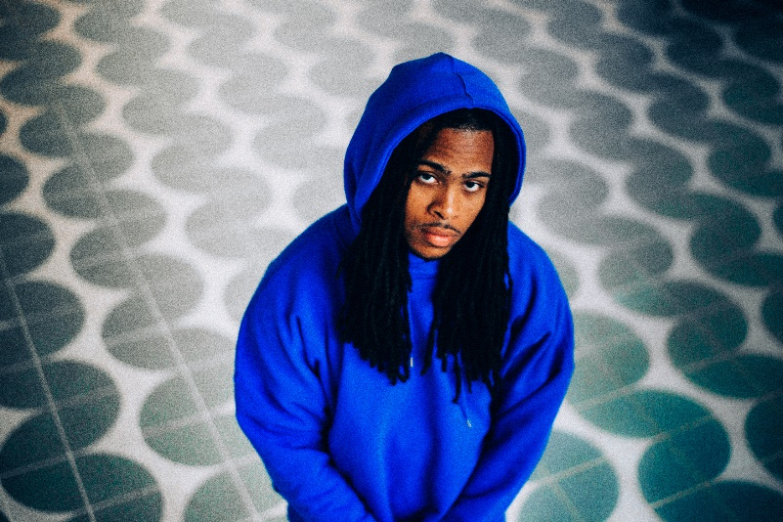
DOWNLOAD PRESS IMAGES HERE

# # #

CONNECT WITH CHILDISH MAJOR
INSTAGRAM | TWITTER | YOUTUBE | SOUNDCLOUD | WEBSITE

PRESS CONTACT
SELAM BELAY // SELAM.BELAY@ATLANTICRECORDS.COM

