FOR IMMEDIATE RELEASE
JUNE 25, 2021

DON TOLIVER, LIL DURK & LATTO SPEED THROUGH THE “FAST LANE”

OFFICIAL MUSIC VIDEO OUT TODAY IN CELEBRATION OF THE THEATRICAL RELEASE OF F9

THE LATEST INSTALLMENT OF THE MOST SUCCESSFUL SOUNDTRACK FRANCHISE IN HISTORY IS OUT NOW FEATURING BRAND NEW AND EXCLUSIVE MUSIC FROM TY DOLLA $IGN, JACK HARLOW, 24KGOLDN, POP SMOKE, SKEPTA, LIL TECCA, AMENAZZY, FARRUKO, MYKE TOWERS & ROCHY RD

F9 ARRIVES IN THEATRES NATIONWIDE TODAY

WATCH VIDEO HERE | DOWNLOAD/STREAM ALBUM HERE

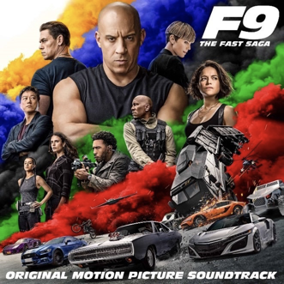

Atlantic Records and Universal Pictures have unveiled the official video for “Fast Lane” by Don Toliver, Lil Durk and Latto. The visual for the new single from F9: THE FAST SAGA (ORIGINAL MOTION PICTURE SOUNDTRACK) is now available to watch HERE.

The explosive video arrives on the heels of F9: THE FAST SAGA (ORIGINAL MOTION PICTURE SOUNDTRACK) released last week. Met with rapturous reviews from Pitchfork, HipHop DX, Complex and Fader alike, it is sure to be the soundtrack to the summer. The “Fast Lane” visual features Don Toliver and Latto; unfortunately, Lil Durk does not make an appearance as he is taking time off to mourn the sudden loss of his brother, but he joins them on the track. F9: THE FAST SAGA (ORIGINAL MOTION PICTURE SOUNDTRACK) is available now at all DSPs and streaming services HERE. F9 opens in theatres nationwide today.

The release of F9: THE FAST SAGA (ORIGINAL MOTION PICTURE SOUNDTRACK) was proceeded by the popular singles “I Won” with Ty Dolla $ign, Jack Harlow & 24kGoldn, “Rapido” from Amenazzy, Farruko, Myke Towers & Rochy RD and “Furiosa” by Anitta which is featured in the Rocket League Fast & Furious Bundle Trailer and as a Rocket League Player Anthem.

F9: THE FAST SAGA (ORIGINAL MOTION PICTURE SOUNDTRACK) carries on the FAST & FURIOUS Saga’s long history of equally explosive musical releases with a collection of all-new tracks inspired by the hugely popular film series.

Furthermore, F9: THE FAST SAGA (ORIGINAL MOTION PICTURE SOUNDTRACK) includes all brand-new songs from a truly epic line-up of rising stars and chart-topping Latin and hip-hop/R&B luminaries. Among the artists featured are Don Toliver, Lil Durk, Skepta, Pop Smoke, Offset, Trippie Redd, Kevin Gates, King Von, Polo G, The Prodigy, Anitta, Justin Quiles, Dalex, Rico Nasty, and NLE Choppa, to name but a few (see tracklisting below).

F9: THE FAST SAGA (ORIGINAL MOTION PICTURE SOUNDTRACK) continues. F9: THE FAST SAGA (ORIGINAL MOTION PICTURE SOUNDTRACK) continues the blockbuster partnership between Atlantic Records and Universal Pictures forged on two previous FAST SAGA soundtrack releases, including 2017’s “THE FATE OF THE FURIOUS: THE ALBUM“and 2015’s worldwide smash, “FURIOUS 7: ORIGINAL MOTION PICTURE SOUNDTRACK.”

For updates and additional information, please visit www.fastsaga.com and atlanticrecords.com.

* * * * *
ABOUT F9
No matter how fast you are, no one outruns their past.

F9 is the ninth chapter in the FAST & FURIOUS Saga, which has endured for two decades and has earned more than $5 billion around the world.

Vin Diesel’s Dom Toretto is leading a quiet life off the grid with Letty and his son, little Brian, but they know that danger always lurks just over their peaceful horizon. This time, that threat will force Dom to confront the sins of his past if he’s going to save those he loves most. His crew joins together to stop a world-shattering plot led by the most skilled assassin and high-performance driver they’ve ever encountered: a man who also happens to be Dom’s forsaken brother, Jakob (John Cena, the upcoming The Suicide Squad).

F9 sees the return of Justin Lin as director, who helmed the third, fourth, fifth, and sixth chapters of the series when it transformed into a global blockbuster. The action hurtles around the globe – from London to Tokyo, from Central America to Edinburgh, and from a secret bunker in Azerbaijan to the teeming streets of Tbilisi. Along the way, old friends will be resurrected, old foes will return, history will be rewritten, and the true meaning of family will be tested like never before.

The film stars returning cast members Michelle Rodriguez, Tyrese Gibson, Chris “Ludacris” Bridges, Nathalie Emmanuel, Jordana Brewster, and Sung Kang, with Oscar® winner Helen Mirren, with Kurt Russell and Oscar® winner Charlize Theron. F9 also features GRAMMY®-winning superstar Cardi B as new franchise character Leysa, a woman with a connection to Dom’s past, and a cameo by reggaetón sensation Ozuna.

F9 is produced by Neal H. Moritz p.g.a., Vin Diesel p.g.a., Justin Lin p.g.a., Jeff Kirschenbaum p.g.a., Joe Roth, Clayton Townsend p.g.a., and Samantha Vincent. Universal Pictures presents an Original Film/One Race Films/Perfect Storm production in association with Roth/Kirschenbaum Films, a Justin Lin film.

For more information, please visit www.thefastsaga.com.

# # #

F9 THE FAST SAGA: ORIGINAL MOTION PICTURE SOUNDTRACK
(Atlantic Records)
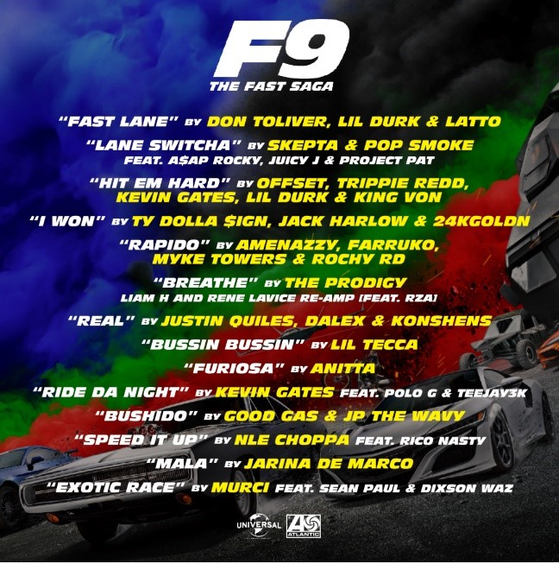

TRACKLIST
“Fast Lane” – Don Toliver, Lil Durk & Latto
“Lane Switcha (Feat. A$AP Rocky, Juicy J & Project Pat)” – Skepta & Pop Smoke
“Hit Em Hard” – Offset, Trippie Redd, Kevin Gates, Lil Durk & King Von
“I Won” – Ty Dolla $ign, Jack Harlow & 24kGoldn
“Rapido” – Amenazzy, Farruko, Myke Towers & Rochy RD
“Breathe (Liam H and Rene LaVice Re-Amp) [Feat. RZA]” – The Prodigy
“Real” – Justin Quiles, Dalex & Konshens
“Bussin Bussin” – Lil Tecca
“Furiosa” – Anitta
“Ride Da Night (Feat. Polo G & Teejay3k)” – Kevin Gates
“Bushido” – Good Gas & JP THE WAVY
“Speed It Up (Feat. Rico Nasty)” – NLE Choppa
“Mala” – Jarina De Marco
“Exotic Race (Feat. Sean Paul & Dixson Waz)” – Murci

# # #

For press inquiries, please contact:
Ariana.White@atlanticrecords.com

