FOR IMMEDIATE RELEASE
JUNE 18, 2021

F9: THE FAST SAGA (ORIGINAL MOTION PICTURE SOUNDTRACK) IS ZOOMING PAST THE FINISH LINE

LONG-AWAITED MUSICAL COMPANION TO NINTH CHAPTER IN THE FAST & FURIOUS SAGA FEATURES THE NEW SINGLES “RAPIDO” FROM AMENAZZY, FARRUKO, MYKE TOWERS & ROCHY RD, “FURIOSA” BY ANITTA AND “HIT EM HARD” BY OFFSET, TRIPPIE REDD, KEVIN GATES, LIL DURK & KING VON

ALBUM ALSO INCLUDES BRAND NEW TRACKS FROM POLO G, LIL TECCA, JUSTIN QUILES, SKEPTA, POP SMOKE, NLE CHOPPA, RICO NASTY, DON TOLIVER, LIL DURK, LATTO, TY DOLLA $IGN, JACK HARLOW, 24KGOLDN AND MORE

NEWEST ADDITION TO THE MOST SUCCESSFUL SOUNDTRACK FRANCHISE IN HISTORY

F9 ARRIVES IN THEATRES NATIONWIDE ON FRIDAY, JUNE 25TH

STREAM/DOWNLOAD F9: THE FAST SAGA (ORIGINAL MOTION PICTURE SOUNDTRACK) HERE

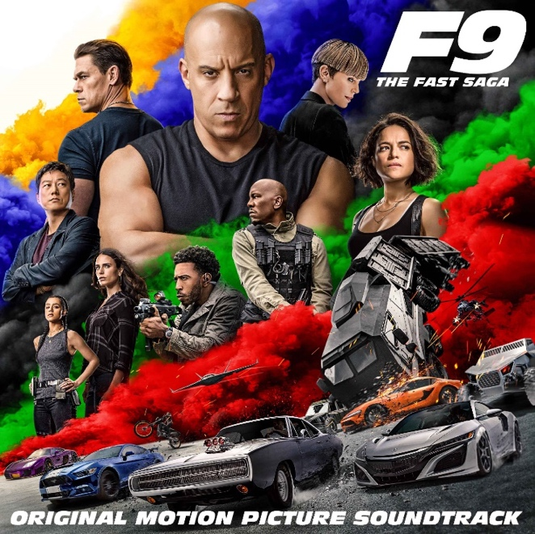

After several weeks of anticipation, Atlantic Records and Universal Pictures have officially announced the release of F9: THE FAST SAGA (ORIGINAL MOTION PICTURE SOUNDTRACK), available now at all digital platforms HERE. F9 opens in theatres nationwide on Friday, June 25th.

Today’s release is highlighted by “Rapido” from Amenazzy, Farruko, Myke Towers & Rochy RD, “Hit Em Hard” from Offset, Trippie Redd, Kevin Gates, Lil Durk & King Von and “Furiosa” by Anitta – which is featured in the Rocket League Fast & Furious Bundle Trailer and as a Rocket League Player Anthem. These tracks arrive on the heels of two previously released singles, “I Won” from Ty Dolla $ign, Jack Harlow & 24kGoldn, and “Fast Lane” by Don Toliver, Lil Durk & Latto, the latter of which will play audiences out of theaters as the end title to the film. In addition, “I Won” is joined by an official music video streaming now via YouTube HERE.

F9: THE FAST SAGA (ORIGINAL MOTION PICTURE SOUNDTRACK) will carry on the FAST & FURIOUS Saga’s long history of equally explosive musical releases with a collection of all-new tracks inspired by the hugely popular film series. The album showcases all brand-new songs from a truly epic line-up of rising stars and chart-topping Latin and hip-hop/R&B luminaries. Among the artists featured are Skepta, Pop Smoke, Trippie Redd, Kevin Gates, King Von, The Prodigy, Lil Tecca, Justin Quiles, Dalex, Rico Nasty, and NLE Choppa, to name but a few (see tracklisting below).

F9: THE FAST SAGA (ORIGINAL MOTION PICTURE SOUNDTRACK) continues the blockbuster partnership between Atlantic Records and Universal Pictures forged on two previous FAST SAGA soundtrack releases, including 2017’s “THE FATE OF THE FURIOUS: THE ALBUM” and 2015’s worldwide smash, “FURIOUS 7: ORIGINAL MOTION PICTURE SOUNDTRACK.”

For updates and additional information, please visit www.thefastsaga.com and atlanticrecords.com.

* * * * *
ABOUT F9
No matter how fast you are, no one outruns their past.

F9 is the ninth chapter in the FAST & FURIOUS Saga, which has endured for two decades and has earned more than $5 billion around the world.

Vin Diesel’s Dom Toretto is leading a quiet life off the grid with Letty and his son, little Brian, but they know that danger always lurks just over their peaceful horizon. This time, that threat will force Dom to confront the sins of his past if he’s going to save those he loves most. His crew joins together to stop a world-shattering plot led by the most skilled assassin and high-performance driver they’ve ever encountered: a man who also happens to be Dom’s forsaken brother, Jakob (John Cena, the upcoming The Suicide Squad).

F9 sees the return of Justin Lin as director, who helmed the third, fourth, fifth, and sixth chapters of the series when it transformed into a global blockbuster. The action hurtles around the globe – from London to Tokyo, from Central America to Edinburgh, and from a secret bunker in Azerbaijan to the teeming streets of Tbilisi. Along the way, old friends will be resurrected, old foes will return, history will be rewritten, and the true meaning of family will be tested like never before.

The film stars returning cast members Michelle Rodriguez, Tyrese Gibson, Chris “Ludacris” Bridges, Nathalie Emmanuel, Jordana Brewster, and Sung Kang, with Oscar® winner Helen Mirren, with Kurt Russell and Oscar® winner Charlize Theron. F9 also features GRAMMY®-winning superstar Cardi B as new franchise character Leysa, a woman with a connection to Dom’s past, and a cameo by reggaetón sensation Ozuna.

F9 is produced by Neal H. Moritz p.g.a., Vin Diesel p.g.a., Justin Lin p.g.a., Jeff Kirschenbaum p.g.a., Joe Roth, Clayton Townsend p.g.a., and Samantha Vincent. Universal Pictures presents an Original Film/One Race Films/Perfect Storm production in association with Roth/Kirschenbaum Films, a Justin Lin film.

For more information, please visit www.thefastsaga.com.

# # #

F9 THE FAST SAGA: ORIGINAL MOTION PICTURE SOUNDTRACK
(Atlantic Records)
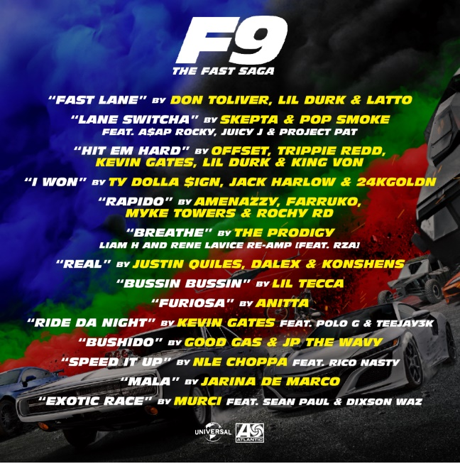

TRACKLIST
“Fast Lane” – Don Toliver, Lil Durk & Latto
“Lane Switcha (Feat. A$AP Rocky, Juicy J & Project Pat)” – Skepta & Pop Smoke
“Hit Em Hard” – Offset, Trippie Redd, Kevin Gates, Lil Durk & King Von
“I Won” – Ty Dolla $ign, Jack Harlow & 24kGoldn
“Rapido” – Amenazzy, Farruko, Myke Towers & Rochy RD
“Breathe (Liam H and Rene LaVice Re-Amp) [Feat. RZA]” – The Prodigy
“Real” – Justin Quiles, Dalex & Konshens
“Bussin Bussin” – Lil Tecca
“Furiosa” – Anitta
“Ride Da Night (Feat. Polo G & Teejay3k)” – Kevin Gates
“Bushido” – Good Gas & JP THE WAVY
“Speed It Up (Feat. Rico Nasty)” – NLE Choppa
“Mala” – Jarina De Marco
“Exotic Race (Feat. Sean Paul & Dixson Waz)” – Murci

# # #

For press inquiries, please contact:
Ariana.White@atlanticrecords.com

