FOR IMMEDIATE RELEASE
JUNE 11, 2021

DON TOLIVER, LIL DURK & LATTO SWITCH TO THE “FAST LANE”

F9: THE FAST SAGA (ORIGINAL MOTION PICTURE SOUNDTRACK) AVAILABLE FRIDAY, JUNE 18TH

LONG-AWAITED MUSICAL COMPANION TO NINTH CHAPTER IN THE FAST & FURIOUS SAGA
INCLUDES BRAND NEW TRACKS FROM TY DOLLA $IGN, JACK HARLOW, ANITTA, A$AP ROCKY, OFFSET, POLO G AND MORE

F9 ARRIVES IN THEATRES NATIONWIDE ON FRIDAY, JUNE 25TH

ALBUM PRE-ORDER AVAILABLE NOW

DOWNLOAD/STREAM HERE | PRE-ORDER HERE

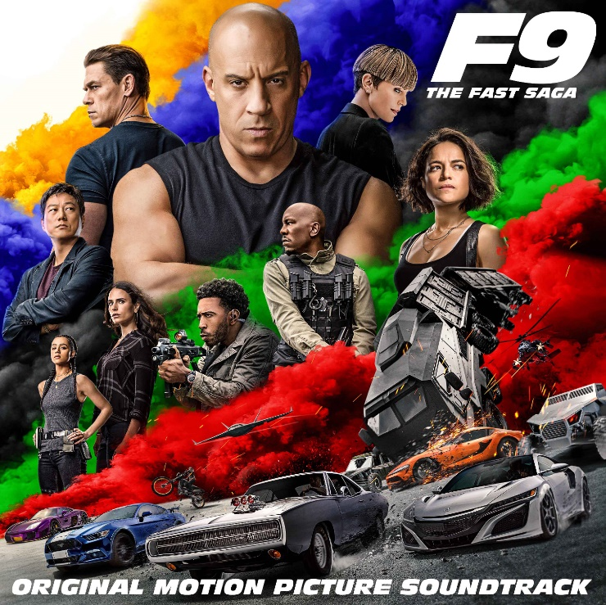

Atlantic Records and Universal Pictures has returned with the second official single from F9: THE FAST SAGA (ORIGINAL MOTION PICTURE SOUNDTRACK). “Fast Lane” by Don Toliver, Lil Durk and Latto is available now at all DSPs and streaming services HERE. The bouncy record comes on the heels of last week’s release of “I Won” from Ty Dolla $ign, Jack Harlow and 24kGoldn and will play audiences out of the theater as the end title to the film. F9: THE FAST SAGA (ORIGINAL MOTION PICTURE SOUNDTRACK) is available for pre-order everywhere HERE and arrives at all digital platforms on June 18th; F9 opens in theatres nationwide on Friday, June 25th.

F9: THE FAST SAGA (ORIGINAL MOTION PICTURE SOUNDTRACK) will carry on the FAST & FURIOUS Saga’s long history of equally explosive musical releases with a collection of all-new tracks inspired by the hugely popular film series.

Furthermore, F9: THE FAST SAGA (ORIGINAL MOTION PICTURE SOUNDTRACK) will include all brand-new songs from a truly epic line-up of rising stars and chart-topping Latin and hip-hop/R&B luminaries. Among the artists featured are Don Toliver, Lil Durk, Skepta, Pop Smoke, Offset, Trippie Redd, Kevin Gates, King Von, Polo G, The Prodigy, Anitta, Justin Quiles, Dalex, Rico Nasty, and NLE Choppa, to name but a few (see tracklisting below). Additional track releases will follow in the coming weeks leading up to the soundtrack’s eagerly anticipated release.

F9: THE FAST SAGA (ORIGINAL MOTION PICTURE SOUNDTRACK) continues the blockbuster partnership between Atlantic Records and Universal Pictures forged on two previous FAST SAGA soundtrack releases, including 2017’s “THE FATE OF THE FURIOUS: THE ALBUM“ and 2015’s worldwide smash, “FURIOUS 7: ORIGINAL MOTION PICTURE SOUNDTRACK.”

For updates and additional information, please visit www.thefastsaga.com and atlanticrecords.com.

* * * * *
ABOUT F9
No matter how fast you are, no one outruns their past.

F9 is the ninth chapter in the FAST & FURIOUS Saga, which has endured for two decades and has earned more than $5 billion around the world.

Vin Diesel’s Dom Toretto is leading a quiet life off the grid with Letty and his son, little Brian, but they know that danger always lurks just over their peaceful horizon. This time, that threat will force Dom to confront the sins of his past if he’s going to save those he loves most. His crew joins together to stop a world-shattering plot led by the most skilled assassin and high-performance driver they’ve ever encountered: a man who also happens to be Dom’s forsaken brother, Jakob (John Cena, the upcoming The Suicide Squad).

F9 sees the return of Justin Lin as director, who helmed the third, fourth, fifth, and sixth chapters of the series when it transformed into a global blockbuster. The action hurtles around the globe – from London to Tokyo, from Central America to Edinburgh, and from a secret bunker in Azerbaijan to the teeming streets of Tbilisi. Along the way, old friends will be resurrected, old foes will return, history will be rewritten, and the true meaning of family will be tested like never before.

The film stars returning cast members Michelle Rodriguez, Tyrese Gibson, Chris “Ludacris” Bridges, Nathalie Emmanuel, Jordana Brewster, and Sung Kang, with Oscar® winner Helen Mirren, with Kurt Russell and Oscar® winner Charlize Theron. F9 also features GRAMMY®-winning superstar Cardi B as new franchise character Leysa, a woman with a connection to Dom’s past, and a cameo by reggaetón sensation Ozuna.

F9 is produced by Neal H. Moritz p.g.a., Vin Diesel p.g.a., Justin Lin p.g.a., Jeff Kirschenbaum p.g.a., Joe Roth, Clayton Townsend p.g.a., and Samantha Vincent. Universal Pictures presents an Original Film/One Race Films/Perfect Storm production in association with Roth/Kirschenbaum Films, a Justin Lin film.

For more information, please visit www.thefastsaga.com.

# # #

F9 THE FAST SAGA: ORIGINAL MOTION PICTURE SOUNDTRACK
(Atlantic Records)

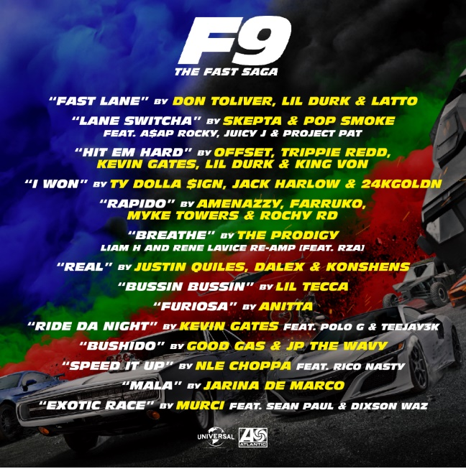

TRACKLIST
“Fast Lane” – Don Toliver, Lil Durk & Latto
“Lane Switcha (Feat. A$AP Rocky, Juicy J & Project Pat)” – Skepta & Pop Smoke
“Hit Em Hard” – Offset, Trippie Redd, Kevin Gates, Lil Durk & King Von
“I Won” – Ty Dolla $ign, Jack Harlow & 24kGoldn
“Rapido” – Amenazzy, Farruko, Myke Towers & Rochy RD
“Breathe (Liam H and Rene LaVice Re-Amp) [Feat. RZA]” – The Prodigy
“Real” – Justin Quiles, Dalex & Konshens
“Bussin Bussin” – Lil Tecca
“Furiosa” – Anitta
“Ride Da Night (Feat. Polo G & Teejay3k)” – Kevin Gates
“Bushido” – Good Gas & JP THE WAVY
“Speed It Up (Feat. Rico Nasty)” – NLE Choppa
“Mala” – Jarina De Marco
“Exotic Race (Feat. Sean Paul & Dixson Waz)” – Murci

# # #

For press inquiries, please contact:
Ariana.White@atlanticrecords.com

