FOR IMMEDIATE RELEASE
JANUARY 19, 2022

FKA TWIGS
META ANGEL
VISUAL OUT NOW

British artist FKA twigs’ releases the visual for her song “meta angel”, from her new mixtape CAPRISONGS. The visual follows twigs to a rooftop as she hunts a version of herself. She fires an arrow, we fly through the city and straight into twigs’ heart - “I got voices in my head / Telling me that I won’t make it far / Mirrors singing in my face / Where’d you go, where’d you go?” The track was highlighted in The New York Times’ ‘The Playlist’ which identified the track as “wrenching, shape-shifting,” and Pitchfork stated it is “a cherubic, slow-rocking number about craving validation from a higher power.” Watch the visual here.

FKA twigs new mixtape CAPRISONGS, has been met with widespread critical acclaim. As her first major release via Atlantic Records, the joyous collection of songs was highlighted on NPR’s ‘New Music Friday’ who acknowledged “On 'CAPRISONGS,' FKA twigs vibrates at her highest frequency.” It received additional rave reviews from Rolling Stone who claimed CAPRISONGS as “the most buoyant music of her career.” They also went on to declare it “an unbridled thrill,” in their 4-star review. Nylon agreed to note CAPRISONGS as “one of her most buoyant, unfussy, and — perhaps most notably – playful projects yet.” Consequence went on to declare “CAPRISONGS is perhaps the most explicit example of her ample supply of influences, only further testifying to her status as one of the decade’s most innovative pop musicians.” Listen to CAPRISONGS here.

CAPRISONGS is executive produced by FKA twigs and El Guincho and features production from FKA twigs, El Guincho, Koreless, P2J, Mike Dean, Marius de Vries, Jasper Harris, Teo Halm, Arca, FRED, Psymun, Cirkut, BKay, Reaper, Sega Bodega, Fake Guido, Pau, Felix Joseph, AoD, Jeff Kleinman, Warren Ellis, Jonathan Coffer and BAK.

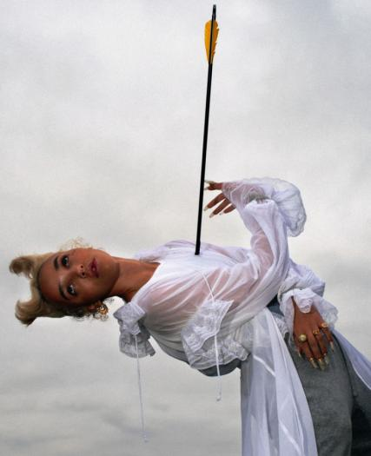

Download hi-res press images here, photo credit is Orograph.

FKA twigs Official Site / Instagram / Facebook / Twitter / YouTube

For more information on FKA twigs, please contact:

Benny Tarantini / BT PR
Benny@BTPR.biz

Moya Crowley / BT PR
Moya@BTPR.biz

Ariana White / Atlantic Records
Ariana.White@atlanticrecords.com

