FOR IMMEDIATE RELEASE
NOVEMBER 5, 2021

CKAY REVEALS THE LONG-AWAITED OFFICIAL VIDEO FOR THE NORTH AFRICAN REMIX OF THE GLOBAL SMASH ‘LOVE NWANTITI’
FEATURES MORROCAN RAPPER EL GRANDE TOTO

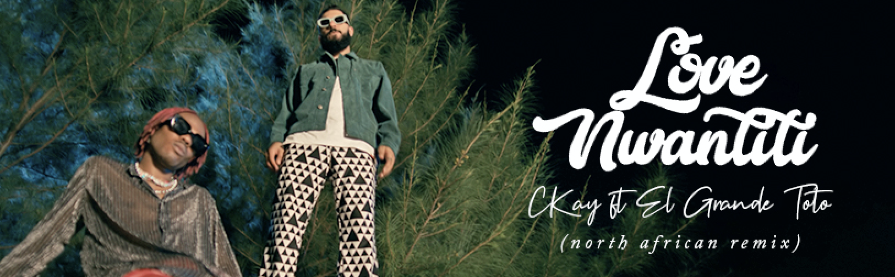
Watch Here
Nigerian producer, performer and singer-songwriter CKay is proud to present the visual companion to his Global smash hit ‘love nwantiti’. Enlisting the help of ElGrande Toto, who stars, and top Nigerian director TG Omori, CKay created his cinematic take on the classic high school love story.

Shot on location in Nigeria in October 2021, in response to the unprecedented demand for visuals of the viral hit. It all started when the North African remix of the track, ft El GrandeToto catapulted into the Shazam Global Top 10, off the back of a major TikTok trend which started in North Africa before impacting massively across Europe and the Americas, with the Tik Tok ‘sounds’ of the original version plus various official remixes being used by millions of creators including Kendall Jenner, who used the sound for her Tik Tok video upon arrival at the Met Gala and Manchester United used it as the soundtrack to Christiano Ronaldo’s ‘drink water’ video on the short-form video platform.

Says CKay, “This is one of the most organic collaborations I ever did. Started from a dm, and shortly after it became a monster hit in North Africa, the Middle East and far beyond. We just had to shoot a video for this version, and for the culture, we had to shoot it in Nigeria. Enjoy!”
Since this original viral moment, ‘love nwantiti’ locked down the #1 on the Shazam Global Chart where it continues to hold steady, and has gone on to be streamed 700m times and counting, whilst climbing to #1 on Official charts in 8 countries including France, India and the Netherlands, and hitting Top 10 in UK, Canada, Germany, Australia, South Africa and more. All told, the worldwide popularity of “love nwantiti” has seen the track receive platinum certification in Canada, India, Switzerland, and Portugal, gold certification in Australia, South Africa, Italy, and New Zealand, and silver certification in the UK.

CONNECT:
Instagram
TikTok
YouTube
Spotify
Facebook

CONTACT:
ARIANA.WHITE@ATLANTICRECORDS.COM

