FOR IMMEDIATE RELEASE
JANUARY 15, 2021
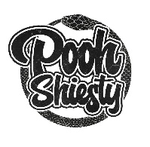
POOH SHIESTY LIFTS CURTAIN ON “GUARD UP” AND ANNOUNCES DEBUT MIXTAPE, SHIESTY SEASON

CELEBRATES FIRST CAREER ENTRY ON BILLBOARD’S HOT 100 WITH NEW SINGLE AND VIDEO

SHIESTY SEASON ARRIVES VIA THE NEW 1017 AND ATLANTIC RECORDS
ON FRIDAY, FEBRUARY 5TH; PRE-ORDERS AVAILABLE NOW

DOWNLOAD/STREAM “GUARD UP”
WATCH/SHARE “GUARD UP”

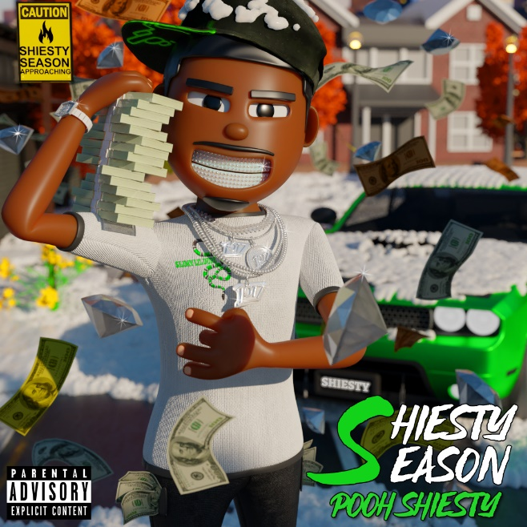
DOWNLOAD HI-RES ARTWORK HERE

“Just about anything with Memphis rapper Pooh Shiesty’s name on it is practically guaranteed to go gangbusters. With a laconic delivery and chilly street narratives, he justifies the attention.”
- UPROXX

Celebrating his first career entry on Billboard’s Hot 100 this week with “Back In Blood” feat. Lil Durk, rising Memphis rapper Pooh Shiesty has released his latest single “Guard Up,” which arrives with a companion visual available for viewing now. He’s also officially announced the arrival of his debut mixtape SHIESTY SEASON on Friday, February 5th via Gucci Mane’s The New 1017 and Atlantic Records. Pre-orders are available now.

In addition to “Guard Up,” the long-awaited debut mixtape is set to include the recently released “Twerksum” (over 19M views) and the undeniable earworm “Back In Blood” which has peaked at #6 and #15 on Apple Music’s Hip-Hop/Rap & U.S. All Genre charts, respectively, while peaking at #29 on Spotify’s Viral 50. The track has also recently entered Spotify’s Top 200 at #171. The video for “Back In Blood,” which was released at the top of this month pulled in an astounding 2.4M views within its first 24 hours and quickly began trending on YouTube. It now boasts over 12M views.

Named by Spotify’s “Rap Caviar” as one of their “10 Artists to Watch in 2021,” Pooh Shiesty has staked his claim on a number of other influential charts in addition to Billboard’s Hot 100, including Rolling Stone’s “Breakthrough 25” (debuting at #3) and Billboard’s Emerging Artists chart (debuting at #30). He also spent over 20 weeks at the top of Pandora’s Trendsetter Chart.

Known for snaking through airy beats with a venomous bite and slick melodies, the Memphis born-and-bred rapper first incited buzz with 2019’s “Shiesty Summer” (8.9M views), earning the attention of GRAMMY® Award-nominated, multi-platinum icon Gucci Mane, who promptly signed Pooh to his groundbreaking The New 1017 label. A series of increasingly popular hits followed, including “Monday to Sunday (Feat. Lil Baby & Big 30)“ (31M views), “7.62 God“ (19.5M views), “Main Slime Remix (Feat. Moneybagg Yo)“ (17.3M views), and “ABCGE (Feat. Big 30)“ (8.6M views), to name just a few. In addition, Pooh recently kicked off Audiomack’s “17 Bars with The New 1017” series with a cover of Gucci Mane’s classic “Lemonade,” currently boasting close to 3M views.

Now, with the long-awaited release of SHIESTY SEASON, Pooh Shiesty is set to deliver a sound as raw as his hometown, his intense presence and inimitable talent has become increasingly impossible to deny.

“Ain’t nobody messing with me,” says Pooh Shiesty. “I’m going into this hard like I was always meant to.”

DOWNLOAD HI-RES IMAGE HERE
VIEW FULL BIO HERE

CONNECT:
WEBSITE | INSTAGRAM | TWITTER | FACEBOOK | SOUNDCLOUD | AUDIOMACK

POOH SHIESTY CONTACT:
SELAM.BELAY@ATLANTICRECORDS.COM

THE NEW 1017 LABEL CONTACT:
ASHLEY.KALMANOWITZ@ATLANTICRECORDS.COM

