FOR IMMEDIATE RELEASE
JUNE 4, 2021

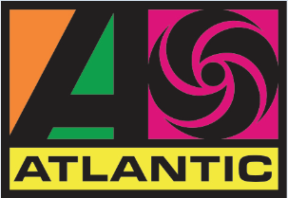

HIGHBRIDGE THE LABEL AND ATLANTIC RECORDS OFFICIALLY WELCOME ENISA

BROOKLYN-BASED SINGER-SONGWRITER FOLLOWS WORLDWIDE #1 HITS
WITH TODAY’S PREMIERE OF BRAND-NEW SINGLE AND VISUAL, “TEARS HIT THE GROUND”

DOWNLOAD/STREAM
WATCH/SHARE

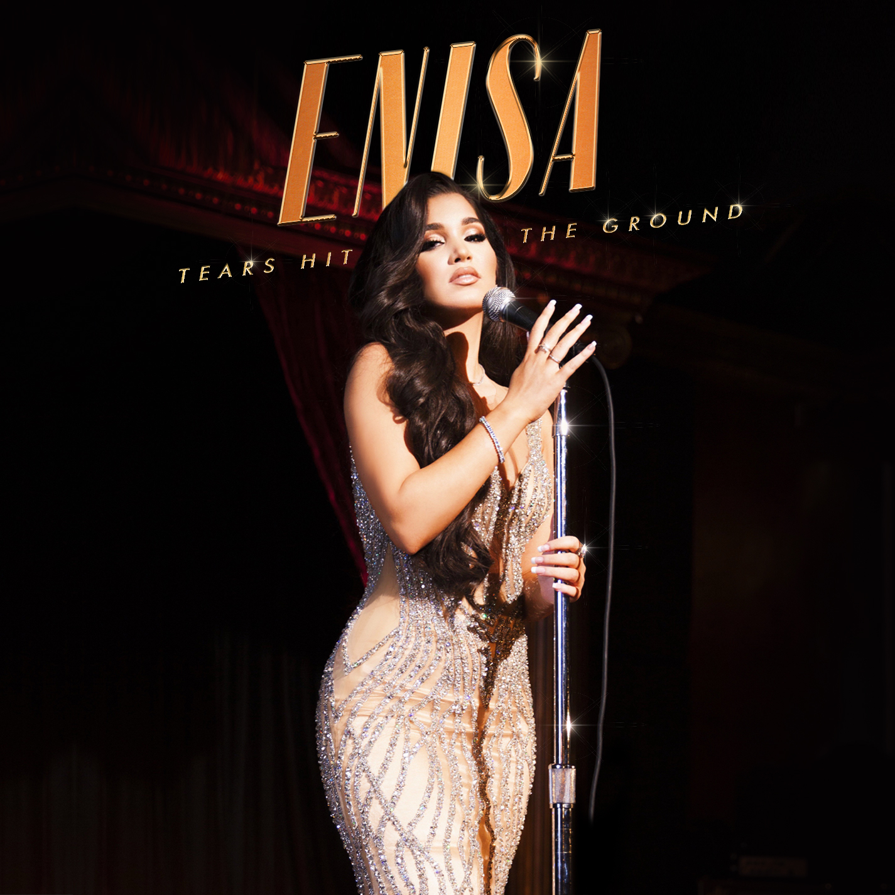
DOWNLOAD HI-RES GRAPHIC HERE

Highbridge The Label and Atlantic Records have announced acclaimed new singer-songwriter Enisa as the latest member of its prestigious roster. The Brooklyn-based artist is celebrating with today’s premiere of a brand new single, “Tears Hit The Ground,” available now at all DSPs and streaming services; an official music video is also available now. “Tears Hit The Ground” can be seen on her debut EP due for release later this summer.

Download/stream “Tears Hit The Ground”
Watch/share “Tears Hit The Ground”

“I finished writing this song 4 years ago and held onto it until the perfect moment. I wrote it at a time where I felt like I was getting let down left and right by everyone in my life. It’s a song about feeling betrayed but feeling power in the fact that karma would make its way around and that hole that I felt like I was in would only be temporary,” says Enisa.

The first lady of Highbridge The Label – who recently hit #1 on both Billboard’s “Next Big Sound” chart and Pandora’s “Predictions” chart – has fast proven a truly global favorite, earning chart-topping success in Nigeria, Gambia, Portugal, Algeria, Tunisia, Morocco, Sri Lanka, and India, to name a few. “Tears Hit The Ground” marks the latest in a series of increasingly popular releases from the gifted young artist, following after “Love Cycle (10.6M views),” “Dumb Boy (9.4M views),” and “Count My Blessings (15.5M views).”

After the overwhelming success of “Love Cycle” after it dropped last November, Enisa recruited Davido and quickly followed with the “Love Cycle (Remix) (2.1M views).” Enisa marked the track’s worldwide popularity with live performances on MajorStage and OkayAfrica. Enisa also performed her own acoustic rendition of “Love Cycle.”

Enisa has spent her whole life preparing for this journey as a first-generation American born to Albanian immigrant parents. Following her graduation from Brooklyn’s esteemed Edward R. Murrow High School, she attended Brooklyn College where she continued to develop her unique musical vision. A series of distinctive cover versions exploded across social media, earning her millions of views and critical acclaim from the likes of Complex, XXL, ThisSongIsSick, and more. With the wind at her back, Enisa continued to hone her diverse musical approach, infusing contemporary soul pop with Middle Eastern flourishes inspired by her own Muslim heritage. Track releases like Scridge and Genda’s viral smash “Karma (Remix)” and such solo singles as “Burn This Bridge” and “Wait for Love” showcased a spectacular knack for raw soul and endless attitude, earning her close to 16M views and more than 3M global streams as an independent artist.

“When you hear me, I want you to walk away empowered,” Enisa says. “I know firsthand you can come out of every situation stronger. I hope you hear a song, apply it to your life, and feel like you can overcome anything. My music is all about embracing this confidence.”

CONNECT WITH ENISA
INSTAGRAM | FACEBOOK | TWITTER | SOUNDCLOUD | YOUTUBE

PRESS CONTACT
Selam Belay | selam.belay@atlanticrecords.com

