JUCEE FROOT DEBUTS “BLACK SHEEP” MIXTAPE
16-TRACK MIXTAPE BOASTS FEATURES FROM A BOOGIE WIT DA HOODIE, RICO NASTY,
JUICY J, AND KEVO MUNEY

UPCOMING TOUR WITH KASH DOLL KICKS OFF MARCH 23RD

STREAM “BLACK SHEEP” HERE
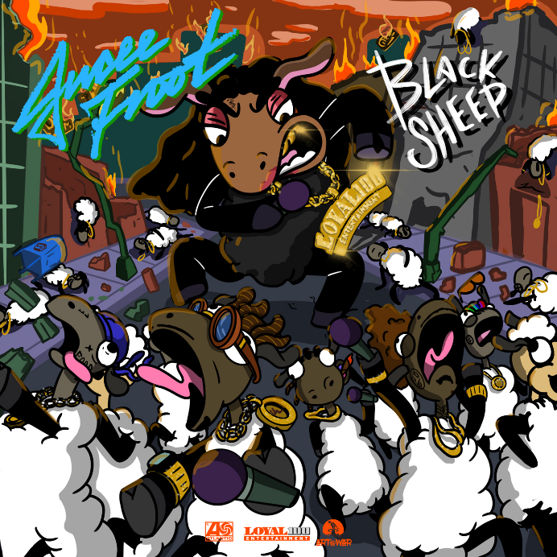

Memphis rapper Jucee Froot has unveiled her hard-hitting “Black Sheep” mixtape; available on all DSPs and streaming platforms HERE. Jucee Froot’s 16-track mixtape is highlighted by tracks such as “Life’s A Bitch,” “Psycho (Remix) (Feat. Rico Nasty),” and additional features from A Boogie Wit Da Hoodie, Juicy J, and Kevo Muney. Jucee fearlessly moves through both heavy issues and light-hearted flows on her new release.

Jucee’s “Black Sheep” mixtape was heralded by the release of a fiery music video for “Psycho (Remix) (Feat. Rico Nasty)”. The video, premiered exclusively via Complex, takes place in a prison where Jucee and fellow rap powerhouse Rico Nasty are serving time; streaming HERE. The Memphis rapper also recently debuted a companion video for “Life’s A Bitch,” streaming HERE.

Jucee Froot also recorded track “Danger” for BIRDS OF PREY: THE ALBUM, Atlantic Records’ star-studded, all-female musical companion to the blockbuster new film from Warner Bros. Pictures.

Along with the release of her “Black Sheep” mixtape, Jucee is gearing up for an opening slot on tour with Kash Doll and an appearance at Rolling Loud Festival. The Kash Doll tour gets underway March 23rd at New York City’s Gramercy Theatre and then continues through early April. Jucee Froot has also been announced for the hugely anticipated Rolling Loud Miami, set for Sunday, May 10th. For updates and more, please visit www.officialjuceefroot.com/#tour.

Jucee Froot has quickly become a vital presence in hip-hop, an honest voice equally hailed for her fearless approach as well as her bulletproof bars, confessional choruses, and clever adlibs. The Memphis, TN-based rapper earned every bit of that acclaim through tear-filled viral freestyles, countless shows nationwide, and a prolific string of independent releases, all of which led to more than 20 million worldwide streams, praise from such icons as Birdman and Kevin Gates, and now, a major label deal with Loyal 100 Entertainment/Art@War/Atlantic Records. Indeed, irresistible tracks like “Life’s A Bitch” and “F*cked Up” – both streaming now on all DSP’s - affirm Jucee Froot as a one-of-a-kind new artist with a remarkable true story to share with the world.

“I’m not afraid to speak on anything,” she says. “I’ve made songs about daddy issues, being raped, getting pregnant, and everything. I got songs you can dance to. I got songs that make you think. It’s all-around. I respect listeners through being honest all the time. I’m a female who made it out of the bottom, took everything, and still kept going regardless of anything. I’m a different breed. I want everybody to see my talent and know the story.”

Black Sheep Tracklist
Life’s A Bitch
Wristwork
Psycho (Remix) (Feat. Rico Nasty)
Queen Talk
My Cat
Sidewalk
Distance (Feat. A Boogie Wit Da Hoodie)
Girls Kissing Girls (Feat. Juicy J)
Understandable (Feat. Kevo Muney)
Devil Want My Soul
Used To
Just Fine
D.I.R.
Nightmare
Heartbeat
Loyal 100

JUCEE FROOT
ON TOUR 2020

MARCH
23 – New York, NY – Gramercy Theatre
24 – Philadelphia, PA – The Foundry
26 – Atlanta, GA – Hell at the Masquerade
27 – Birmingham, AL - Zydeco
29 – Houston, TX – The Studio at Warehouse Live
30 – Dallas, TX - Trees

APRIL
1 – Los Angeles, CA – The Roxy
3 – Oakland, CA – The New Parish
5 – Washington, DC – Union Stage
7 – Cleveland, OH – Grog Shop
8 – Toronto, ON – The Opera House
9 - Cambridge, MA – The Middle East Downstairs

MAY
10 – Miami, FL – Rolling Loud Miami *

ALL DATES W/KASH DOLL “THE DOLLHOUSE TOUR” EXCEPT *

CONNECT WITH JUCEE FROOT:
OFFICIAL
INSTAGRAM
FACEBOOK
TWITTER

PRESS CONTACT:
Ashley Kalmanowitz | Ashley.Kalmanowitz@atlanticrecords.com

