FOR IMMEDIATE RELEASE

APRIL 30, 2021

**JAMIE MILLER GETS PERSONAL ON NEW SINGLE “HERE’S YOUR PERFECT”**

**First Co-written SINGLE available now WITH VIDEO**

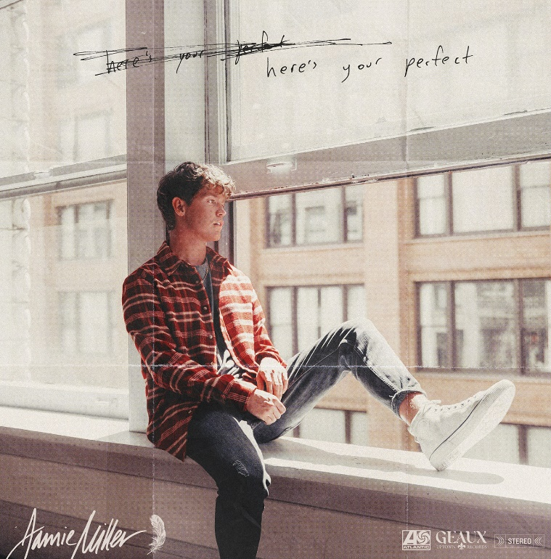

[DOWNLOAD HIGH-RES IMAGES](https://press.atlanticrecords.com/jamie-miller/)

**WATCH/STREAM “HERE’S YOUR PERFECT”:** <https://JamieMiller.lnk.to/HeresYourPerfectPR>

Singer-songwriter **Jamie** **Miller** gets personal on his new single “**Here’s Your Perfect**” – available now via **Atlantic Records** and **Geaux Uptown Records** alongside an **Andrew** **Sandler**-directed (**Machine Gun Kelly**, **Yungblud**) video. Co-penned by Miller with **Gian** **Stone** (**Nick Jonas**, **Justin Bieber**), **Bendik Møller** & **Salem Ilese** (“**Mad at Disney**”), the resilient ballad took off to the tune of 2.5 million views after being previewed via TikTok.

*“I was in a relationship back in London, in my comfort zone and the happiest I’d ever been,”* explains Miller of the song’s inspiration. *“But eventually when I moved to Los Angeles, I got cheated on and was so heartbroken. I went into a studio session devastated, but wrote through it and realized there is so much more to the world. Since then, I’ve experienced so much and really found myself through the pandemic – specifically coming to terms with my sexuality and realizing that gender doesn’t determine who I can fall in love with. It was one of the most challenging but amazing journeys I’ve worked though, and I hope it can be heard in the music.”*

“**Here’s Your Perfect**” follows Miller’s explosive 2020 debut single “[**City That Never Sleeps**](https://youtu.be/eWpI5yFglLg),” penned/produced by GRAMMY-nominated **MNEK** (**Beyoncé**, **Dua Lipa**), **Noise** **Club** (**Liam Payne**, **Zedd**) & **Asia Whitacre** (**Hailee Steinfeld, 5 Seconds of Summer**). The single garnered buzz from the likes of **PEOPLE Magazine**, **The Huffington Post** (calling the track a *“dreamy pop debut”*), **Billboard** (praising Miller’s *“incredible vocal range and control”)* & more – in addition to amassing over 1.5 million music video views & 6.4 million global streams since release. Meanwhile, Miller’s follow-up singles “[**Onto** **Something**](https://youtu.be/4GIxmQZ6hh0)” (penned/produced by **Quinn** **XCII** & **Louis Schoorl**) & “[**Hold You ‘Til We’re Old**](https://youtu.be/C9EQ87sjiu0)” (penned/produced by **Wrabel**, **Michael** **Pollack**, **Nate** **Cyphert** & 4x GRAMMY-nominee **Stuart** **Crichton**) have continued to captivate, with **Sweety High** declaring him “*an incredible talent that should be on everyone's radar.”*

Born and raised in Wales, Miller cites early musical inspiration from gospel, R&B, and soul classics fostered by parents (including the catalogues of **Donny** **Hathaway** and **Michael** **Jackson**) before discovering and honing his voice to modern talents such as **Bruno** **Mars**, **Sam Smith** & others. Initially timid in nature, Miller shied away publicly from his natural talent until the age of 18 when he mustered up the courage to relocate to London and appear for the first time on UK broadcast television in 2017. In the years that followed, he eventually migrated to Los Angeles to craft his own original music while simultaneously amassing an explosive online following thanks to ongoing displays of his jaw-dropping vocal talent. Receiving over 20 million views across platforms, Miller has captured the attention of today’s top musicians and his own personal idols – including [**Kelly Clarkson**](https://www.instagram.com/p/CBGoLPyAjyW/), [**P!nk**](https://twitter.com/Pink/status/1235084044712329216), [**Sam Smith**](https://twitter.com/samsmith/status/1184186239043457024), [**Jennifer Hudson**](https://www.facebook.com/jamiemillmusic/videos/384899798570240/?v=384899798570240), [**Khloe Kardashian**](https://www.instagram.com/p/BVThBgSlKtu/?utm_source=ig_embed) & more.

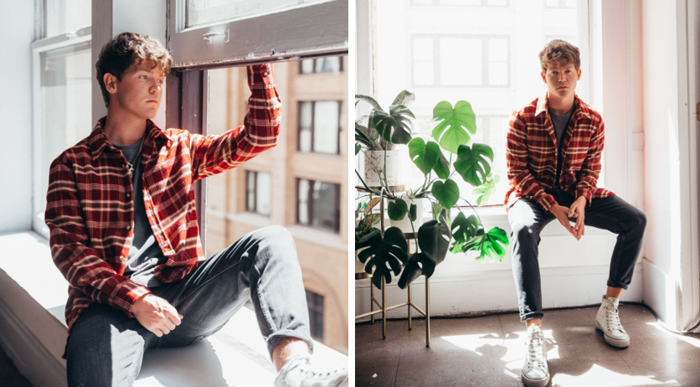

[DOWNLOAD HIGH-RES IMAGES](https://press.atlanticrecords.com/jamie-miller/)

**CONNECT:**

[OFFICIAL](https://www.jamiemillermusic.com/) | [FACEBOOK](https://www.facebook.com/jamiemillmusic/) | [TWITTER](https://twitter.com/jamiemillmusic) | [INSTAGRAM](https://www.instagram.com/jamiemillmusic/?hl=en) | [YOUTUBE](https://www.youtube.com/channel/UCilqV3GecszUjixKZWsuZ-w/featured) | [TIKTOK](https://www.tiktok.com/@jamiemillmusic) | [PRESS ASSETS](https://press.atlanticrecords.com/jamie-miller/)

**CONTACT:**

[TED.SULLIVAN@ATLANTICRECORDS.COM](mailto:TED.SULLIVAN@ATLANTICRECORDS.COM)