FOR IMMEDIATE RELEASE

AUGUST 13, 2021

**JAMIE MILLER DUETS WITH SALEM ILESE ON**

**GLOBAL BREAKOUT SINGLE “HERE’S YOUR PERFECT”**

**“Here’s Your Perfect” streaming over 2 million times daily,**

**over 105 million worldwide streams to date!**

**Debut New York & Los Angeles headline shows announced for October 2021**

**Duet version with viral co-writer Salem Ilese out now with performance video**

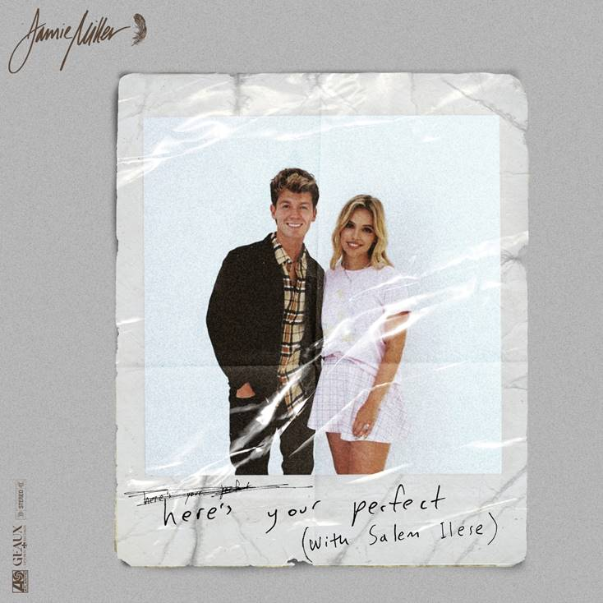

[DOWNLOAD HIGH-RES IMAGES](https://press.atlanticrecords.com/jamie-miller/)

**WATCH/STREAM “HERE’S YOUR PERFECT” (DUET):** <https://jamiemiller.lnk.to/HYPwithSalemPR>

Singer-songwriter **Jamie** **Miller** has shared a stunning duet rendition of his global smash single “[**Here’s Your Perfect**](https://www.youtube.com/watch?v=cRi-x2r88no),” performed alongside co-writer & viral pop vocalist **Salem Ilese** (“**Mad at Disney**,” “**Build A Bitch**”) – available now alongside a performance video via **Atlantic Records** and **Geaux Uptown Records**. Deemed a “*breakout hit”* by **Rolling** **Stone**, the track recently made its debut on **Billboard**’s Global ex-US chart as it continues to amass over 2 million daily streams with a running total of over 105 million worldwide to date and over 50 million combined video views.

On the heels of the single’s take-off, Miller has also announced his first ever live shows with headline performances slated for October 20th at Los Angeles’ Moroccan Lounge and October 26th at New York’s Mercury Lounge. For tickets & more information, please visit [jamiemillermusic.com](https://www.jamiemillermusic.com/).

“**Here’s Your Perfect**” follows Miller’s explosive 2020 debut single “[**City That Never Sleeps**](https://youtu.be/eWpI5yFglLg),” penned/produced by GRAMMY-nominated **MNEK** (**Beyoncé**, **Dua Lipa**), **Noise** **Club** (**Liam Payne**, **Zedd**) & **Asia Whitacre** (**Hailee Steinfeld, 5 Seconds of Summer**). The single garnered buzz from the likes of **PEOPLE Magazine**, **The Huffington Post** (calling the track a *“dreamy pop debut”*), **Billboard** (praising Miller’s *“incredible vocal range and control”)* & more. Meanwhile, Miller’s follow-up singles “[**Onto** **Something**](https://youtu.be/4GIxmQZ6hh0)” (penned/produced by **Quinn** **XCII** & **Louis Schoorl**) & “[**Hold You ‘Til We’re Old**](https://youtu.be/C9EQ87sjiu0)” (penned/produced by **Wrabel**, **Michael** **Pollack**, **Nate** **Cyphert** & 4x GRAMMY-nominee **Stuart** **Crichton**) have continued to captivate, with **Sweety High** declaring him “*an incredible talent that should be on everyone's radar.”*

Born and raised in Wales, Miller cites early musical inspiration from gospel, R&B, and soul classics fostered by parents (including the catalogues of **Donny** **Hathaway** and **Michael** **Jackson**) before discovering and honing his voice to modern talents such as **Bruno** **Mars**, **Sam Smith** & others. Initially timid in nature, Miller shied away publicly from his natural talent until the age of 18 when he mustered up the courage to relocate to London and appear for the first time on UK broadcast television in 2017. In the years that followed, he eventually migrated to Los Angeles to craft his own original music while simultaneously amassing an explosive online following thanks to ongoing displays of his jaw-dropping vocal talent – in addition to capturing the attention of today’s top musicians and his own personal idols including [**Kelly Clarkson**](https://www.instagram.com/p/CBGoLPyAjyW/), [**P!nk**](https://twitter.com/Pink/status/1235084044712329216), [**Sam Smith**](https://twitter.com/samsmith/status/1184186239043457024), [**Jennifer Hudson**](https://www.facebook.com/jamiemillmusic/videos/384899798570240/?v=384899798570240), [**Khloe Kardashian**](https://www.instagram.com/p/BVThBgSlKtu/?utm_source=ig_embed) & more.

**ABOUT SALEM ILESE:**

21-year-old Northern California pop singer and songwriter Salem Ilese hopes to spread awareness about important issues through her catchy pop songs. This mission includes her breakout single “Mad At Disney”; released in July 2020, the song unpacked Disney’s harmful stereotypes of women and has over 300 million streams to date.  Salem’s May 2021 EP ‘(L)only Child’ is full of coming of age electro-pop anthems about self-acceptance and the social issues plaguing our world. The new project arrived on the heels of her writing credit on TikToker-turned-popstar Bella Poarch’s “Build a Bitch” single, which has been streamed over 150 million times. Similar to Salem’s own smash hit “Mad At Disney,” Bella’s “Build a Bitch” is an anthem of female empowerment, turning establishment led gender norms on their heads.

**CONNECT:**

[OFFICIAL](https://www.jamiemillermusic.com/) | [FACEBOOK](https://www.facebook.com/jamiemillmusic/) | [TWITTER](https://twitter.com/jamiemillmusic) | [INSTAGRAM](https://www.instagram.com/jamiemillmusic/?hl=en) | [YOUTUBE](https://www.youtube.com/channel/UCilqV3GecszUjixKZWsuZ-w/featured) | [TIKTOK](https://www.tiktok.com/@jamiemillmusic) | [PRESS ASSETS](https://press.atlanticrecords.com/jamie-miller/)

**CONTACT:**

[TED.SULLIVAN@ATLANTICRECORDS.COM](mailto:TED.SULLIVAN@ATLANTICRECORDS.COM)