FOR IMMEDIATE RELEASE

FEBRUARY 12, 2021

**JAMIE MILLER SHARES NEW SINGLE “HOLD YOU ‘TIL WE’RE OLD”**

**THIRD SINGLE from phenomenally talented**

**SINGER-SONGWRITER available now WITH VIDEO**

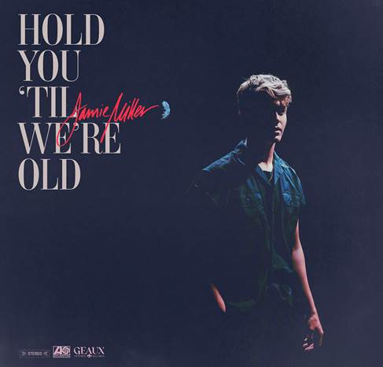

[DOWNLOAD HIGH-RES IMAGES](https://press.atlanticrecords.com/jamie-miller/)

**WATCH/STREAM “HOLD YOU ‘TIL WE’RE OLD”:** [https://JamieMiller.lnk.to/HYTWO](https://nam04.safelinks.protection.outlook.com/?url=https%3A%2F%2Fjamiemiller.lnk.to%2FHYTWO&data=04%7C01%7CBrian.Sommer%40atlanticrecords.com%7C023846ed26ef430c953c08d8cd1099ff%7C8367939002ec4ba1ad3d69da3fdd637e%7C0%7C0%7C637484818469363271%7CUnknown%7CTWFpbGZsb3d8eyJWIjoiMC4wLjAwMDAiLCJQIjoiV2luMzIiLCJBTiI6Ik1haWwiLCJXVCI6Mn0%3D%7C1000&sdata=PlpUOksIUtv0z8kxvQUkP61pCvg29AUlOA89xvFLYJw%3D&reserved=0)

Phenomenally talented singer-songwriter **Jamie** **Miller** has shared new single “**Hold You ‘Til We’re Old**” – available now via **Atlantic Records** and **Geaux Uptown Records** alongside a moving performance-based music video directed by **Evan Hara**. Penned by **Wrabel** (**Kesha**, **Galantis**), **Michael** **Pollack** (**Justin** **Bieber**, **Miley** **Cyrus**, **Maroon** **5**), **Nate** **Cyphert** (**Florida** **Georgia** **Line**, **Steve** **Aoki**) & produced by 4x GRAMMY-nominee **Stuart** **Crichton**, the track is an uplifting ode to love that mounts to feature Miller’s stunning signature falsetto (which alone amassed over 600k views on TikTok when previewed last month).

“**Hold You ‘Til We’re Old**” follows Miller’s 2020 debut single “[**City That Never Sleeps**](https://jamiemiller.lnk.to/CityThatNeverSleepsTA),” penned/produced by GRAMMY-nominated **MNEK** (**Beyoncé**, **Dua Lipa**), **Noise** **Club** (**Liam Payne**, **Zedd**) & **Asia Whitacre** (**Hailee Steinfeld, 5 Seconds of Summer**). The single garnered early praise from the likes of **PEOPLE Magazine**, **The Huffington Post** (declaring the track a *“dreamy pop debut”*), **Billboard** (praising Miller’s *“incredible vocal range and control”)* & more – in addition to amassing over 1.4 million music video views & 4.8 million global streams since release. Meanwhile his second single, “[**Onto** **Something**](https://JamieMiller.lnk.to/OntoSomethingPR),” was penned/produced by **Quinn** **XCII** & **Louis Schoorl** and simply deemed *“perfect”* by **Sweety** **High**.

Born and raised in Wales, Miller cites early musical inspiration from gospel, R&B, and soul classics fostered by parents (including the catalogues of **Donny** **Hathaway** and **Michael** **Jackson**) before discovering and honing his voice to modern talents such as **Bruno** **Mars**, **Sam Smith** & others. Initially timid in nature, Miller shied away publicly from his natural talent until the age of 18 when he mustered up the courage to relocate to London and appear for the first time on UK broadcast television in 2017. In the years that followed, he eventually migrated to Los Angeles to craft his own original music while simultaneously amassing an explosive online following thanks to ongoing displays of his jaw-dropping vocal talent. Receiving over 20 million views across platforms, Miller has captured the attention of today’s top musicians and his own personal idols – including [**Kelly Clarkson**](https://www.instagram.com/p/CBGoLPyAjyW/), [**P!nk**](https://twitter.com/Pink/status/1235084044712329216), [**Sam Smith**](https://twitter.com/samsmith/status/1184186239043457024), [**Jennifer Hudson**](https://www.facebook.com/jamiemillmusic/videos/384899798570240/?v=384899798570240), [**Khloe Kardashian**](https://www.instagram.com/p/BVThBgSlKtu/?utm_source=ig_embed) & more.

When it comes to his craft, **Jamie** **Miller** packs raw conviction into every performance. *“I want everyone to know my music comes from a real place,”* he explains*. “It’s my life. I aim to give them three minutes of happiness. I came from a town where there wasn’t much opportunity, but I was willing to get out and move to the other side of the world. I’ve gotten strength from the journey. I hope to share it in the music.”*

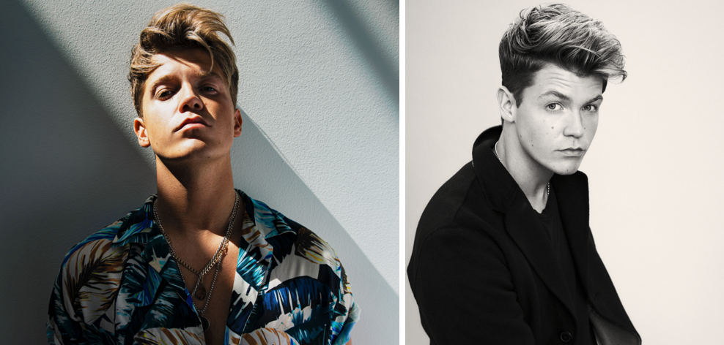

[DOWNLOAD HIGH-RES IMAGES](https://press.atlanticrecords.com/jamie-miller/) (credit: Jimmy Fontaine)

**CONNECT:**

[OFFICIAL](https://www.jamiemillermusic.com/) | [FACEBOOK](https://www.facebook.com/jamiemillmusic/) | [TWITTER](https://twitter.com/jamiemillmusic) | [INSTAGRAM](https://www.instagram.com/jamiemillmusic/?hl=en) | [YOUTUBE](https://www.youtube.com/channel/UCilqV3GecszUjixKZWsuZ-w/featured) | [TIKTOK](https://www.tiktok.com/@jamiemillmusic) | [PRESS ASSETS](https://press.atlanticrecords.com/jamie-miller/)

**CONTACT:**

[TED.SULLIVAN@ATLANTICRECORDS.COM](mailto:TED.SULLIVAN@ATLANTICRECORDS.COM)