FOR IMMEDIATE RELEASE
NOVEMBER 5, 2021

JAMIE MILLER PREPARES FOR THE HOLIDAYS WITH “HOME BY MIDNIGHT”

ACCLAIMED SINGLE “HERE’S YOUR PERFECT” SOARS PAST 250 MILLION GLOBAL STREAMS

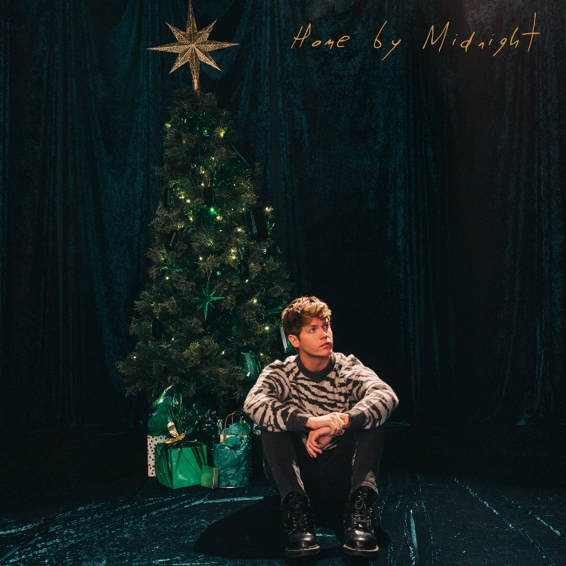
DOWNLOAD HIGH-RES ARTWORK

STREAM/DOWNLOAD “Home By Midnight”: https://jamiemiller.lnk.to/HomeByMidnightPR

Rising pop singer/songwriter Jamie Miller is getting into the holiday spirit with his new single, “Home By Midnight,” released today via Atlantic Records. Produced by Jon Hume (Galantis, Bebe Rexha, Elle King) and written by Hume and Sierra Deaton (5 Seconds Of Summer, gnash, Jagwar Twin) of Alex & Sierra, “Home By Midnight” is a passionate yuletide ballad with an anthemic chorus.

“Home By Midnight” follows Miller’s viral smash single, “Here’s Your Perfect,” which spent a lengthy 13 weeks on the Billboard Global Ex-US chart and has amassed over 250 million global streams and 61 million video views. The track has also basked in critical acclaim from the likes of Rolling Stone, declaring the track to be “a plinking piano ballad that swells quickly to arena size” and further predicting “it’s possible that the song will be performed in arenas before long.” Meanwhile, recent months have seen Miller collaborate with singer and “Here’s Your Perfect” co-writer Salem Ilese for a stunning duet version of the song, in addition to DJ/producer Alan Walker for the infectious breakup anthem “Running Out Of Roses” which debuted at #32 on Billboard’s Hot Dance/Electronic Songs Charts.

“Home By Midnight” also follows Miller’s explosive 2020 debut single “City That Never Sleeps,” penned/produced by GRAMMY-nominated MNEK (Beyoncé, Dua Lipa), Noise Club (Liam Payne, Zedd) & Asia Whitacre (Hailee Steinfeld, 5 Seconds of Summer). The single garnered buzz from the likes of PEOPLE Magazine, The Huffington Post (calling the track a “dreamy pop debut”), Billboard (praising Miller’s “incredible vocal range and control”) & more. Meanwhile, Miller’s follow-up singles “Onto Something” (penned/produced by Quinn XCII & Louis Schoorl) & “Hold You ‘Til We’re Old” (penned/produced by Wrabel, Michael Pollack, Nate Cyphert & 4x GRAMMY-nominee Stuart Crichton) have continued to captivate, with Sweety High declaring him “an incredible talent that should be on everyone's radar.”

Born and raised in Wales, Miller cites early musical inspiration from gospel, R&B, and soul classics fostered by parents (including the catalogues of Donny Hathaway and Michael Jackson) before discovering and honing his voice to modern talents such as Bruno Mars, Sam Smith & others. Initially timid in nature, Miller shied away publicly from his natural talent until the age of 18 when he mustered up the courage to relocate to London and appear for the first time on UK broadcast television in 2017. In the years that followed, he eventually migrated to Los Angeles to craft his own original music while simultaneously amassing an explosive online following thanks to ongoing displays of his jaw-dropping vocal talent – in addition to capturing the attention of today’s top musicians and his own personal idols including Kelly Clarkson, P!nk, Sam Smith, Jennifer Hudson, Khloe Kardashian & more.

CONNECT:
OFFICIAL | FACEBOOK | TWITTER | INSTAGRAM | YOUTUBE | TIKTOK | PRESS ASSETS

CONTACT:
TED.SULLIVAN@ATLANTICRECORDS.COM

