FOR IMMEDIATE RELEASE
JANUARY 28, 2022

Jamie Miller soars with “I Lost Myself In Loving You”

New single from rising pop singer/songwriter available now

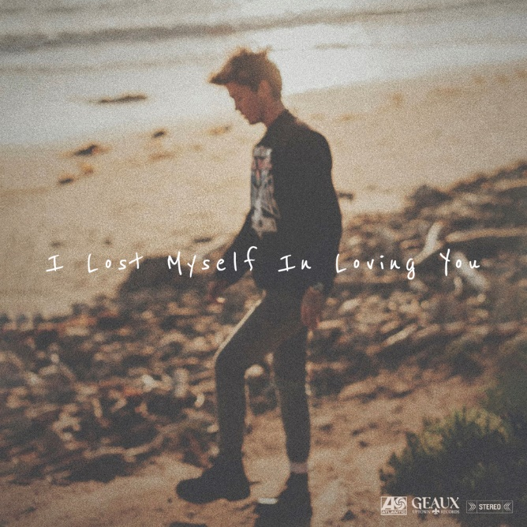

WATCH “I Lost Myself In Loving You” VIDEO: https://youtu.be/DUv-r_OCoZo
Stream “I Lost Myself In Loving You”: https://jamiemiller.lnk.to/ILMILYPR

Meteorically rising pop singer/songwriter Jamie Miller releases his most heartfelt and personal single to date, “I Lost Myself In Loving You” – available now via Atlantic Records and Geaux Uptown Records. Written by Miller alongside Sierra Deaton (5 Seconds of Summer) and GRAMMY-nominated Jon Hume (Bebe Rexha, Dean Lewis, JP Cooper), the intimate and candid track delves into the tribulations of blind love.

“I wrote this song after falling completely in love with the wrong person. After coming out as bisexual last year, I found myself in love with a guy for the first time and was completely blinded by my emotions. Although our time together left me deceived and heartbroken, I hope this song can help mend a few broken hearts.” – JAMIE MILLER

“I Lost Myself In Loving You” arrives on the heels of “Wishes,” a stunning ballad recorded for the soundtrack of the hit Korean TV drama series Snowdrop, airing globally on Disney+ and starring Jisoo of BLACKPINK. In just a week, the track has amassed over 4 million streams and 2.5 million video views worldwide.

Last year saw Miller make a splash with his viral single “Here’s Your Perfect,” which spent a lengthy 13 weeks on Billboard’s Global Ex-US chart. Deemed a “breakout hit” by Rolling Stone, the track has amassed over 338 million global streams to date and over 135 million combined video views. Meanwhile, Miller’s debut single “City That Never Sleeps,” penned/produced by GRAMMY-nominated MNEK (Beyoncé, Dua Lipa), Noise Club (Liam Payne, Zedd) & Asia Whitacre (Hailee Steinfeld, 5 Seconds of Summer), garnered buzz from the likes of PEOPLE Magazine, The Huffington Post (calling the track a “dreamy pop debut”), Billboard (praising Miller’s “incredible vocal range and control”) & more.

Born and raised in Wales, Miller cites early musical inspiration from gospel, R&B, and soul classics fostered by his parents (including the catalogues of Donny Hathaway and Michael Jackson) before discovering and honing his voice to modern talents such as Bruno Mars, Sam Smith, Lewis Capaldi & others. Initially timid in nature, Miller shied away publicly from his natural talent until the age of 18 when he mustered up the courage to relocate to London and appear for the first time on UK broadcast television in 2017. In the years that followed, he eventually migrated to Los Angeles to craft his own original music while simultaneously amassing an explosive online following thanks to ongoing displays of his jaw-dropping vocal talent – in addition to capturing the attention of today’s top musicians and his own personal idols including Kelly Clarkson, P!nk, Sam Smith, Jennifer Hudson & more.

CONNECT:
OFFICIAL | FACEBOOK | TWITTER | INSTAGRAM | YOUTUBE | TIKTOK | PRESS ASSETS

CONTACT:
TED.SULLIVAN@ATLANTICRECORDS.COM

