FOR IMMEDIATE RELEASE
OCTOBER 23, 2020

JAMIE MILLER IS “ONTO SOMETHING”

Second single & video from phenomenally talented vocalist available now

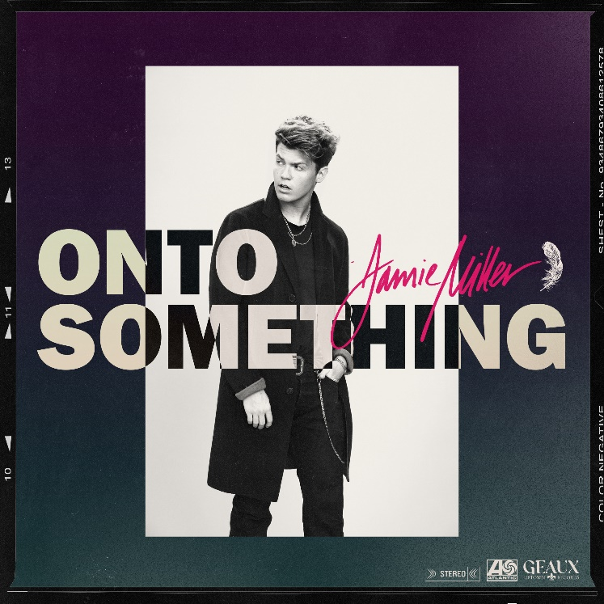
DOWNLOAD HIGH-RES IMAGES

WATCH/STREAM “ONTO SOMETHING”: https://JamieMiller.lnk.to/OntoSomethingPR

Phenomenally talented singer-songwriter Jamie Miller has shared his highly anticipated second single “Onto Something” – available now via Atlantic Records and Geaux Uptown Records alongside a suave Evan Hara-directed music video. Penned/produced by Quinn XCII & Louis Schoorl, the track features a slick beat and palm-muted guitar as Miller’s voice takes flight on the infectious hook.

“Onto Something” follows Miller’s debut single “City That Never Sleeps,” penned/produced by GRAMMY-nominated MNEK (Beyoncé, Dua Lipa), Noise Club (Liam Payne, Zedd) & Asia Whitacre (Hailee Steinfeld, 5 Seconds of Summer). The single garnered early praise from the likes of PEOPLE Magazine, The Huffington Post (declaring the track a “dreamy pop debut”), Billboard (praising Miller’s “incredible vocal range and control”) & more – in addition to amassing over 1.3 million music video views & 2.8 million global streams since release.

Born and raised in Wales, Miller cites early musical inspiration from gospel, R&B, and soul classics fostered by parents (including the catalogues of Donny Hathaway and Michael Jackson) before discovering and honing his voice to modern talents such as Bruno Mars, Sam Smith & others. Initially timid in nature, Miller shied away publicly from his natural talent until the age of 18 when he mustered up the courage to relocate to London and appear for the first time on UK broadcast television in 2017. In the years that followed, he eventually migrated to Los Angeles to craft his own original music while simultaneously amassing an explosive online following thanks to ongoing displays of his jaw-dropping vocal talent. Receiving over 20 million views across platforms, Miller has captured the attention of today’s top musicians and his own personal idols – including Kelly Clarkson, P!nk, Sam Smith, Jennifer Hudson, Khloe Kardashian & more.

When it comes to his craft, Jamie Miller packs raw conviction into every performance. “I want everyone to know my music comes from a real place,” he explains. “It’s my life. I aim to give them three minutes of happiness. I came from a town where there wasn’t much opportunity, but I was willing to get out and move to the other side of the world. I’ve gotten strength from the journey. I hope to share it in the music.”

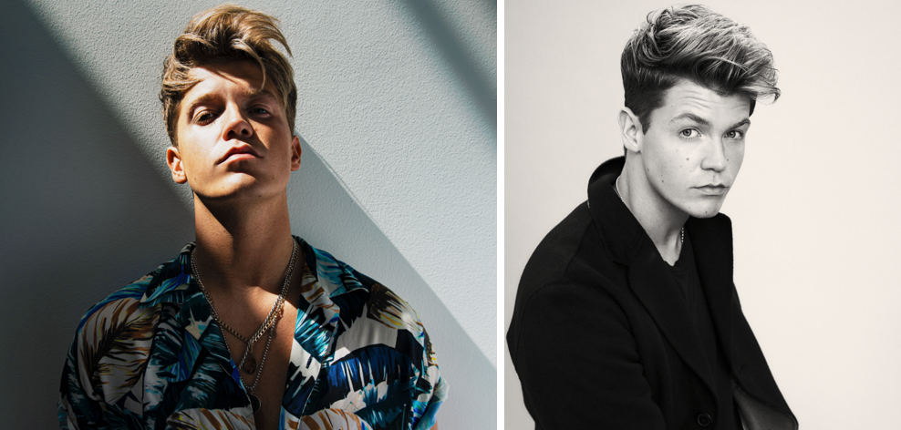
DOWNLOAD HIGH-RES IMAGES (credit: Jimmy Fontaine)

CONNECT:
OFFICIAL | FACEBOOK | TWITTER | INSTAGRAM | YOUTUBE | TIKTOK | PRESS ASSETS

CONTACT:
TED.SULLIVAN@ATLANTICRECORDS.COM

