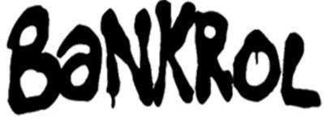

**OFFICIAL BOILERPLATE**

*UPDATED JANUARY 2021*

Modesto, CA rapper Bankrol Hayden gave a voice to not just his community, but the culture at large. With the city behind him, he went from a local favorite to a national contender fueled by otherworldly off-kilter bars and confident and confessional choruses. Streamed over 60 million times by 2020, he primed himself to make an impact on his full-length debut for Atlantic Records. By high school, he started to rap over vinyl instrumentals from the famous Rasputin Music. At 15-years-old, his first Soundcloud upload “Humble” cracked 40,000 streams based on local support alone. Maintaining this momentum, he dropped “Ride with You” in the fall of 2017. A horrific car crash made the teen grow up quickly. Teased on Instagram first, he made his return with the emotionally charged “29” in 2018. Recounting the accident in cinematic detail through his nimble flows and a tearful prayer, it amassed over 12 million Spotify streams and reignited his buzz. However, that buzz exploded a year later with the release of “Brothers” [feat. Luh Kel]. It scored 28.8 million Spotify streams and 6.5 million YouTube plays in under six months. Signed to Atlantic Records, he kicked off 2020 with “Costa Rica” followed by “Divorced,” “Drop A Tear,” and “Die Right Now” off his debut album *Pain Is Temporary*. Through an emphasis on substance above all, Bankrol Hayden does Modesto proud by empowering listeners everywhere far beyond his hometown.