JASIAH, DENZEL CURRY & RICO NASTY TEACH THE “ART OF WAR”

ALT-RAP DREAM TEAM DEBUT NEW SINGLE PRODUCED BY LUKE SWIRSKY, KEANU & FNZ

JASIAH TO SUPPORT RAPPER POUYA ON NATIONAL TOUR THIS FALL

DOWNLOAD/STREAM: “Art of War (Feat. Denzel Curry & Rico Nasty)”

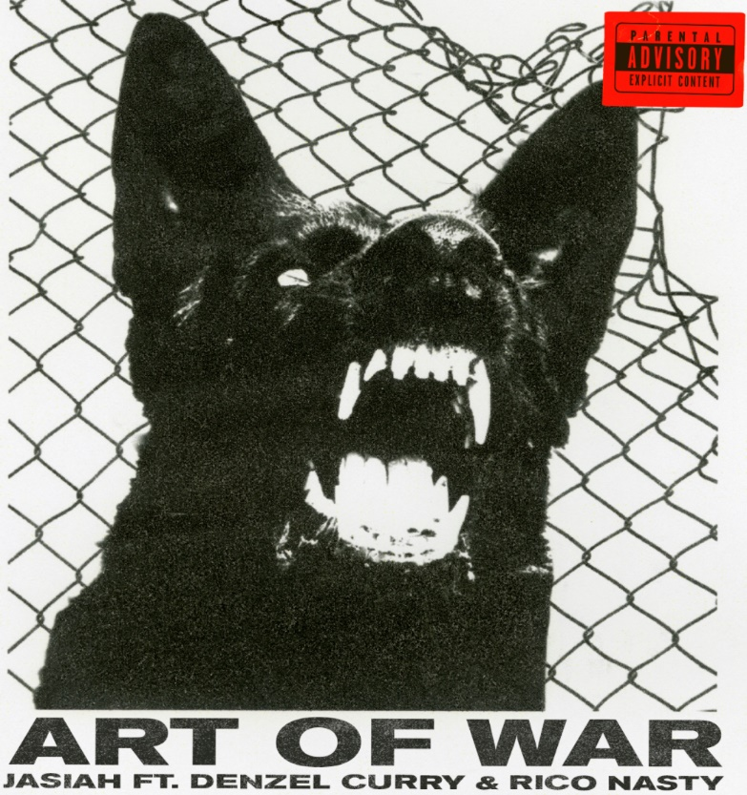
DOWNLOAD HIGH-RES ARTWORK HERE

New York, NY – June 4, 2021 – Genre-bending recording artist and Dayton, OH native Jasiah has teamed up with alt-rap superstars Denzel Curry and Rico Nasty for a voracious new single titled “Art of War,” – LISTEN HERE.

Produced by Luke Swirsky, Keanu & FNZ, “Art of War” finds the trio trading fiery verses over an explosive beat and arrives fresh off the heels of Jasiah’s acclaimed War EP which boasted collaborations with Rico Nasty, nascar aloe, TheHxliday and Pouya, the latter of whom Jasiah will support on his upcoming national tour this fall.
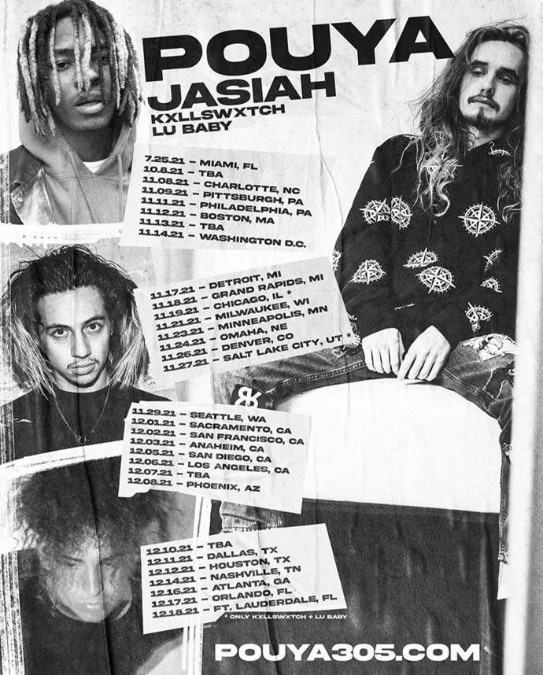

FALL 2021 TOUR:

7/25 – Miami, FL
10/8 – TBA
11/8 – Charlotte, NC
11/9 – Pittsburgh, PA
11/11 – Philadelphia, PA
11/12 – Boston, MA
11/13 – TBA
11/14 – Washington, DC
11/17 – Detroit, MI
11/18 – Grand Rapids, MI
11/21 – Milwaukee, WI
11/23 – Minneapolis, MN
11/24 – Omaha, NE
11/26 – Denver, CO
11/29 – Seattle, WA
12/1 – Sacramento, CA
12/2 – San Francisco, CA
12/3 – Anaheim, CA
12/5 – San Diego, CA
12/6 – Los Angeles, CA
12/7 – TBA
12/8 – Phoenix, AZ
12/10 – TBA
12/11 – Dallas, TX
12/12 – Houston, TX
12/14 – Nashville, TN
12/16 – Atlanta, GA
12/17 – Orlando, FL
12/18 – Ft. Lauderdale, FL

ABOUT JASIAH:
Known for his groundbreaking fusion of sonic styles, from melodic R&B and emo rap to aggro rock and even opera, Jasiah made his name with self-produced tracks on SoundCloud before truly exploding onto the national consciousness with “Case 19 (Feat. 6Ix9ine),” which was joined by a companion video that proved an equivalent smash with total video views now totaling over 12 million HERE. “Shenanigans (Feat. Yung Bans)“ followed, quickly rising to #1 on both SoundCloud’s “New & Hot” chart as well as the official TikTok chart, where it has become an undeniable viral favorite. As if all that weren’t enough, after the release of his single, “Heartbreak (Feat. Travis Barker),” Complex praised the song, highlighting “Jasiah and Barker’s high-performance energy, which oscillates between hushed and aggressive.” In 2019, Jasiah released his debut project, Jasiah I Am, and subsequently released a handful of singles in 2020 and early 2021 including “Unintelligible (Feat. nascar aloe),” ““Crisis,” “Surfs Up,” “Rebel” & “Break Sh*t,” the latter of which received an accompanying visual that aptly illustrated the insane energy of his live shows. These tracks heralded in Jasiah’s acclaimed War EP, which boasted collaborations with Rico Nasty, TheHxliday, Pouya and more. With an astounding 285 million career streams under his belt, Jasiah is ready to take the world by storm one mosh pit anthem at a time.

Jasiah Press Contacts: Jason Davis – jason.davis@atlanticrecords.com | Brian Sommer – brian.sommer@atlanticrecords.com

Rico Nasty Press Contact: Ariana White – ariana.white@atlanticrecords.com

PRESS PHOTO:
DOWNLOAD HIGH-RES PHOTO
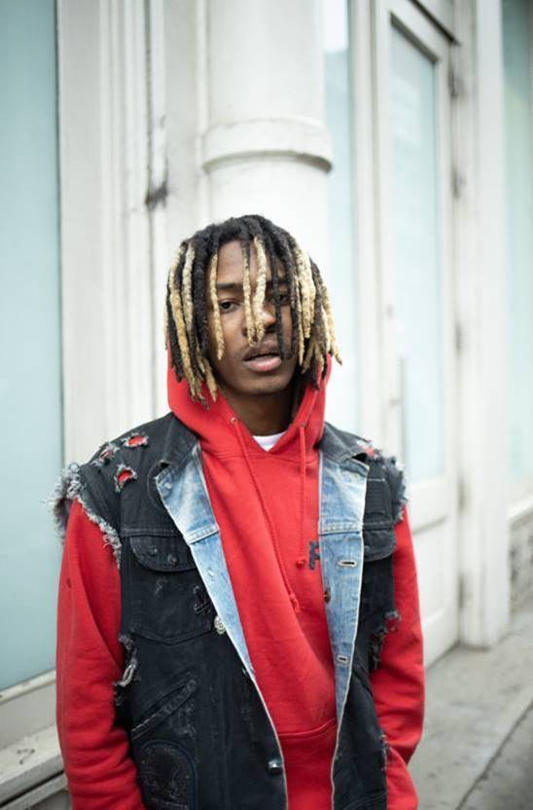

CONNECT WITH JASIAH:
WEBSITE | FACEBOOK | TWITTER | INSTAGRAM | YOUTUBE

# # #

