**GENRE-DEFYING ARTIST JASIAH RAGES IN VIDEO FOR NEW SONG “BREAK SH*T”**

**LATEST VISUAL CHRONICLES RECENTLY WRAPPED SOLD OUT “NORTH AMERICAN TOUR,” CO-HEADLINED WITH $NOT**

**“BREAK SH*T” TO APPEAR ON JASIAH’S FORTHCOMING NEW PROJECT; COMING SOON**

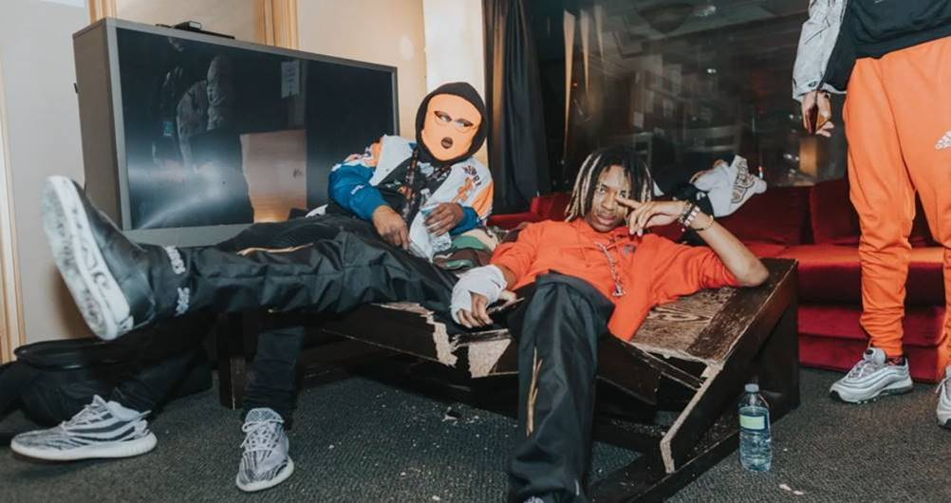

**Critical Praise:**

*"Midwest artist Jasiah has dropped off his Jasiah I Am full-length offering. The effort is a comprehensive blend of all the elements that makes the Ohio native one to watch as he flexes production skills"* ***– HotNewHipHop***

*"Rock-rap isn’t a new concept, but for the finger-flipping patrons who enjoy their hip-hop with doses of alternative, Dayton, Ohio MC Jasiah and Juice WRLD delivered [at Day N Vegas]. The former held down the Roll The Dice stage, where the crowd mirrored a low-key mosh pit from the outskirts."* ***- Billboard***

**The Video:**

A virtuosic vocalist who channels his classical training into full-throated belts, **Jasiah** is one of the rap game's most invigorating new voices. Today, the Dayton, Ohio native shares **"**[**Break Sh*t!**](https://youtu.be/k70UDI89tMw)**"**, his ferocious new single. A furious assault on the senses, it's impossible to sit still while listening to "Break Sh*t," as Jasiah layers his ragged screams atop marching band horns and relentless 808s: "F*ck you, b*tch/and the clique that you came with/I don't wanna bullsh*t, I just need my payment!" Produced by Jasiah himself, "Break Sh*t" is an anti-authoritarian anthem--a cathartic release of feral energy for anyone who feels trapped in their lives.

Compiled of scenes from Jasiah's recent co-headlining national tour with **$not**, the "Break Sh*t" video aptly illustrates the mosh-pit ready energy of the new song, showing how Jasiah and his crowds feed off each other's energy until they're whipped into a frenzy.

"Break Sh*t" is the first salvo from an upcoming EP from the artist--entirely produced by Jasiah himself. The follow-up to last year's successful ***Jasiah I Am***, the upcoming EP arrives in **Spring 2020** via **Atlantic Records**.

A firebrand whose deep passion for music shines through everything he does, Jasiah started his as an opera singer, receiving classical training as a high school student. The Atlantic Records signee first rose to fame in 2018 with his single **"Shenanigans**," a **Ronny J**-produced record which samples the theme song from Cartoon Network's *Courage The Cowardly Dog*, earning over 30 million streams across platforms, topping charts on SoundCloud and Tik Tok, and nabbing Cole Bennett for the video. He's since developed a style that encompasses his early passion for opera, his teenage love of emo and alt-rock (Jasiah won a fan in **Travis Barker**, who collaborated with the young rapper on "**Heartbreak**" from *Jasiah I Am*), and his  abiding passion for rap, fueled by the likes of XXXTentacion.

With a voracious work ethic and unlimited talent, Jasiah is truly capable of anything, Stay tuned in 2020 for much more.

**Watch "Break Sh*t":** <https://youtu.be/k70UDI89tMw>

**Buy/Stream "Break Sh*t":** [https://Jasiah.lnk.to/BreakShit](https://jasiah.lnk.to/BreakShit)

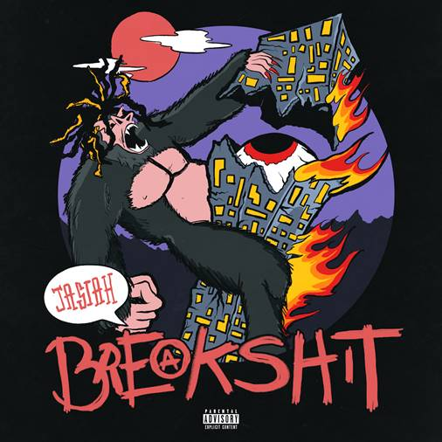

**The Background:**

Known for his groundbreaking fusion of sonic styles, from melodic R&B and emo rap to aggro rock and even opera, Jasiah made his name with self-produced tracks on SoundCloud before truly exploding onto the national consciousness with [**"Case 19 (Feat. 6Ix9ine),”**](https://jasiah.lnk.to/Case19) which was joined by a companion [video](https://www.youtube.com/watch?v=gr0EgCcD-v0) that proved an equivalent smash with total video views exceeding **10 million**. [**"Shenanigans (Feat. Yung Bans)"**](https://www.youtube.com/watch?v=ToL-Mn2ZISM) followed, quickly rising to **#1 on both SoundCloud’s “New & Hot” chart as well as the official TikTok chart**, where it has become an undeniable viral favorite. As if all that weren’t enough, after the release of his latest single, [**“Heartbreak (Feat. Travis Barker),”**](https://www.youtube.com/watch?v=trg5z-4bg0U)[***Complex***](https://www.complex.com/music/2019/09/jasiah-travis-barker-heartbreak-video) praised the song, highlighting “Jasiah and Barker’s high-performance energy, which oscillates between hushed and aggressive.” Jasiah released his debut full-length project, [***Jasiah I Am***](https://jasiah.lnk.to/JasiahIAm), to wide-spread critical acclaim. In early 2020, Jasiah embarked on the sold-out, co-headlining “*North American Tour,*” alongside rising rapper $NOT, which concluded in Los Angeles, CA at The Roxy on March 3rd.

**Connect with Jasiah:**

[Instagram](https://www.instagram.com/jasiah/) | [Twitter](https://twitter.com/PHREEJASIAH) | [YouTube](https://www.youtube.com/channel/UCMLLndGScE19J-WgBOMDOaw) | [Facebook](https://www.facebook.com/jasiah999/) | [Soundcloud](https://soundcloud.com/jasiah999)

**Press Contacts:**

Jason Davis | [Jason.Davis@AtlanticRecords.com](mailto:Jason.Davis@AtlanticRecords.com)

Michelle McDevitt | [Michelle@AudibleTreats.com](mailto:Michelle@AudibleTreats.com)

Scott Jawson | [ScottJ@AudibleTreats.com](mailto:ScottJ@AudibleTreats.com)