**JASIAH ANNOUNCES THE “NORTH AMERICAN TOUR” ALONGSIDE $NOT**

***17-CITY TOUR SET TO BEGIN FEBRUARY 6TH IN DALLAS, TX***

***DEBUT PROJECT*** [***‘JASIAH I AM’***](https://jasiah.lnk.to/JasiahIAmID) ***OUT NOW***

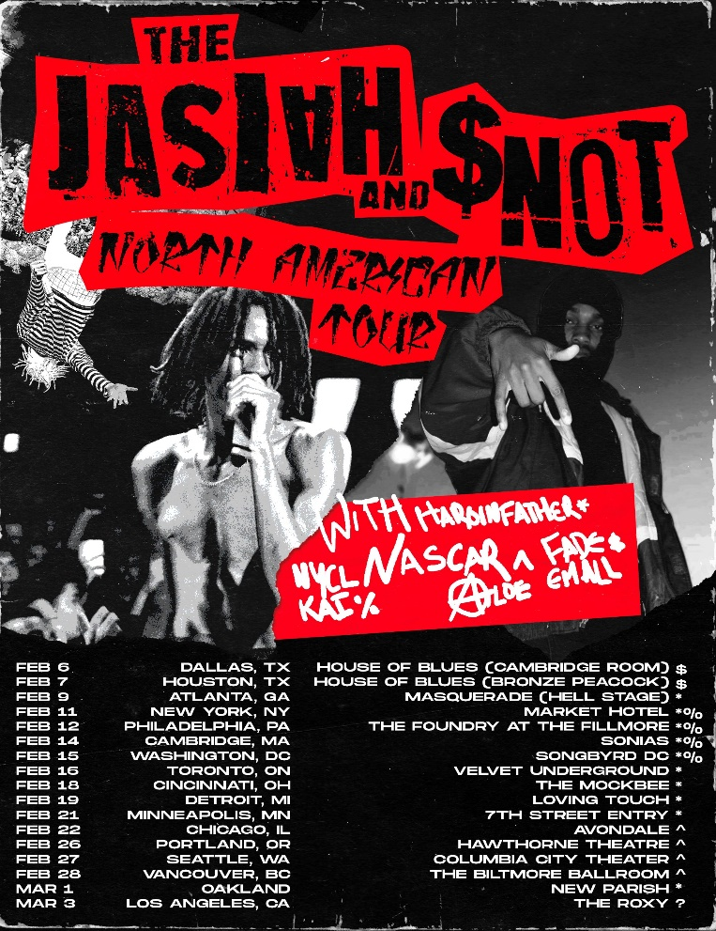

[**DOWNLOAD ADMAT HERE**](https://warnermusicgroup.box.com/s/f6xdavrra6oc3bdfhyprofmqrv0e5msl)

**(New York, NY) December 3, 2019 –** Rising artist **Jasiah** has announced plans for a nationwide tour. The dates – which see the genre-bending Dayton, OH native co-headlining alongside **$NOT** – begin on February 6th at Dallas, TX’s House of Blues - Cambridge Room and then continue through an eagerly awaited show at the world-famous Roxy Theatre in West Hollywood, CA on March 3rd.

The announcement follows the release of his debut project, ***Jasiah I Am****,* and precedes his upcoming set at **Rolling Loud LA** on December 16th.

“…*an exciting new artist with a penchant for blending genres.”*

**- HYPEBEAST**

*“[‘Jasiah I Am’] is a comprehensive blend of all the elements that makes the Ohio native one to watch…”*

**- HOT NEW HIP HOP**

Tickets for the tour will be available to the general public on December 6th. A fan pre-sale will begin (Passcode: NORTHAMERICANTOUR) on Wednesday, December 4th (10AM Local) and end on Thursday, December 5th (10PM Local). A BandsInTown pre-sale (Passcode: CASE19) will begin on Wednesday, December 4th (12PM Local) and end on Thursday, December 5th (10PM Local).

For complete details and ticket availability, please see [https://www.phreejasiah.com](https://www.phreejasiah.com/).

***ABOUT JASIAH:***

Known for his groundbreaking fusion of sonic styles, from melodic R&B and emo rap to aggro rock and even opera, Jasiah made his name with self-produced tracks on SoundCloud before truly exploding onto the national consciousness with [**“Case 19 (Feat. 6Ix9ine),”**](https://jasiah.lnk.to/Case19) which was joined by a companion video that proved an equivalent smash with total video views now approaching **10 million** [**HERE**](https://www.youtube.com/watch?v=gr0EgCcD-v0). [**“Shenanigans (Feat. Yung Bans)“**](https://www.youtube.com/watch?v=ToL-Mn2ZISM) followed, quickly rising to **#1 on both SoundCloud’s “New & Hot” chart as well as the official TikTok chart**, where it has become an undeniable viral favorite. As if all that weren’t enough, after the release of his latest single, [**“Heartbreak (Feat. Travis Barker),”**](https://www.youtube.com/watch?v=trg5z-4bg0U)[***Complex***](https://www.complex.com/music/2019/09/jasiah-travis-barker-heartbreak-video) praised the song, highlighting “Jasiah and Barker’s high-performance energy, which oscillates between hushed and aggressive.”

**“NORTH AMERICAN TOUR”:**

2/6 – Dallas, TX – House of Blues - Cambridge Room $

2/7 – Houston, TX – House of Blues - Bronze Peacock $

2/9 – Atlanta, GA – Masquerade - Hell Stage *\**

2/11 – Brooklyn, NY – Market Hotel *\*%*

2/12 – Philadelphia, PA – The Foundry at The Fillmore *\*%*

2/14 – Cambridge, MA – Sonia’s *\*%*

2/15 – Washington, DC – Songbyrd DC *\*%*

2/16 – Toronto, ON - Velvet Underground *\**

2/18 – Cincinnati, OH – The Mockbee *\**

2/19 – Ferndale, MI – The Loving Touch *\**

2/21 – Minneapolis, MN - 7th Street Entry *\**

2/22 – Chicago, IL – Avondale Music Hall *^*

2/26 – Portland, OR – Hawthorne Theatre *^*

2/27 – Seattle, WA – Columbia City Theater *^*

2/28 – Vancouver, BC – The Biltmore Ballroom *^*

3/1 – Oakland, CA – The New Parish *\**

3/3 – West Hollywood, CA – The Roxy Theatre ?

*$ Dates with Fade Em All*

*\* Dates with Haroinfather*

*% Dates with NYCL KAI*

*^ Dates with Nascar Aloe*

**APPROVED PRESS PHOTO:**

*[Photo Credit Travis Shinn]*

[**DOWNLOAD HIGH-RES IMAGE HERE**](https://warnermusicgroup.box.com/s/mj3z6qv6dpwimevjcgdl07y82grte9jy)

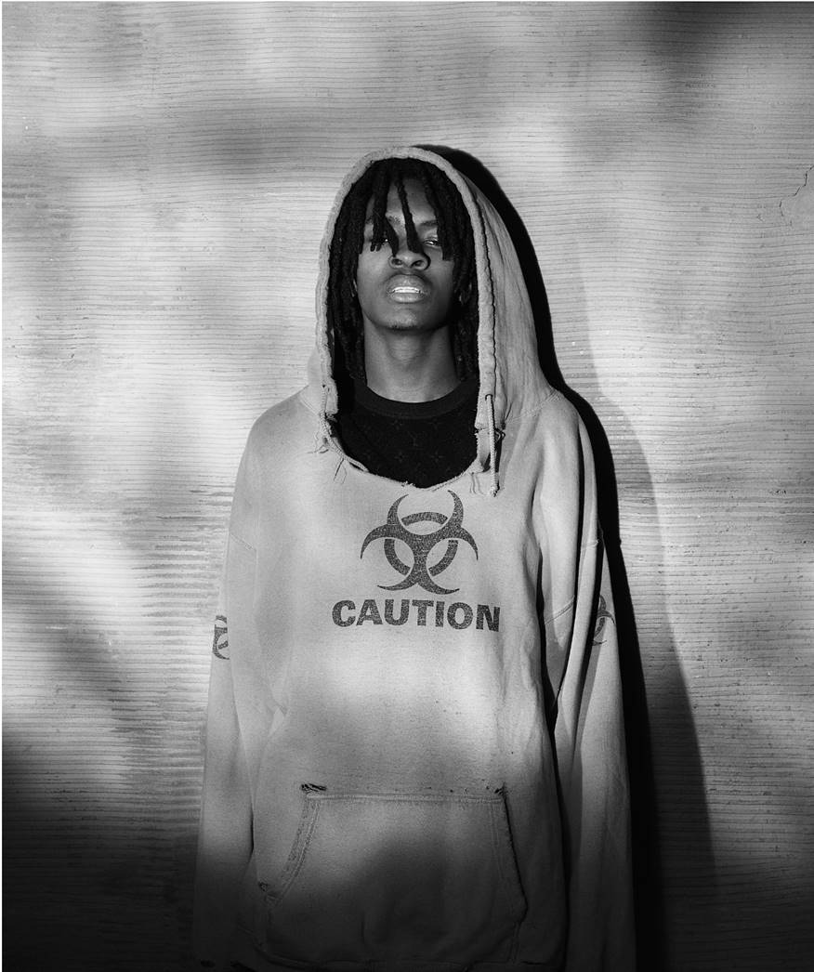

**CONTACT:**

Jason Davis | [Jason.Davis@AtlanticRecords.com](mailto:Jason.Davis@AtlanticRecords.com)

**CONNECT WITH JASIAH:**

[Instagram](https://www.instagram.com/jasiah/?hl=en)| [Twitter](https://twitter.com/PHREEJASIAH?ref_src=twsrc%5Egoogle%7Ctwcamp%5Eserp%7Ctwgr%5Eauthor) | [Facebook](https://www.facebook.com/Jasiah-270415950237747/) | [YouTube](https://www.youtube.com/channel/UCMLLndGScE19J-WgBOMDOaw/featured) | [Website](https://www.phreejasiah.com/)

# # #