**JASIAH TAPS TRAVIS BARKER FOR “RIGHT NOW”**

**NEW SONG FROM GENRE-DEFYING RECORDING ARTIST & DAYTON, OH NATIVE FOLLOWS FIERY TRACKS “ART OF WAR (FEAT. DENZEL CURRY & RICO NASTY)” + “WORLD $TAR”**

[**STREAM/DOWNLOAD: “Right Now (Feat. Travis Barker)”**](https://jasiah.lnk.to/RightNow)

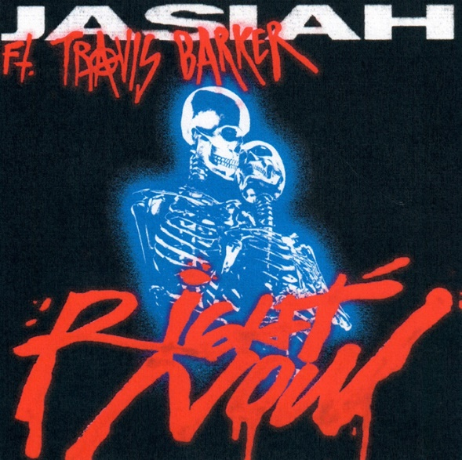

[DOWNLOAD ARTWORK HERE](https://nam04.safelinks.protection.outlook.com/?url=http%3A%2F%2Fpress.atlanticrecords.com%2Fjasiah%2F&data=04%7C01%7CBrian.Sommer%40atlanticrecords.com%7C789636c8c7b6484598b508d94dde9ba5%7C8367939002ec4ba1ad3d69da3fdd637e%7C0%7C0%7C637626440780008908%7CUnknown%7CTWFpbGZsb3d8eyJWIjoiMC4wLjAwMDAiLCJQIjoiV2luMzIiLCJBTiI6Ik1haWwiLCJXVCI6Mn0%3D%7C1000&sdata=2irNKUcU1%2FjQY3RfBSAXZXkLLG8td%2F5gLbwBr1ZxUYw%3D&reserved=0)

**New York, NY – August 27, 2021 –** Genre-defying recording artist **Jasiah** is continuing his string of explosive singles with his fiery new song, **“Right Now,”** featuring legendary drummer/producer/songwriter **Travis Barker**, available now via Atlantic Records – [LISTEN HERE](https://jasiah.lnk.to/RightNow). Previews of **“Right Now”** have accrued over **200,000 likes** and **1.6 million views** on TikTok alone since **Jasiah** began teasing the new song mid-August.

**“Right Now”** follows a handful of **Jasiah**’s recent releases including the incendiary track “[WORLD $TAR”](https://jasiah.lnk.to/worldstar) and the **Rico Nasty** & **Denzel Curry**-assisted [“Art of War,”](https://jasiah.lnk.to/artofwar) the latter of which was hailed by ***PAPER***as an “…exhilarating, blown-out rager.” ***UPROXX*** also praised the collaboration as, *“an absolute head-banging track, one that should be perfect for the mosh pits that are set to return at festivals later this year.”*

**Jasiah**’s recent releases arrive after the debut of his ***War*** EP which boasted collaborations with **Rico Nasty, nascar aloe**, **TheHxliday** and **Pouya**. **Jasiah** and his ***War*** EP were highly-regarded by ***Pitchfork***, which emphasized that, *“the rap industry has always moved fast, but the tempo at which new hip-hop trends spread and proliferate means that many artists can become deeply influential while still being relatively young. Dayton, Ohio’s Jasiah is an obvious byproduct of the speed of digital music, steeped in a world of online micro-genres…”*

**Jasiah** will also hit the road this fall as support for **Pouya**’s upcoming nationwide tour after performing at a handful of high-profile festivals over the summer including **Rolling Loud,** **Hive Festival** and **Lyrical Lemonade Summer Smash**.

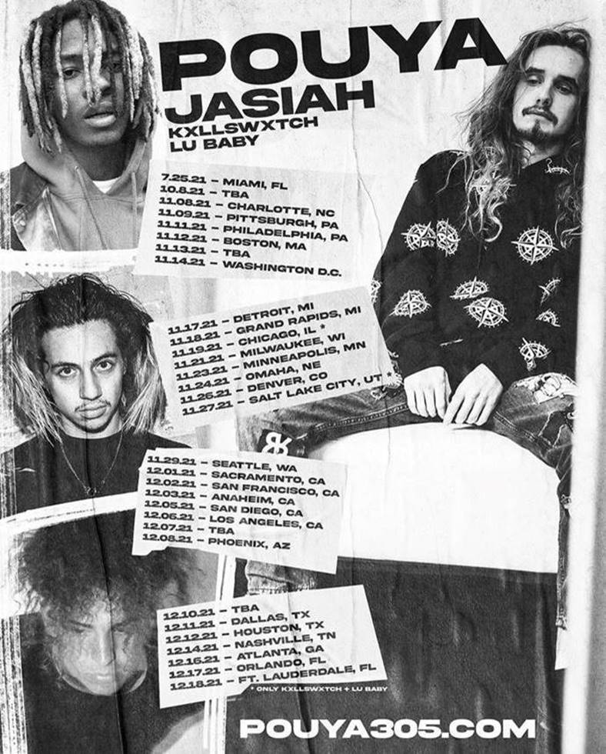

**FALL 2021 TOUR:**

**10/8 –** TBA

**11/8 –** Charlotte, NC

**11/9 –** Pittsburgh, PA

**11/11 –** Philadelphia, PA

**11/12 –** Boston, MA

**11/13 –** TBA

**11/14 –** Washington, DC

**11/17 –** Detroit, MI

**11/18 –** Grand Rapids, MI

**11/21 –** Milwaukee, WI

**11/23 –** Minneapolis, MN

**11/24 –** Omaha, NE

**11/26 –** Denver, CO

**11/29 –** Seattle, WA

**12/1 –** Sacramento, CA

**12/2 –** San Francisco, CA

**12/3 –** Anaheim, CA

**12/5 –** San Diego, CA

**12/6 –** Los Angeles, CA

**12/7 –** TBA

**12/8 –** Phoenix, AZ

**12/10 –** TBA

**12/11** – Dallas, TX

**12/12 –** Houston, TX

**12/14 –** Nashville, TN

**12/16 –** Atlanta, GA

**12/17 –** Orlando, FL

**12/18 –** Ft. Lauderdale, FL

**ABOUT JASIAH:**

Known for his groundbreaking fusion of sonic styles, from melodic R&B and emo rap to aggro rock and even opera, Jasiah made his name with self-produced tracks on SoundCloud before truly exploding onto the national consciousness with [“Case 19 (Feat. 6Ix9ine),”](https://nam04.safelinks.protection.outlook.com/?url=https%3A%2F%2Fjasiah.lnk.to%2FCase19&data=04%7C01%7CBrian.Sommer%40atlanticrecords.com%7C789636c8c7b6484598b508d94dde9ba5%7C8367939002ec4ba1ad3d69da3fdd637e%7C0%7C0%7C637626440780028897%7CUnknown%7CTWFpbGZsb3d8eyJWIjoiMC4wLjAwMDAiLCJQIjoiV2luMzIiLCJBTiI6Ik1haWwiLCJXVCI6Mn0%3D%7C1000&sdata=7xkkazdLGgHoUT5WvMI6hrx9BeEjjSFliIkd3s5e7nw%3D&reserved=0) which was joined by a companion video that proved an equivalent smash with total video views now totaling over 12 million [HERE](https://nam04.safelinks.protection.outlook.com/?url=https%3A%2F%2Fwww.youtube.com%2Fwatch%3Fv%3Dgr0EgCcD-v0&data=04%7C01%7CBrian.Sommer%40atlanticrecords.com%7C789636c8c7b6484598b508d94dde9ba5%7C8367939002ec4ba1ad3d69da3fdd637e%7C0%7C0%7C637626440780038888%7CUnknown%7CTWFpbGZsb3d8eyJWIjoiMC4wLjAwMDAiLCJQIjoiV2luMzIiLCJBTiI6Ik1haWwiLCJXVCI6Mn0%3D%7C1000&sdata=Rs%2BWpUNQPpt1hPXrTYivmW5rin%2F8I9FvJQuCAQMNicQ%3D&reserved=0). [“Shenanigans (Feat. Yung Bans)“](https://nam04.safelinks.protection.outlook.com/?url=https%3A%2F%2Fwww.youtube.com%2Fwatch%3Fv%3DToL-Mn2ZISM&data=04%7C01%7CBrian.Sommer%40atlanticrecords.com%7C789636c8c7b6484598b508d94dde9ba5%7C8367939002ec4ba1ad3d69da3fdd637e%7C0%7C0%7C637626440780038888%7CUnknown%7CTWFpbGZsb3d8eyJWIjoiMC4wLjAwMDAiLCJQIjoiV2luMzIiLCJBTiI6Ik1haWwiLCJXVCI6Mn0%3D%7C1000&sdata=68tW8a8Jao7KF9hczl9DTdAHrEeSvt8AkPliGetcTV8%3D&reserved=0) followed, quickly rising to #1 on both SoundCloud’s “New & Hot” chart as well as the official TikTok chart, where it has become an undeniable viral favorite. As if all that weren’t enough, after the release of his single, [“Heartbreak (Feat. Travis Barker),”](https://nam04.safelinks.protection.outlook.com/?url=https%3A%2F%2Fwww.youtube.com%2Fwatch%3Fv%3Dtrg5z-4bg0U&data=04%7C01%7CBrian.Sommer%40atlanticrecords.com%7C789636c8c7b6484598b508d94dde9ba5%7C8367939002ec4ba1ad3d69da3fdd637e%7C0%7C0%7C637626440780048883%7CUnknown%7CTWFpbGZsb3d8eyJWIjoiMC4wLjAwMDAiLCJQIjoiV2luMzIiLCJBTiI6Ik1haWwiLCJXVCI6Mn0%3D%7C1000&sdata=lcOY3NCaisqkjN8u03mcTjQQVubs77YwFnQl%2BCTkumw%3D&reserved=0) [*Complex*](https://nam04.safelinks.protection.outlook.com/?url=https%3A%2F%2Fwww.complex.com%2Fmusic%2F2019%2F09%2Fjasiah-travis-barker-heartbreak-video&data=04%7C01%7CBrian.Sommer%40atlanticrecords.com%7C789636c8c7b6484598b508d94dde9ba5%7C8367939002ec4ba1ad3d69da3fdd637e%7C0%7C0%7C637626440780058878%7CUnknown%7CTWFpbGZsb3d8eyJWIjoiMC4wLjAwMDAiLCJQIjoiV2luMzIiLCJBTiI6Ik1haWwiLCJXVCI6Mn0%3D%7C1000&sdata=HQNX2WRXPTZuZsapncaNgPmvZKoWJbi%2FX83WyjCpNA4%3D&reserved=0) praised the song, highlighting “Jasiah and Barker’s high-performance energy, which oscillates between hushed and aggressive.” In 2019, Jasiah released his debut project, [*Jasiah I Am*](https://nam04.safelinks.protection.outlook.com/?url=https%3A%2F%2Fjasiah.lnk.to%2FJasiahIAm&data=04%7C01%7CBrian.Sommer%40atlanticrecords.com%7C789636c8c7b6484598b508d94dde9ba5%7C8367939002ec4ba1ad3d69da3fdd637e%7C0%7C0%7C637626440780058878%7CUnknown%7CTWFpbGZsb3d8eyJWIjoiMC4wLjAwMDAiLCJQIjoiV2luMzIiLCJBTiI6Ik1haWwiLCJXVCI6Mn0%3D%7C1000&sdata=AzTeS%2Fj98L7pr9QBPNcetb33AnKKufhtq%2Fyf4FxpM0k%3D&reserved=0), which accrued over 175M+ streams, and subsequently released a handful of singles in 2020 and early 2021 including [“Unintelligible (Feat. nascar aloe),”](https://nam04.safelinks.protection.outlook.com/?url=https%3A%2F%2Fwww.youtube.com%2Fwatch%3Fv%3DLm0smgFYZrU&data=04%7C01%7CBrian.Sommer%40atlanticrecords.com%7C789636c8c7b6484598b508d94dde9ba5%7C8367939002ec4ba1ad3d69da3fdd637e%7C0%7C0%7C637626440780068870%7CUnknown%7CTWFpbGZsb3d8eyJWIjoiMC4wLjAwMDAiLCJQIjoiV2luMzIiLCJBTiI6Ik1haWwiLCJXVCI6Mn0%3D%7C1000&sdata=3b62k8iWzs815msSE8iGX45R0rg%2BSSaqIY1oCNmjhb8%3D&reserved=0) “[“Crisis,”](https://nam04.safelinks.protection.outlook.com/?url=https%3A%2F%2Fwww.youtube.com%2Fwatch%3Fv%3DzBdSP9XZlcE&data=04%7C01%7CBrian.Sommer%40atlanticrecords.com%7C789636c8c7b6484598b508d94dde9ba5%7C8367939002ec4ba1ad3d69da3fdd637e%7C0%7C0%7C637626440780078867%7CUnknown%7CTWFpbGZsb3d8eyJWIjoiMC4wLjAwMDAiLCJQIjoiV2luMzIiLCJBTiI6Ik1haWwiLCJXVCI6Mn0%3D%7C1000&sdata=Ow%2FhrgtX2zAB3MRSDEbNCzDvcX3vCeFSMA0LkkPsgqY%3D&reserved=0) [“Surfs Up,”](https://nam04.safelinks.protection.outlook.com/?url=https%3A%2F%2Fwww.youtube.com%2Fwatch%3Fv%3DEisc0534d-0&data=04%7C01%7CBrian.Sommer%40atlanticrecords.com%7C789636c8c7b6484598b508d94dde9ba5%7C8367939002ec4ba1ad3d69da3fdd637e%7C0%7C0%7C637626440780078867%7CUnknown%7CTWFpbGZsb3d8eyJWIjoiMC4wLjAwMDAiLCJQIjoiV2luMzIiLCJBTiI6Ik1haWwiLCJXVCI6Mn0%3D%7C1000&sdata=Qj3MH86vo%2FKMX%2FDTxBpmRvcNXV5DRCCzU3e5tcN1XnA%3D&reserved=0) [“Rebel”](https://nam04.safelinks.protection.outlook.com/?url=https%3A%2F%2Fwww.youtube.com%2Fwatch%3Fv%3DMbl5Go9dUYc&data=04%7C01%7CBrian.Sommer%40atlanticrecords.com%7C789636c8c7b6484598b508d94dde9ba5%7C8367939002ec4ba1ad3d69da3fdd637e%7C0%7C0%7C637626440780088861%7CUnknown%7CTWFpbGZsb3d8eyJWIjoiMC4wLjAwMDAiLCJQIjoiV2luMzIiLCJBTiI6Ik1haWwiLCJXVCI6Mn0%3D%7C1000&sdata=HZ%2BlSWbmJmT8tVhM0XHS5VsqF65ts1yNY2NLECYYwiE%3D&reserved=0) & [“Break Sh*t,”](https://nam04.safelinks.protection.outlook.com/?url=https%3A%2F%2Fwww.youtube.com%2Fwatch%3Fv%3Dk70UDI89tMw%26feature%3Dyoutu.be&data=04%7C01%7CBrian.Sommer%40atlanticrecords.com%7C789636c8c7b6484598b508d94dde9ba5%7C8367939002ec4ba1ad3d69da3fdd637e%7C0%7C0%7C637626440780098856%7CUnknown%7CTWFpbGZsb3d8eyJWIjoiMC4wLjAwMDAiLCJQIjoiV2luMzIiLCJBTiI6Ik1haWwiLCJXVCI6Mn0%3D%7C1000&sdata=YzYejJQQddgJ%2FTf%2B3pxwhjp7tGIpseQoR24WSDf9aTg%3D&reserved=0) the latter of which received an accompanying visual that aptly illustrated the insane energy of his live shows. These tracks heralded in Jasiah’s acclaimed [*War EP*](https://nam04.safelinks.protection.outlook.com/?url=https%3A%2F%2Fjasiah.lnk.to%2FWar&data=04%7C01%7CBrian.Sommer%40atlanticrecords.com%7C789636c8c7b6484598b508d94dde9ba5%7C8367939002ec4ba1ad3d69da3fdd637e%7C0%7C0%7C637626440780098856%7CUnknown%7CTWFpbGZsb3d8eyJWIjoiMC4wLjAwMDAiLCJQIjoiV2luMzIiLCJBTiI6Ik1haWwiLCJXVCI6Mn0%3D%7C1000&sdata=SlFepAThVzIlrWNLvQ9BpgDNzM0jp6I5qn29QS9jjyw%3D&reserved=0), which boasted collaborations with Rico Nasty, TheHxliday, Pouya and more. With an astounding 300M+ careerstreams under his belt, Jasiah is ready to take the world by storm one mosh pit anthem at a time.

**Jasiah Press Contacts:** Jason Davis – [jason.davis@atlanticrecords.com](mailto:jason.davis@atlanticrecords.com) | Brian Sommer – [brian.sommer@atlanticrecords.com](mailto:brian.sommer@atlanticrecords.com)

[DOWNLOAD HIGH-RES PHOTO](https://nam04.safelinks.protection.outlook.com/?url=http%3A%2F%2Fpress.atlanticrecords.com%2Fjasiah%2F&data=04%7C01%7CBrian.Sommer%40atlanticrecords.com%7C789636c8c7b6484598b508d94dde9ba5%7C8367939002ec4ba1ad3d69da3fdd637e%7C0%7C0%7C637626440780108855%7CUnknown%7CTWFpbGZsb3d8eyJWIjoiMC4wLjAwMDAiLCJQIjoiV2luMzIiLCJBTiI6Ik1haWwiLCJXVCI6Mn0%3D%7C1000&sdata=9xlNQCtoP9q0Aa9opOrQ1FtxdxmSWQVIWbTZLzQGqsg%3D&reserved=0):

*Credit: Nathan James*



**CONNECT WITH JASIAH:**

[WEBSITE](https://nam04.safelinks.protection.outlook.com/?url=https%3A%2F%2Fwww.phreejasiah.com%2F&data=04%7C01%7CBrian.Sommer%40atlanticrecords.com%7C789636c8c7b6484598b508d94dde9ba5%7C8367939002ec4ba1ad3d69da3fdd637e%7C0%7C0%7C637626440780118844%7CUnknown%7CTWFpbGZsb3d8eyJWIjoiMC4wLjAwMDAiLCJQIjoiV2luMzIiLCJBTiI6Ik1haWwiLCJXVCI6Mn0%3D%7C1000&sdata=8bYQCb%2BIg%2BEpL%2B%2BcRYUmDXmS2PFCZnab6jGXbjT7gqw%3D&reserved=0) |[FACEBOOK](https://nam04.safelinks.protection.outlook.com/?url=https%3A%2F%2Fwww.facebook.com%2Fjasiah999%2F&data=04%7C01%7CBrian.Sommer%40atlanticrecords.com%7C789636c8c7b6484598b508d94dde9ba5%7C8367939002ec4ba1ad3d69da3fdd637e%7C0%7C0%7C637626440780128838%7CUnknown%7CTWFpbGZsb3d8eyJWIjoiMC4wLjAwMDAiLCJQIjoiV2luMzIiLCJBTiI6Ik1haWwiLCJXVCI6Mn0%3D%7C1000&sdata=I2j%2B5N5Zuw%2BIe88W54bAZK3ooKRXoDR19EP7I5crFvI%3D&reserved=0) | [TWITTER](https://nam04.safelinks.protection.outlook.com/?url=https%3A%2F%2Ftwitter.com%2Fphreejasiah&data=04%7C01%7CBrian.Sommer%40atlanticrecords.com%7C789636c8c7b6484598b508d94dde9ba5%7C8367939002ec4ba1ad3d69da3fdd637e%7C0%7C0%7C637626440780138833%7CUnknown%7CTWFpbGZsb3d8eyJWIjoiMC4wLjAwMDAiLCJQIjoiV2luMzIiLCJBTiI6Ik1haWwiLCJXVCI6Mn0%3D%7C1000&sdata=DxS6WGdhFca%2B6WSHarwqDQSpFR9J0%2BCh5oHJMCOSKNQ%3D&reserved=0) |[INSTAGRAM](https://nam04.safelinks.protection.outlook.com/?url=https%3A%2F%2Fwww.instagram.com%2Fjasiah%2F&data=04%7C01%7CBrian.Sommer%40atlanticrecords.com%7C789636c8c7b6484598b508d94dde9ba5%7C8367939002ec4ba1ad3d69da3fdd637e%7C0%7C0%7C637626440780158817%7CUnknown%7CTWFpbGZsb3d8eyJWIjoiMC4wLjAwMDAiLCJQIjoiV2luMzIiLCJBTiI6Ik1haWwiLCJXVCI6Mn0%3D%7C1000&sdata=P9%2FtFAkIO4HYxw%2BC40oUmMlaYOd5wAHh6tNb89TSzrE%3D&reserved=0) |[YOUTUBE](https://nam04.safelinks.protection.outlook.com/?url=https%3A%2F%2Fwww.youtube.com%2Fchannel%2FUCMLLndGScE19J-WgBOMDOaw&data=04%7C01%7CBrian.Sommer%40atlanticrecords.com%7C789636c8c7b6484598b508d94dde9ba5%7C8367939002ec4ba1ad3d69da3fdd637e%7C0%7C0%7C637626440780168816%7CUnknown%7CTWFpbGZsb3d8eyJWIjoiMC4wLjAwMDAiLCJQIjoiV2luMzIiLCJBTiI6Ik1haWwiLCJXVCI6Mn0%3D%7C1000&sdata=6VL6rcluYl4gdQ8OAkWv3wb8JngiXNBIfC8JNgtiC5o%3D&reserved=0)

# # #