JASIAH DECLARES WAR

NEW EP FROM GENRE-BENDING ARTIST ARRIVES TODAY

FEATURES COLLABORATIONS WITH RICO NASTY, NASCAR ALOE & MORE

STREAM/DOWNLOAD WAR EP

VOTE FOR JASIAH FOR XXL’S FRESHMAN COVER 10TH SPOT

DOWNLOAD ARTWORK HERE

War EP Track List:
1. Zit (Feat. Pouya)
2. Break Shit
3. Unintelligible (Feat. nascar aloe)
4. Surfs Up
5. Crisis
6. In N Out (Feat. The Hxliday & Rico Nasty)
7. Spit

***

VOTE JASIAH FOR XXL’S 10TH SPOT IN THE FRESHMAN CLASS OF 2021

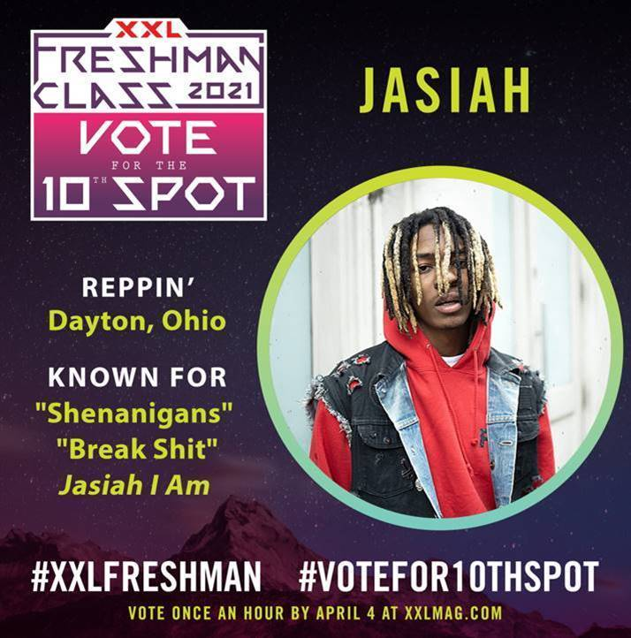

+ CHECK OUT SOME OF JASIAH’S MOST RECENT VIDEOS:
“Unintelligible (Feat. nascar aloe)” | “Surfs Up” | “Rebel” | “Break Shit”

***

ABOUT JASIAH:
Known for his groundbreaking fusion of sonic styles, from melodic R&B and emo rap to aggro rock and even opera, Jasiah made his name with self-produced tracks on SoundCloud before truly exploding onto the national consciousness with “Case 19 (Feat. 6Ix9ine),” which was joined by a companion video that proved an equivalent smash with total video views now totaling over 12 million HERE. “Shenanigans (Feat. Yung Bans)“ followed, quickly rising to #1 on both SoundCloud’s “New & Hot” chart as well as the official TikTok chart, where it has become an undeniable viral favorite. As if all that weren’t enough, after the release of his latest single, “Heartbreak (Feat. Travis Barker),” Complex praised the song, highlighting “Jasiah and Barker’s high-performance energy, which oscillates between hushed and aggressive.” In 2019, Jasiah released his debut project, Jasiah I Am, and subsequently released a handful of singles in 2020 and early 2021 including “Unintelligible (Feat. nascar aloe),” ““Crisis,” “Surfs Up,” “Rebel” & “Break Sh*t,” the latter of which received an accompanying visual that aptly illustrated the insane energy of his live shows. With an astounding 258 million career streams under his belt, Jasiah is ready to take the world by storm one mosh pit anthem at a time.

PRESS PHOTO:
DOWNLOAD HIGH-RES PHOTO

CONNECT WITH JASIAH:
WEBSITE | FACEBOOK | TWITTER | INSTAGRAM | YOUTUBE

CONTACT:
JASON DAVIS | JASON.DAVIS@ATLANTICRECORDS.COM
BRIAN SOMMER | BRIAN.SOMMER@ATLANTICRECORDS.COM

# # #

