For Immediate Release
APRIL 29, 2022

Jax brings the nostalgia on “u love u” (feat. JVKE)

Multi-talented singer-songwriter & iHeartRadio Music Award winner
returns with cheerful new single

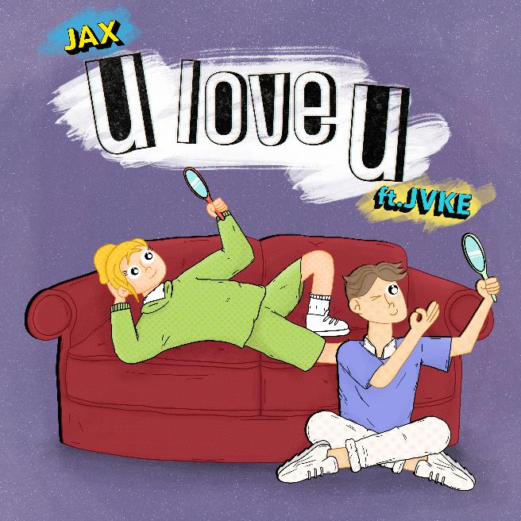
DOWNLOAD HIGH-RES IMAGES

WATCH/STREAM “U LOVE U”: LINK

Multi-talented singer-songwriter Jax brings the ultimate nostalgia with her new single “u love u” featuring viral hit singer-songwriter and GRAMMY® nominated producer JVKE – available now via Atlantic Records. Co-penned/produced by Jason Hahs (Salem Ilese’s “Mad at Disney”), the cheerful track is an earworm that is sure to set the internet ablaze.

“The song is about being secure with yourself, because that’s when tour relationship works out the best! It’s much easier to be in love when you love yourself first. We wanted to talk about past relationships not working out because of jealousy and games… and boom. It turned into a goofy cocky love song!” – JAX

“u love u” continues what has already been an exciting year for Jax, kicking off with the release of her swooning single “To All The Boys I’ve Loved Before” which was deemed “a viral hit” by Billboard and even parodied alongside country music superstar Carrie Underwood. Last month also saw Jax take home the iHeartRadio Music Award for TikTok Songwriter of the Year, thanks to her incredibly creative TikTok songs that have featured cameos from the likes of Leslie Jordan, John Stamos, Natasha Bedingfield and more.

Raised in New Jersey by way of New York, Jax got her start by performing a wide variety of genres and in bands growing up. At the age of 18, she developed cancer above her vocal cords, which returned following a couple months of remission right as she relocated to Los Angeles in pursuit of her music. Left unable to sing herself, Jax turned to songwriting for others and found industry success behind-the-scenes.

As her ability to perform returned, Jax needed to pivot yet again when the COVID-19 pandemic struck. This time she turned to TikTok, posting a hilarious response to the pop gem “Stacy’s Mom” from “Stacy’s Mom’s Perspective” which exploded with nearly 9 million views in just a few months and follow-ups including “Update from Avril Lavigne & Sk8er Boi 18 years later.” She continued to go viral a dozen or more times over, eventually amassing over 8 million followers on the platform and over 130 million “likes” to date. Meanwhile her top performing video, “From The Kid I Babysit’s Perspective” has garnered a tremendous 113 million views. With a massive online audience under her belt, Jax began sharing her own original music in late 2020 to an overwhelmingly positive response – ultimately leading to her signing with Atlantic Records for her forthcoming debut full-length.

“u love u” marks the latest in a catalog of fan-favorite singles from the Jax – including her heartwarming ballad “Like My Father” which has amassed over 80 million streams and was crowned amongst “the best father-daughter dance songs of all time” by The Knot. Meanwhile, her nostalgia-fueled anthem “90s Kids” received over 1 million weekly streams for 21 consecutive weeks and label-debut single “Ring Pop” yielded high-profile appearances on The Ellen DeGeneres Show, Access Hollywood & more.

ABOUT JVKE:
JVKE – 20 year old pop prodigy from Cranston, RI — grew up in a musical family. His mother a public school music teacher and his father a pastor, JVKE was playing piano, guitar and drums by age 3 and by age 7 he was leading his church music team performances on a weekly basis. By 14 he was producing, and by 18 he dropped out of college and signed his first publishing deal, through which he has landed cuts with artists such as Jason Derulo and EXO as well as the latest single for Kpop mega group Super Junior. In June of 2020, JVKE started his TikTok page that has grown from zero to over 3 million followers in under two months (currently 6 million+), thanks to the instant virality of his self-produced audios.

His single, “Upside Down” – a frothy, upbeat, bop with pulsing synthesizers and emo-pop melodies that sing about memories of a fresh love lost – has become a TikTok anthem. It is the most viral yet of JVKE's TikTok songs with over 15 million videos made to it. The song's meteoric success led to a Charlie Puth remix collab, which earned both JVKE and Charlie a 2021 Trending VMA nomination. JVKE's follow up, "Dandelion" was a joint release with global DJ superstars, Galantis, and has accumulated over 100 million streams to date. In September 2021, JVKE released "this is what falling in love feels like," an instant smash that is currently at Top 40 radio and was used by Samsung for their global launch commercial for the Galaxy Z Flip phone. With over 425 million global streams and 140 million video views, JVKE is certainly an artist on the rise and has more in store for 2022.

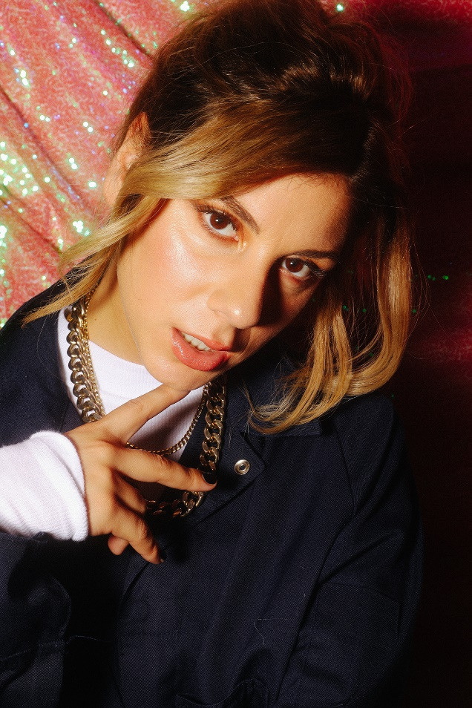
DOWNLOAD HIGH-RES IMAGES

CONNECT WITH JAX:
TikTok | YouTube | Instagram | Twitter | Facebook | Press Assets
Ted Sullivan | ted.sullivan@atlanticrecords.com

CONNECT WITH JVKE:
TikTok | YouTube | Instagram | Twitter | Facebook
Dvora Englefield | Dvora.Englefield@ledecompany.com
Chris Iacullo | Chris.Iacullo@ledecompany.com

