FOR IMMEDIATE RELEASE

SEPTEMBER 25TH, 2020

**ATLANTIC RECORDS WELCOMES RISING R&B/POP ARTIST AND TIK-TOK STAR JEVEN TO ITS ROSTER**

**HIS DEBUT SINGLE, “BUTTERFLIES” AVAILABLE NOW**

**WATCH THE OFFICIAL VIDEO** [**HERE**](https://jevenreliford.lnk.to/ButterfliesVideo)

**LISTEN TO “BUTTERFLIES”** [**HERE**](https://jevenreliford.lnk.to/Butterflies)

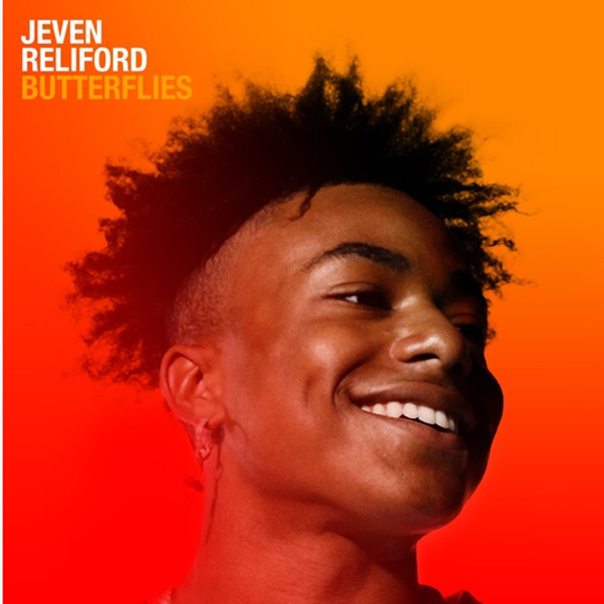

Today, Atlantic Records partners with Music The Label on newest signee, rising singer/songwriter and global TikTok sensation, Jeven. The multi-talented artist is known for generating nearly 200 million views and building an audience of over 4 million followers in under one year on TikTok. As he gears up for the next chapter in his career as a musician, the artist has announced the official release of his debut single, “Butterflies,” which is now available via Music The Label/Atlantic Records at all digital retailers and streaming platforms [HERE](https://jevenreliford.lnk.to/Butterflies). Watch the official video [HERE](https://jevenreliford.lnk.to/ButterfliesVideo).

“I don’t want to sound like anybody else,” he affirms. “I try to make everything my own. I switch it up and keep my content personal. I’ve been through a lot, but I’m always going to try to make people smile. I give as much as I can.”

- - -

Nothing changes your mood quite like a song does. Within a few minutes or even seconds, it might turn your whole day around. Jeven Reliford holds this prospect in the highest regard. Emboldened by towering range, unassuming charisma, and relatable spirit, the Georgia-born singer, songwriter, and performer brightens up pop with a contrast of R&B energy and sharp sensitivity. He introduces a singular style on a series of singles for Music The Label/Atlantic Records and more music on the horizon.

Born in Dallas, GA but raised in Cartersville, GA as the youngest of three siblings, he initially embraced music by singing along with his older sisters. He really honed his voice by belting out the Bruno Mars staple “When I Was Your Man.” Simultaneously, he developed a wide palette, listening to everyone from Drake and Ashanti to Florida Georgia Line, Morgan Wallen, Chris Stapleton, and Luke Combs. In between football, Brazilian jiu-jitsu, wrestling, and track, he spent as much time as possible outside, recalling a childhood *“in the country, riding four wheelers, and popping wheelies on dirt bikes*.*”*In 2019, he endured the loss of his friend Curtis to suicide.

During September 2019, a short clip of Jeven singing Post Malone’s “Goodbyes” exploded on Tik Tok with 3.5 million views. Rather than flood the platform with content, he took a highly curated and selective approach, showcasing the breadth of his voice and choosing quality over quantity. Among a handful of highly trafficked posts, he covered Frank Sinatra’s “Fly Me To The Moon” (37.9 million views, 5.5 million*“likes”*) and Leonard Cohen’s “Hallelujah” (26.9 million views, 4.8 million *“likes”*). His ambitions exceeded social media though. “From the beginning, I didn’t want to be an influencer or just get internet famous,” he elaborates. “Singing is a place where I can go and not think about anything but the note I’m hitting. If I feel some type of way, I can turn the music on and jam out. I express a lot of emotions through my vocal cords, so I treated this very seriously.”

The approach paid off. After only 12 videos, he met veteran music executive Anthony “T.A.” Tate and inked a deal with Music The Label/Atlantic Records shortly thereafter, hitting the studio in Atlanta, GA. Now, his debut single “Butterflies” floats over a throwback beat towards a confessional chorus, *“Girl, I got a crush on you. Got me feeling like I’m in high school. I got butterflies when I’m around you*.*”* His fluttering falsetto immediately takes flight. “You meet a girl, and the energy shocks you right off the bat,” he goes on. “She gives you a feeling you haven’t had in a long time. It’s a classic mood to me.”

Elsewhere, “Hit Me Up” brushes off fake friends online with a high register refrain and swaggering groove. Then, there’s “Follow.” It culminates on a hypnotic hook, *“about a girl you want to follow you back on Social Media not just Instagram*.*”*

In the end, Jeven might just make your day a little better. “When you hear me, I want you to get true excitement, fun, and good vibes,” he leaves off. “Maybe, it soothes you or gives you some peace.”

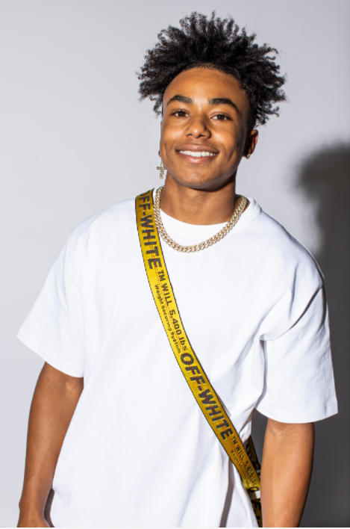

***# # #***

**FOR PRESS INQUIRIES CONTACT:**

SYDNEY MARGETSON

[SYDNEY.MARGETSON@ATLANTICRECORDS.COM](mailto:SYDNEY.MARGETSON@ATLANTICRECORDS.COM)

CONNECT WITH JEVEN:

[INSTAGRAM](https://nam04.safelinks.protection.outlook.com/?url=https%3A%2F%2Fwww.instagram.com%2Fjevenreliford%2F%3Fhl%3Den&data=02%7C01%7CAlyssa.Reddish%40atlanticrecords.com%7C4f946aa60f164db30ff408d85efdd87d%7C8367939002ec4ba1ad3d69da3fdd637e%7C0%7C0%7C637363791646481607&sdata=Uxf3if6t89jN0cyfPI9Inm81tkCd%2FkpnXvcKv4JTdFo%3D&reserved=0) | [TWITTER](https://nam04.safelinks.protection.outlook.com/?url=https%3A%2F%2Ftwitter.com%2Fjevenreliford%3Flang%3Den&data=02%7C01%7CAlyssa.Reddish%40atlanticrecords.com%7C4f946aa60f164db30ff408d85efdd87d%7C8367939002ec4ba1ad3d69da3fdd637e%7C0%7C0%7C637363791646481607&sdata=nU0gwsWMPzB%2F5eBE2P6NQusHqS3DlZSvgkwj8pSzbK4%3D&reserved=0) | [FACEBOOK](https://nam04.safelinks.protection.outlook.com/?url=https%3A%2F%2Fwww.facebook.com%2FJevenRelifordOfficial%2F&data=02%7C01%7CAlyssa.Reddish%40atlanticrecords.com%7C4f946aa60f164db30ff408d85efdd87d%7C8367939002ec4ba1ad3d69da3fdd637e%7C0%7C0%7C637363791646491555&sdata=XrabvwBlcr5E9X6bW7baYy8IT6JPJJfDcJUpZGSqGoc%3D&reserved=0) | [TIK TOK](https://nam04.safelinks.protection.outlook.com/?url=https%3A%2F%2Fwww.tiktok.com%2F%40jeven.reliford%3Flang%3Den&data=02%7C01%7CAlyssa.Reddish%40atlanticrecords.com%7C4f946aa60f164db30ff408d85efdd87d%7C8367939002ec4ba1ad3d69da3fdd637e%7C0%7C0%7C637363791646491555&sdata=j8tquiKlECTtaRqiyA08L%2Fx1XQmBnW1t5SOnQWIRavQ%3D&reserved=0)