FOR IMMEDIATE RELEASE
JANUARY 31, 2020

JUCEE FROOT SIGNS TO ART@WAR/ATLANTIC RECORDS
VIA LOYAL 100 ENTERTAINMENT

ACCLAIMED MEMPHIS RAPPER RELEASES HIGHLY ANTICIPATED
“PSYCHO (REMIX) (FEAT. RICO NASTY)” AVAILABLE TODAY

UPCOMING LIVE SCHEDULE INCLUDES NORTH AMERICAN TOUR SUPPORTING KASH DOLL
JUST-ANNOUNCED SLOT AT ROLLING LOUD MIAMI, AND SXSW SHOWCASE

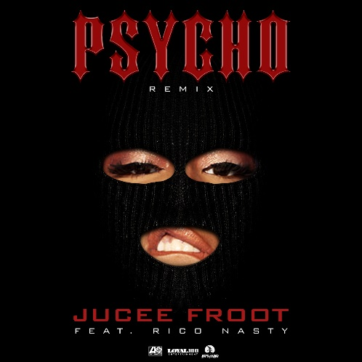
STREAM/DOWNLOAD “PSYCHO (REMIX) (FEAT. RICO NASTY)” HERE

Art@War/Atlantic Records has signed Jucee Froot to an exclusive label deal via Loyal 100 Entertainment, which was announced today via Billboard. The Memphis, TN-bred rapper Jucee Froot has announced the release of the highly anticipated “Psycho (Remix) (Feat. Rico Nasty)” – available today at all DSPs and streaming services via Loyal 100 Entertainment/Art@War/Atlantic Records HERE.

“Psycho (Remix) (Feat. Rico Nasty)” sees the groundbreaking rapper teaming up with the one and only Rico Nasty for a spectacular new version of her 2018 single, “Psycho.” Additionally, a new project will follow shortly thereafter.

Furthermore, Jucee Froot has contributed a new track, “Danger,” to BIRDS OF PREY: THE ALBUM, Atlantic Records’ new musical companion to the eagerly awaited new film from Warner Bros. Pictures, LuckyChap Entertainment, Clubhouse Pictures, and Kroll & Co. Entertainment. BIRDS OF PREY: THE ALBUM arrives in stores and at all online retailers on Friday, February 7th; pre-orders are available now HERE.

Known as a charismatic and compelling live performer, Jucee Froot will celebrate with a major U.S. tour, including a showcase performance at Austin, TX’s upcoming SXSW (March 13th) and a special guest role on Kash Doll’s upcoming Dollhouse Tour. Those dates get underway March 20th at Kalamazoo, MI’s Kalamazoo State Theatre and then continue through early April. Jucee Froot has also been announced for the hugely anticipated Rolling Loud Miami, set for Sunday, May 10th. For updates and more, please visit www.officialjuceefroot.com/#tour.

JUCEE FROOT
ON TOUR 2020

MARCH
13 – Austin, TX – SXSW *
20 – Kalamazoo, MI – Kalamazoo State Theatre
23 – New York, NY – Gramercy Theatre
24 – Philadelphia, PA – The Foundry
26 – Atlanta, GA – Hell at the Masquerade
27 – Birmingham, AL - Zydeco
29 – Houston, TX – The Studio at Warehouse Live
30 – Dallas, TX - Trees

APRIL
1 – Los Angeles, CA – The Roxy
3 – Oakland, CA – The New Parish
5 – Washington, DC – Union Stage
7 – Cleveland, OH – Grog Shop
8 – Toronto, ON – The Opera House
9 - Cambridge, MA – The Middle East Downstairs

MAY
10 – Miami, FL – Rolling Loud Miami *

ALL DATES W/KASH DOLL “THE DOLLHOUSE TOUR” EXCEPT *

# # #

Jucee Froot has quickly become a vital presence in hip-hop, an honest voice equally hailed for her fearless approach as well as her bulletproof bars, confessional choruses, and clever adlibs. The Memphis, TN-based rapper earned every bit of that acclaim through tear-filled viral freestyles, countless shows nationwide, and a prolific string of independent releases, all of which led to more than 20 million worldwide streams, praise from such icons as Birdman and Kevin Gates, and now, a major label deal with Loyal 100 Entertainment/Art@War/Atlantic Records. Indeed, irresistible tracks like “Life’s A Bitch” and “F*cked Up” – both streaming now on all DSP’s - affirm Jucee Froot as a one-of-a-kind new artist with a remarkable true story to share with the world.

“I’m not afraid to speak on anything,” she says. “I’ve made songs about daddy issues, being raped, getting pregnant, and everything. I got songs you can dance to. I got songs that make you think. It’s all-around. I respect listeners through being honest all the time. I’m a female who made it out of the bottom, took everything, and still kept going regardless of anything. I’m a different breed. I want everybody to see my talent and know the story.”

PRESS CONTACT:
Ashley Kalmanowitz | Ashley.Kalmanowitz@atlanticrecords.com

CONNECT WITH JUCEE FROOT:
OFFICIAL
INSTAGRAM
FACEBOOK
TWITTER

