KANO RELEASES NEW SINGLE “PAN-FRIED” FT KOJO FUNDS

TAKEN FROM THE FORTHCOMING LP
HOODIES ALL SUMMER

DOWNLOAD/STREAM “PAN-FRIED” FT KOJO FUNDS HERE
PRE-ORDER HOODIES ALL SUMMER HERE

“Kano is simply one of the best to ever do it.” – CLASH
“More than a decade into his career, this gifted British MC remains on point.”– The Observer

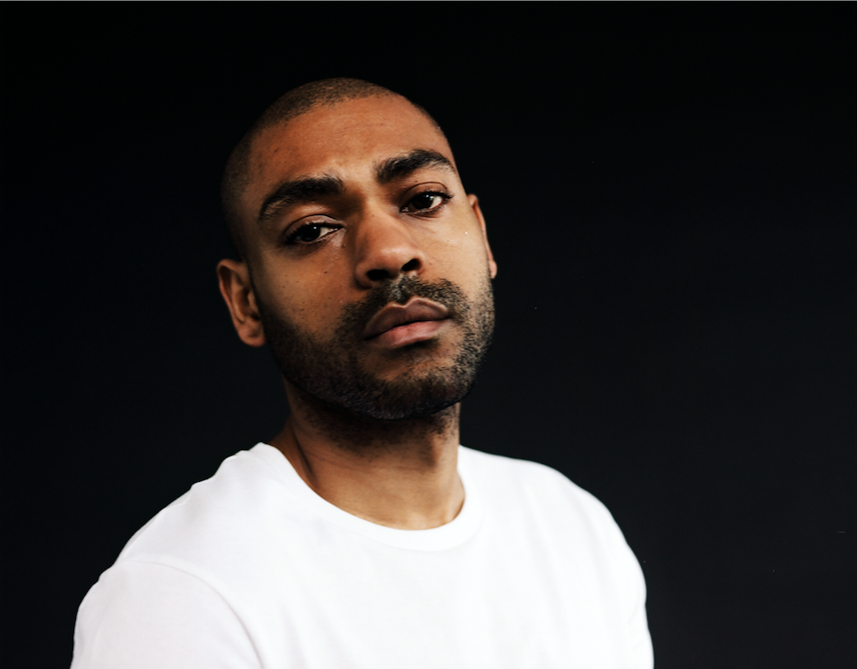
Photo credit: Olivia Rose

Today sees the release of “Pan-Fried” - a brand new track from Kano – taken from the forthcoming LP Hoodies All Summer available everywhere on August 30th via Parlophone/Atlantic Records.

“Pan-Fried” is the third track off the record and follows the release of “Trouble” and “Class Of Deja” which was accompanied by a compelling short film. A song about celebration despite dire circumstances, “Pan-Fried” contrasts summery beats with a furious, dark undertow and features a guest turn from the rapidly ascendant British artist Kojo Funds.

Hoodies All Summer is the sixth studio album from Kano, and his first release since 2016’s acclaimed Mercury-nominated ‘Made In The Manor’. Produced by Blue May and Jodi Milliner, the 10-track album sees Kano explore a more minimal – yet still uniquely British - sound which brings his lyrical prowess to the fore.

This autumn will also see Kano make his much-anticipated return to the stage, accompanied by a full live band, with a head line tour kicking off in Glasgow on 2nd October, ahead of a sold-out hometown show at London’s iconic Royal Albert Hall on 7th October.

Hoodies All Summer will be available on CD, double vinyl and digital download. Pre-order here.

HOODIES ALL SUMMER UK TOUR
2 October GLASGOW The Old Fruitmarket
4 October MANCHESTER The Albert Hall
5 October BIRMINGHAM Town Hall
6 October BRIGHTON Brighton Dome
7 October LONDON Royal Albert Hall

HOODIES ALL SUMMER
Kano
(Parlophone/Atlantic Records)

1. Free Years Later
2. Good Youtes Walk Amongst Evil
3. Trouble
4. Pan-Fried (feat. Kojo Funds)
5. Can’t Hold We Down (feat. Popcaan)
6. Teardrops
7. Bang Down Your Door
8. Got My Brandy, Got My Beats (feat. Lil Silva)
9. Class Of Deja (feat. D Double E & Ghetts)
10. SYM

Download press images and album packshot here: https://we.tl/t-X9lK0wzutb

http://kanomusic.com
Instagram
Twitter
Facebook

Press Contact
Selam Belay // selam.belay@atlanticrecords.com

