KANO SHARES TWO-PART VIDEO FOR
“CAN’T HOLD WE DOWN (FT POPCAAN)”

WATCH/SHARE NOW:
EPISODE 1
EPISODE 2

DOWNLOAD/STREAM HOODIES ALL SUMMER HERE

“…already one of the best MC-led projects of the year and easily one of his own personal bests.”

“He doesn’t miss the mark with these ten urgent tracks; they demand your attention… it’s his most mature, deafening, and profound album yet.”

“Kano's most prolific to date”
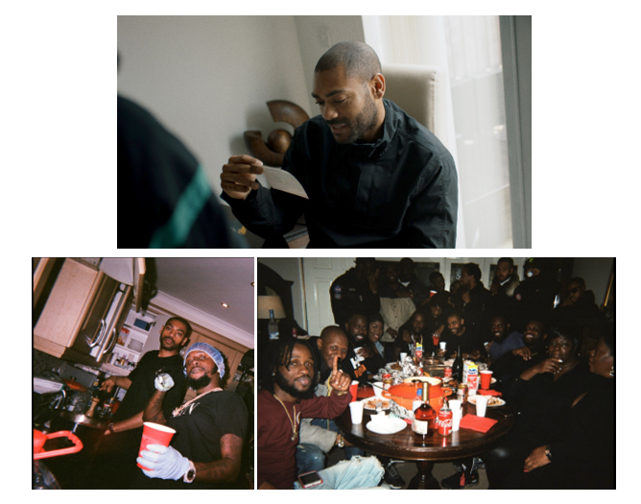
DOWNLOAD ADDITIONAL HI-RES STILLS HERE
PRESS IMAGES AVAILABLE HERE

KANO has dropped the video for “Can’t Hold We Down” featuring Popcaan, taken from his acclaimed sixth studio album HOODIES ALL SUMMER.

Underlined by a galvanising melody, “Can’t Hold We Down” is a celebratory anthem anchored by Kano’s musical heritage, featuring a passion-rich chorus from dancehall star Popcaan on a track brimming with defiance and hope.

The two-part video chronicles Kano’s connection with Jamaica. The trailer/documentary segment (which launched yesterday) sees Kano going through old family photo’s and reflect on good times had there, discussing his love for the culture and how he came to meet and work with Popcaan. The video features appearances from family, friends and collaborators including Giggs, Lethal Bizzle, Ghetts and of course Popcaan.

HOODIES ALL SUMMER, which was produced by Blue May and Jodi Milliner, was released earlier this fall. The 10-track album saw Kano explore a more minimal – yet still uniquely British - sound which brings his lyrical prowess to the fore.

2019 also saw Kano make a much-anticipated return to the stage with a sold-out headline tour crowned by a triumphant hometown show at London’s iconic Royal Albert Hall. The year also saw Kano revisit his starring role in Netflix smash ‘Top Boy’ (executive produced by Drake), as well as pick up the award for Outstanding Contribution to Music at the Q Awards.

Kano will hit the road again next year with the Hoodies All Summer Tour. Kicking off in Bournemouth on 31 January, this second leg will see him visit Cardiff, Bristol, Liverpool, Leeds, Nottingham, Birmingham and Manchester, as well take in as a massive 7,500 capacity gig at The Drumsheds in London. Tour itinerary below.

UPCOMING TOUR DATES:
31 January BOURNEMOUTH – O2 Academy
01 February CARDIFF – C.U. Students Union
02 February BRISTOL – O2 Academy
03 February LIVERPOOL – 02 Academy
07 February LONDON – The Drumsheds
12 February LEEDS – O2 Academy
13 February NOTTINGHAM – Rock City
14 February BIRMINGHAM – O2 Academy
15 February MANCHESTER – O2 Victoria Warehouse

Tickets here: https://kano.seetickets.com/tour/kano

HOODIES ALL SUMMER
KANO
(Parlophone/Atlantic Records)

1. Free Years Later
2. Good Youtes Walk Amongst Evil
3. Trouble
4. Pan-Fried (feat. Kojo Funds)
5. Can’t Hold We Down (feat. Popcaan)
6. Teardrops
7. Bang Down Your Door
8. Got My Brandy, Got My Beats (feat. Lil Silva)
9. Class Of Deja (feat. D Double E & Ghetts)
10. SYM

PRESS CONTACT
Selam Belay // selam.belay@atlanticrecords.com

http://kanomusic.com
Instagram
Twitter
Facebook

