**KOJEY RADICAL ANNOUNCES FIRST NORTH AMERICAN TOUR *FEELS LIKE CASHMERE***

**ANNOUNCEMENT ARRIVES AFTER RECENT NYC PERFORMANCE WITH COLORS STUDIOS**

**SALES BEGIN THIS FRIDAY DECEMBER 20TH 10AM LOCAL TIME**

**DOWNLOAD/STREAM LATEST PROJECT *CASHMERE TEARS*** [**HERE**](https://lnk.to/CashmereTears)

**[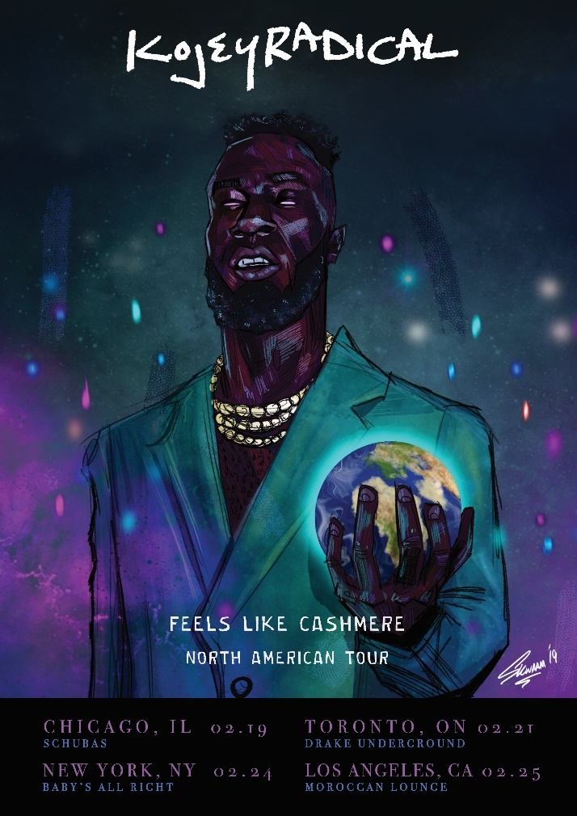](https://warnermusicgroup.box.com/s/ox6ublh4l87p3ylszz7k29gokumsej0y)**

[DOWNLOAD HI-RES GRAPHIC HERE](https://warnermusicgroup.box.com/s/ox6ublh4l87p3ylszz7k29gokumsej0y)

East London artist **KOJEY RADICAL** has officially announced his first North American tour **FEELS LIKE CASHMERE**. The tour kicks off in Chicago on February 19th at Schubas and is set to visit Toronto and New York before wrapping in Los Angeles on February 25th at the Moroccan Lounge. Ticket sales begin this Friday, December 20th at 10AM local time.

Today’s announcement of the FEELS LIKE CASHMERE tour arrives shortly after Kojey’s first NYC live appearance with COLORS Studios where he performed in front of a sold-out crowd. It also arrives after the announcement of his [biggest headline tour to date](http://kojeyradical.online/), a support slot for Daniel Caesar’s European tour, his recent performance with iconic UK artist Kano at the historic Royal Albert Hall along with a few festival appearances at this year’s Glastonbury Festival and the Pitchfork Festival in Paris.

The young artist has accumulated over 15M streams to date and recently introduced his latest project ***CASHMERE TEARS*** which included the title track “[Cashmere Tears](https://youtu.be/8-F4YXptiZA),” “[Can’t Go Back](https://youtu.be/_ZCNgXzRq-o)” and “[20/20](https://youtu.be/Jcb2o4kg0L4).” The latter track was tapped by OkayAfrica as one of “[The 20 Best Ghanaian Songs of 2019](https://www.okayafrica.com/ghana-music-best-songs-2019/).”

"The love and appreciation for the whole *CASHMERE TEARS* project has been emotional to say the least. I didn’t expect people to gravitate to it this much, I wanted to capture the energy felt when people hear this song. How much they want to dance and smile. I want a future generation to look back and see even through hard times we found reason to love. Feel out loud,” says Kojey.

***“THE GENRE IS KOJEY”***

- - - - - - - - - - - - - -

*“Kojey Radical is the creative chameleon you need on your radar.”*

*Image result for gq logo*

*“Kojey Radical is an artist with a capital ‘A’—a multi-disciplinary creative whose work spans music, poetry, fashion, and visual arts.”*

*Image result for pitchfork logo*

*“Kojey Radical is a rare artist – one you imagine will keep evolving.”*

*Image result for vice logo*

[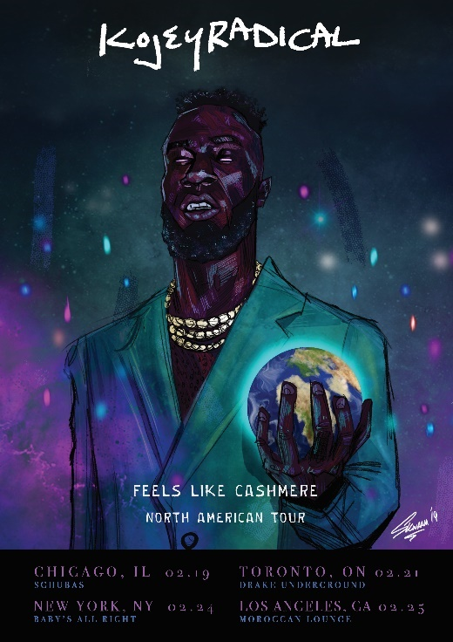](https://warnermusicgroup.box.com/s/ox6ublh4l87p3ylszz7k29gokumsej0y)

**KOJEY RADICAL**

***FEELS LIKE CASHMERE* NORTH AMERICAN TOUR**

|  |  |  |
| --- | --- | --- |
| February 19th | Chicago, IL | Schubas |
| February 21st | Toronto, ON | Drake Underground |
| February 24th | New York, NY | Baby’s All Right |
| February 25th | Los Angeles, CA | Moroccan Lounge |

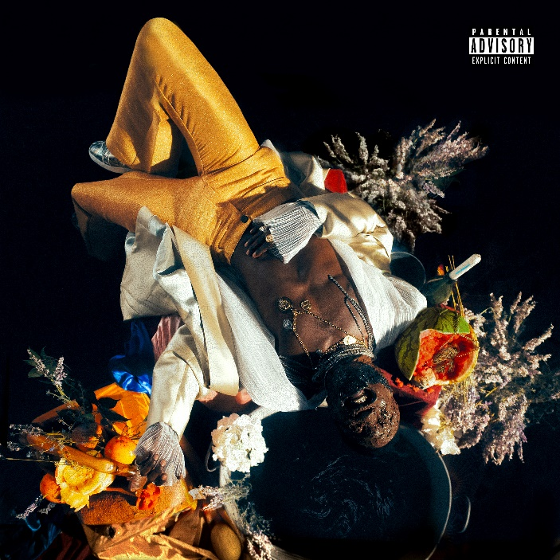

***CASHMERE TEARS***

**KOJEY RADICAL**

(Asylum/Atlantic Records)

1. Where Do I Begin
2. 20/20
3. Can’t Go Back
4. Sugar (feat. Amaarae)
5. Cashmere Tears
6. Hours
7. Eleven
8. Down2This
9. Feel About It
10. Last Night

**KEEP UP WITH KOJEY RADICAL**

[TWITTER](http://www.twitter.com/KojeyRadical) | [FACEBOOK](http://www.facebook.com/kojradical) | [INSTAGRAM](http://www.instagram.com/kojeyradical) | [SOUNDCLOUD](http://www.soundcloud.com/kojeyradical) | [YOUTUBE](https://www.youtube.com/channel/UC7RkBA9GHCB_3Eo_vTNqwpQ/featured)

**PRESS CONTACT**

Selam Belay // [selam.belay@atlanticrecords.com](mailto:selam.belay@atlanticrecords.com)