

**KOJEY RADICAL** **ANNOUNCES NEW SINGLE ‘PROUD OF YOU’**

**SERVES AS HIS FIRST MUSICAL OFFERING OF 2020 VIA ATLANTIC / ASYLUM RECORDS**

**DOWNLOAD/STREAM “PROUD OF YOU”** [**HERE**](https://lnk.to/ProudOfYou)

*“I’m so, I’m so proud of you. True say I never doubted you.*

*Long time we took the longer way. True say you had to pave the way*.”

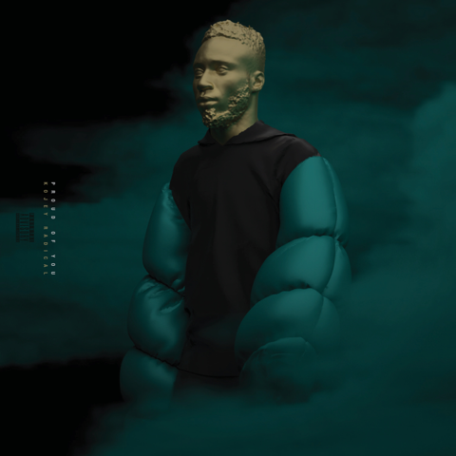

[DOWNLOAD HI-RES GRAPHIC HERE](https://warnermusicgroup.box.com/s/gbmp3luit2kdwd0p3ahh1ecrlu7olhoh)

*“Kojey Radical is the creative chameleon you need on your radar.”*

*Image result for gq logo*

*“Kojey Radical is an artist with a capital ‘A’—a multi-disciplinary creative whose work spans music, poetry, fashion, and visual arts.”*

*Image result for pitchfork logo*

*“Kojey Radical is a rare artist – one you imagine will keep evolving.”*

*Image result for vice logo*

East London rapper **KOJEY RADICAL** releases his first new cut of 2020, in the shape of the heartfelt and honest ‘PROUD OF YOU’ now available for download/streaming [here](https://lnk.to/ProudOfYou).

The new single is his first musical offering since his 2019 [*CASHMERE TEARS*](https://lnk.to/CashmereTears) project, an intricate 10 track body of work which further cemented his position as one of the most unique creatives to come out of the UK with his powerful, progressive style of spoken word, hip-hop and alternative rap.

‘Proud of You’ continues Kojey’s passion for storytelling, a genre-defying rapper who articulately switches gears between intimately singing and rapping on verses. *“*I always seem to forget to reflect and really consider how far I’ve come since I started. The pace of life never really gave me the opportunity to. With all the chaos going on I felt like this song is a perfect way to help remind people to consider what makes you proud of you,” says Kojey about his latest track.

His *CASHMERE TEARS* body of work presented itself as an incredibly powerful collection of songs, positioning Kojey as an important, urgent and crucial voice for our musical landscape. His creativity is displayed through his [exemplary visuals](https://www.youtube.com/playlist?list=PLNGQmbQbYtkZLiZ1Dpl0fx1KC0fBdngZH) and creative output, which have become as much as a calling card for the respected young artist as the music itself.

The last 12 months have seen the ferocious young rapper collect accolades including his debut [JOOLS HOLLAND performance](https://youtu.be/JMJiFKyVEAA), his first US show (Brooklyn) in partnership with COLORS (and a [second performance](https://youtu.be/QzNGAs_5-l4) on the channel), a sold-out headline tour matched with his explosive [debut NORTH AMERICAN tour](https://youtu.be/oONiCu5wmLI), a bespoke bottle design in partnership with 1800 TEQUILA / SELFRIDGES, weighty support slots with KANO, DANIEL CAESAR and an ANNIE MAC Maida Vale session.

Earning acclaim in the shape of a [5* NME review](https://www.nme.com/reviews/kojey-radical-cashmere-tears-review-2547356), [Artist of The Week in The OBSERVER](https://www.theguardian.com/music/2019/sep/28/kojey-radical-scala-review-cashmere-tears) and further nods from MIXMAG, THE FACE, ANOTHER MAN, GQ, COMPLEX, NOWNESS, HYPEBEAST, CLASH, OKAY AFRICA, LINE OF BEST FIT, the young star continues his upward trajectory.

‘Proud Of You’ acts as a taster of further, formidable, new music to drop across 2020 from the East London polymath, with his sold-out ‘FEELS LIKE CASHMERE’ tour dates now rescheduled for December. Full routing below.

***KOJEY RADICAL***

***FEELS LIKE CASHMERE 2020 TOUR DATES***

*THURSDAY, DECEMBER 10th: LEEDS / BELGRAVE MUSIC HALL*

*FRIDAY, DECEMBER 11th: MANCHESTER / GORILLA*

*SATURDAY, DECEMBER 12th: BIRMINGHAM, 02 INSTITUTE*

*TUESDAY, DECEMBER 15th: BRISTOL / THEKLA*

*WEDNESDAY, DECEMBER 16th: LONDON / ROUNDHOUSE*

**KEEP UP WITH KOJEY RADICAL**

[WEBSITE](https://kojeyradical.online/) | [INSTAGRAM](https://www.instagram.com/kojeyradical/?hl=en) | [TWITTER](https://twitter.com/KojeyRadical) | [FACEBOOK](https://www.facebook.com/kojradical/) | [YOUTUBE](https://www.youtube.com/channel/UC7RkBA9GHCB_3Eo_vTNqwpQ) | [SOUNDCLOUD](https://soundcloud.com/kojeyradical)

**PRESS CONTACT**

SELAM BELAY // [SELAM.BELAY@ATLANTICRECORDS.COM](mailto:SELAM.BELAY@ATLANTICRECORDS.COM)