FOR IMMEDIATE RELEASE
NOVEMBER 11, 2021

KOJEY RADICAL RELEASES NEW SINGLE “GANGSTA”
THE SECOND TRACK FROM HIS LONG-AWAITED DEBUT ALBUM
OUT TODAY VIA ATLANTIC RECORDS
DOWNLOAD/STREAM NOW
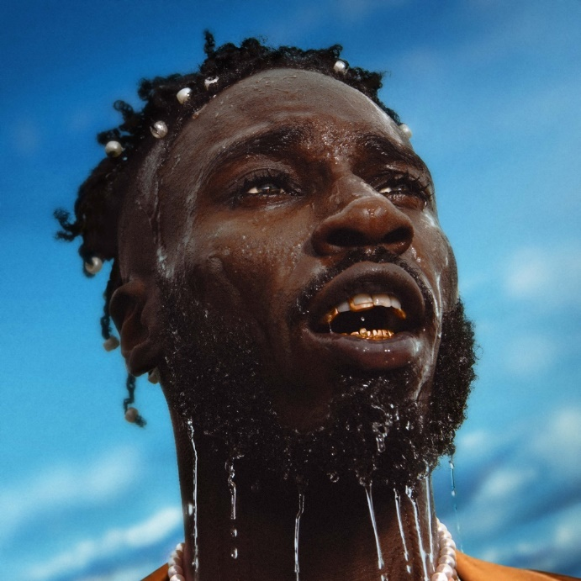
(high res artwork here)
Kojey Radical returns with his latest single “Gangsta”, the second song to be unveiled from his highly anticipated debut album which will finally arrive in 2022. Coming hot off the success of previous single “War Outside (feat. Lex Amor)”, “Gangsta” is Kojey Radical at his most personal and autobiographical as he again flexes his singing voice over an original live score that sounds a great, unearthed orchestral sample and production from KZ, Swindle, Ed Thomas and Jay Weathers. Subverting any preconceptions of how the song will sound from the title alone, “Gangsta” is an anthem for, and tribute to, the powerful female figures in Kojey Radical’s life; first and foremost, his mother (“I think my mama was a gangster, I think my daddy was a rolling stone) and the mother of his son.
“Any time I come to a sense of reasoning or a sense of self, it’s normally because of the advice or presence of women around me, whether that’s my mum, my sisters or the mother or my son. This song is a celebration of the of those women and an appreciation of everything they’ve been through. For me, their ability to persevere through everything is the definition of what a gangster actually is.”
- Kojey Radical
.
Having already made such an indelible mark on British music it's hard to believe that Kojey Radical, one of the UK's most influential voices, has never released an album. That's all about to change. In 2022, Kojey Radical will finally release his long-awaited debut album. Over four previous EPs (2014’s Dear Daisy, 2016's 23Winters, 2017's In God's Body and 2019's Cashmere Tears), Kojey Radical has given people greatness but for the album he'll be striving for perfection. Further expanding on a sound Kojey Radical describes as “space and bass”, “Gangsta” is a second statement of just how high he’s setting the bar and a further demonstration of the confidence, scale and ambition that surrounds this highly-anticipated record.
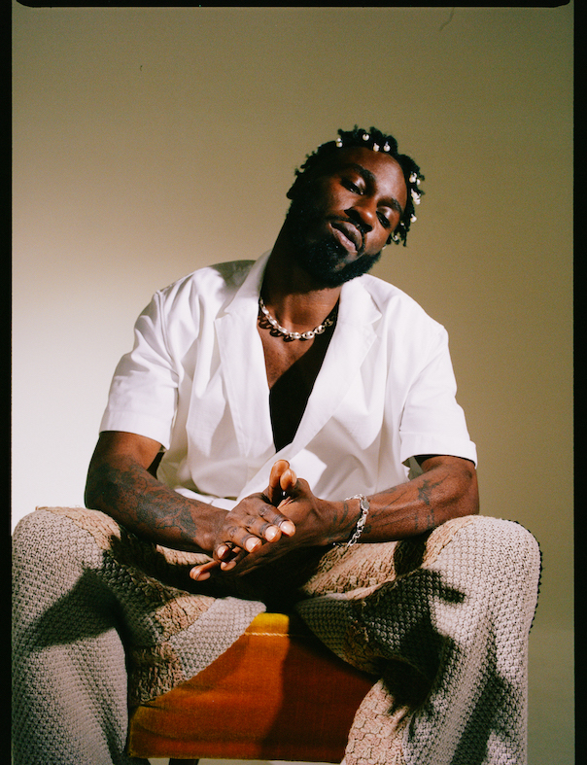
ABOUT KOJEY RADICAL:
Born and raised in East London, British Ghanaian Kwadwo Adu Genfi Amponsah aka Kojey Radical is often described as a “renaissance man”. At 28 years old, he is at the forefront of a generation of young British artists who have pushed underground Black music into the mainstream over the last few years through a series of acclaimed, ambitious EPs - Dear Daisy, 23Winters, In Gods Body and Cashmere Tears - and collaborations with the likes of Mahalia, Mereba, Ghetts, Shy FX, AJ Tracey, Swindle, Wretch32 and MJ Cole. Currently putting the finishing touches to his highly anticipated debut album, Kojey Radical embodies everything that makes an artist truly exciting in 2021; he’s an authentic and uncompromising creative force, constantly evolving and blurring boundaries as he moves from rap, funk, spoken word and poetry to fashion, art and film with an almost effortless fluidity.

CONNECT WITH KOJEY RADICAL:
INSTAGRAM // SPOTIFY // YOUTUBE

