KOJEY RADICAL RELEASES NEW SONG “SILK (FEAT. MASEGO)”

THE LATEST TRACK FROM HIS HIGHLY ANTICIPATED DEBUT ALBUM REASON TO SMILE,
TO BE RELEASED 4TH MARCH 2022 VIA ASYLUM / ATLANTIC RECORDS

BIGGEST EVER HEADLINE SHOWS INCLUDING LONDON’S 02 ACADEMY BRIXTON IN APRIL 2022 - ON SALE NOW

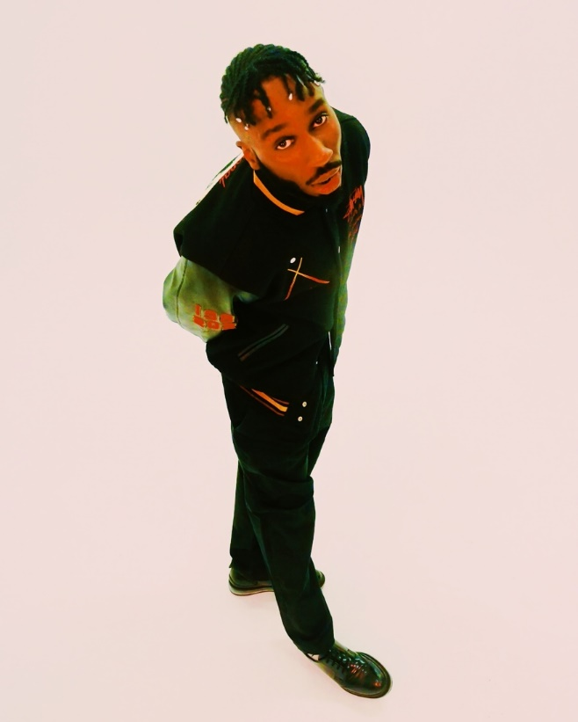
(photo credit: Jerusha Rose. Download high res here)

Friday 18th February – London’s Kojey Radical today releases the latest song from his highly anticipated Reason To Smile debut album (out 4th March via Asylum / Atlantic Records). Produced by Blue Lab Beats and Swindle, “Silk” features vocals from Virginia’s Masego and is one of three US vocal collaborations on the album (the other two being Kelis and Rexx Life Raj). Born from one of many Instagram Live sessions Kojey hosted during lockdown, “Silk” – with its “I feel like shit, I feel like silk” chorus” – is a self-motivating anthem; a song about pulling himself out and pumping himself up from his lowest point.

“Silk” provides another enticing glimpse of what fans can expect from Reasons To Smile. The album is a love letter to the hip hop that’s influenced Kojey, littered with references, sample nods and interpolation. It’s an album about confidence, pride, and identity and features guest appearances from Tiana Major9, Masego, Shaé Universe, Cashh, Kelis, Lex Amor, Knucks, Shakka, Wretch 32, Ego Ella May and Rex Life Raj and his own mother (whose voice weaves throughout the record) alongside a who's-who of global production talent including KZ, Swindle, Jay Prince, iO, The FaNaTiX, Cadenza, 169, Venna, Ric & Thadeus, Blue Lab Beats, Emil Larbi, Mr Cutts and Ed Thomas.

Having already made such an indelible mark on British music it's hard to believe that Kojey Radical has never released an album. Over four previous EPs and writing for artists such as Mahalia, Kojey’s given people greatness; but on Reason To Smile he's striving for perfection. Defined by a sound he describes as "space and bass" and also featuring the previous singles (and sensational accompanying videos) “Payback (ft. Knucks)”, "War Outside (ft Lex Amor)" and "Gangsta", Reason To Smile is without doubt Kojey Radical's most ambitious and complete work to date and an emphatic statement of the levels at which he operates.

Talking about the album, Kojey Radical says:

"This is the first time I've done it to the scale and ambition of what I speak. Previously it's been "I'm warming, I'm warming, I'm warming up". But I'm warm now - put me in the game

Reason To Smile track list:

1. Reason to Smile ft. Tiana Major9
2. Together
3. Nappy
4. Silk ft. Masego
5. Pressure ft. Shaé Universe
6. Born Feat Cash
7. Pusher Man
8. Talkin ft Kelis & Tiana Major9
9. War Outside ft Lex Amor
10. Payback ft Knucks
11. Fubu
12. Beautiful ft Shakka & Wretch 32
13. Anywhere ft Ego Ella May
14. Solo ft. Rexx Life Raj
15. Gangsta

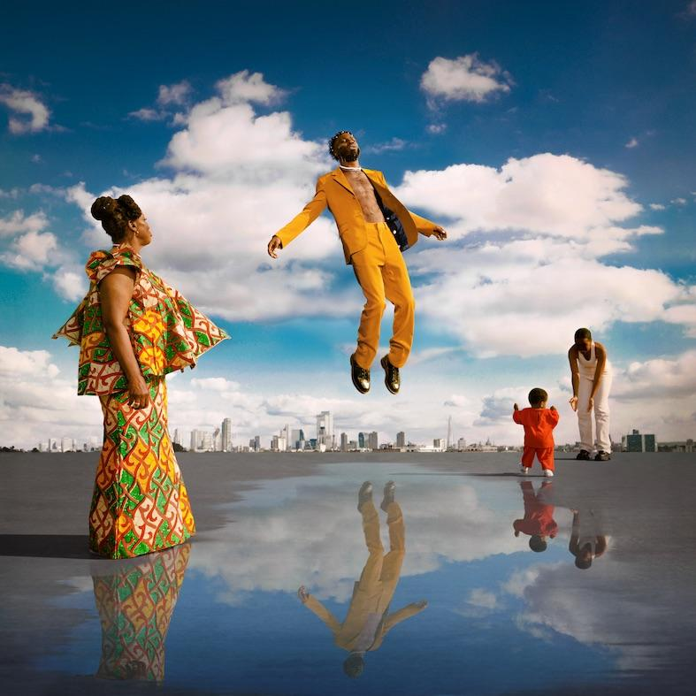
(download high res album art here)

2022 will also see Kojey Radical’s biggest ever live shows. Following a run of intimate UK in store and out-store performances the week of album release, Kojey will headline London’s legendary, 5000 capacity O2 Academy Brixton on 7th April 2022 and Manchester’s 2300 capacity Albert Hall on 6th April. For full details via https://kojeyradical.online/

KOJEY RADICAL LIVE 2022

“From Me To You” Tour

Friday 4th March Rough Trade East / London (Instore Performance + Signing)
Saturday 5th March Banquet Records @ Pryzm / Kingston (Out store Performance + Signing)
Monday 7th March Vinilo / Bournemouth (Performance)
Tuesday 8th March Resident / Brighton (Instore Performance + Signing)
Wednesday 9th March HMV / Manchester (Signing)
Wednesday 9th March Crash / Leeds (Performance)
Thursday 10th March HMV / Birmingham (Signing)

“Reason To Smile” Tour

Wednesday 6th April The Albert Hall, Manchester
Thursday 7th April O2 Academy Brixton, London

About Kojey Radical:

Born and raised in East London, British Ghanaian Kwadwo Adu Genfi Amponsah aka Kojey Radical is often described as a “renaissance man”. At 29 years old, he is at the forefront of a generation of young British artists who have pushed underground Black music into the mainstream over the last few years through a series of acclaimed, ambitious EPs - Dear Daisy, 23Winters, In Gods Body and Cashmere Tears - and collaborations with the likes of Mahalia, Mereba, Ghetts, Shy FX, AJ Tracey, Swindle, Wretch32 and MJ Cole. On the eve of the release of his highly anticipated debut album Reason To Smile, Kojey Radical embodies everything that makes an artist truly exciting in 2022; he’s an authentic and uncompromising creative force, constantly evolving and blurring boundaries as he moves from rap, funk, spoken word and poetry to fashion, art and film with an almost effortless fluidity.

More on Kojey Radical via:
INSTAGRAM // SPOTIFY // YOUTUBE

Press contact:
Selam Belay // selam.belay@atlanticrecords.com

