**KOJEY RADICAL** **RELEASES NEW VIDEO FOR ‘CASHMERE TEARS'**

**DIRECTED BY: CHARLIE DI PLACIDO + KOJEY RADICAL**

**WATCH/SHARE** [**HERE**](https://nam04.safelinks.protection.outlook.com/?url=https%3A%2F%2Fwww.youtube.com%2Fwatch%3Fv%3D8-F4YXptiZA%26feature%3Dyoutu.be&data=02%7C01%7Casher.korner%40atlanticrecords.co.uk%7C3bd7b58e63be4580d22e08d75891a137%7C8367939002ec4ba1ad3d69da3fdd637e%7C0%7C0%7C637075256595991260&sdata=psjM9mvLRYrqEroXoUNKQTZsMu6hHYQuD9N8zpEB4js%3D&reserved=0)

*“Kojey Radical is the creative chameleon you need on your radar.”*

*Image result for gq logo*

*“Kojey Radical is an artist with a capital ‘A’—a multi-disciplinary creative whose work spans music, poetry, fashion, and visual arts.”*

*Image result for pitchfork logo*

*“Kojey Radical is a rare artist – one you imagine will keep evolving.”*

*Image result for vice logo*

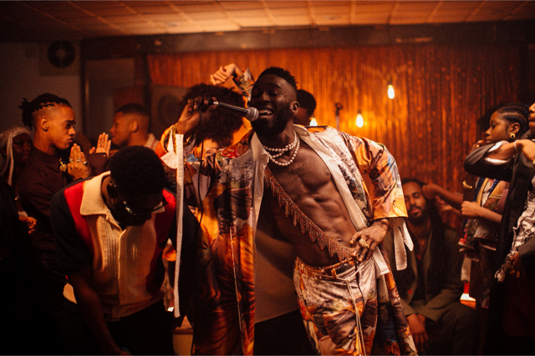

East London enigma **KOJEY RADICAL** releases a luxurious new visual for EP title track ‘CASHMERE TEARS.” The new visual follows the announcement of Kojey’s biggest headline tour to date, a support slot for Daniel Caesar’s European tour, his recent performance with iconic UK artist KANO at the historic Royal Albert Hall, along with his explosive debut on *LATER…WITH JOOLS HOLLAND* on BBC Two. His recent EP, *CASHMERE TEARS* presented itself as an incredibly powerful collection of songs tackling subjects including depression, family, god, hope, self-worth and creativity.

**Download/Stream *CASHMERE TEARS* EP:** [**https://lnk.to/CashmereTears**](https://nam04.safelinks.protection.outlook.com/?url=https%3A%2F%2Flnk.to%2FCashmereTears&data=02%7C01%7CSelam.Belay%40atlanticrecords.com%7C74ccda4b0a4f432a193908d738852cf7%7C8367939002ec4ba1ad3d69da3fdd637e%7C0%7C0%7C637040016958300228&sdata=Er80%2BR93ySFjCBu0W7xkdtpYW05k3HTcJTpeFluBfWA%3D&reserved=0)

**Watch/Share “Cashmere Tears” visual:** [**https://youtu.be/8-F4YXptiZA**](https://youtu.be/8-F4YXptiZA)

Following a run of exemplary, stand out visuals across his recent EP project, the new video delves deeper into the personality of the track and dials up a more light-hearted, carefree side of Kojey. Allow yourself to be transported into the decadent late night world of ‘*CASHMERE TEARS’*  which features cameos from POPPY AJUDHA, SHAKKA and FRANZ DRAMEH.

*"The love and appreciation for whole Cashmere Tears project has been emotional to say the least. I didn’t expect people to gravitate to it this much, I wanted to capture the energy felt when people hear this song. How much they want to dance and smile. I want a future generation to look back and see even through hard times we found reason to love. Feel out loud,”* says Kojey.

**KOJEY RADICAL 2020 UK TOUR**

LEEDS - Belgrave Music Hall // 26th March 2020

GLASGOW - SWG3 Warehouse // 27th March 2020

BIRMINGHAM - Institute2 // 28th March 2020

MANCHESTER - Gorilla // 31st March 2020

BRISTOL - Thekla // 1st April 2020

LONDON - Roundhouse // 2nd April 2020

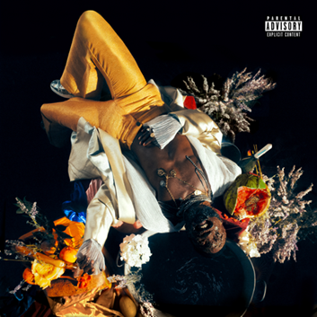

***CASHMERE TEARS***

**KOJEY RADICAL**

(Asylum/Atlantic Records)

1.   Where Do I Begin

2.   2020

3.   Can’t Go Back

4.   Sugar

5.   Cashmere Tears

6.   Hours

7.   Eleven

8.   Down2This

9.   Feel About It

10. Last Night

**KEEP UP WITH KOJEY RADICAL**

[**TWITTER**](http://www.twitter.com/KojeyRadical) **|** [**FACEBOOK**](http://www.facebook.com/kojradical) **|** [**INSTAGRAM**](http://www.instagram.com/kojeyradical) **|** [**SOUNDCLOUD**](http://www.soundcloud.com/kojeyradical) **|** [**VEVO**](http://www.vevo.com/artist/kojey-radical)

**PRESS CONTACT**

Selam Belay // [selam.belay@atlanticrecords.com](mailto:selam.belay@atlanticrecords.com)