FOR IMMEDIATE RELEASE
SEPTEMBER 21, 2021

KOJEY RADICAL RELEASES NEW SINGLE "WAR OUTSIDE” (FEAT. LEX AMOR)

SERVES AS THE FIRST RELEASE FROM HIS LONG-AWAITED DEBUT ALBUM

"This is the first time I've done it to the scale and ambition of what I speak. Previously it's been "I'm warming, I'm warming, I'm warming up". But I'm warm now - put me in the game"
- KOJEY RADICAL

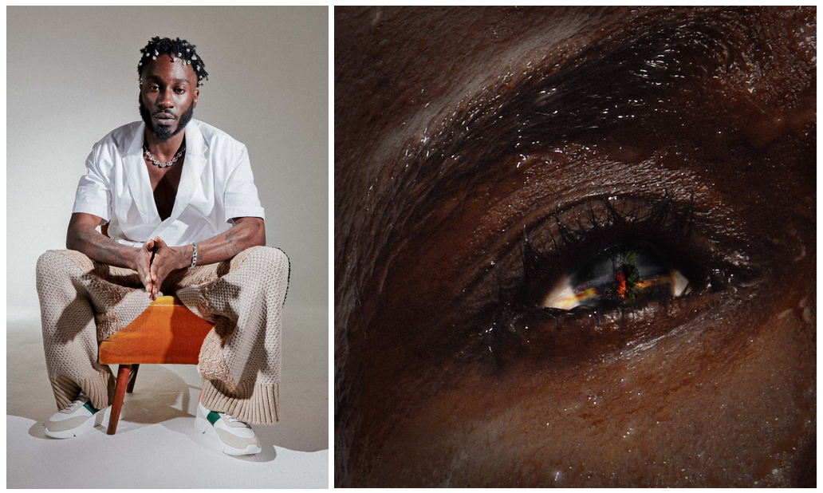
(high res image publicity image here, high res “War Outside” cover art here)

Having already made such an indelible mark on British music it's hard to believe that Kojey Radical, one of the UK's most influential voices, has never released an album. That's all about to change. In 2022, Kojey Radical will finally release his long-awaited debut album and today he reveals the first track.

Featuring the incredible Lex Amor and produced by long-time collaborators KZ and Swindle, "War Outside ("feat Lex Amor)” has all the hallmarks of a future classic. The fact that one of the country's most acclaimed, unique and dextrous rappers chooses to sing, rather than rap, on his debut album curtain raiser is both a sign of Radical's multi-genre versatility and a demonstration of the confidence, scale and ambition that surrounds this highly anticipated record.

Sonically, Radical accurately describes the track as "space and bass", a concept that will also run through the album. It’s built on a cinematic rap beat that in his own words evokes "Uma Thurman in a yellow tracksuit about to go and fight the Crazy 88s". Lyrically, we find him characteristically composed and assured as he looks out of the window at the chaos that surrounded, and continues to surround, us over the last eighteen months. The world has gone through momentous changes recently, but the war isn't new, and on "War Outside" Radical is looking for the bigger picture.

Over four previous EPs (2014’s Dear Daisy, 2016's 23Winters, 2017's In God's Body and 2019's Cashmere Tears), Kojey Radical has given people greatness but for the album he'll be striving for perfection. "War Outside" sets the scene perfectly. Simultaneously timeless and ultra-contemporary, it's everything that's so exciting about Black British music right now. This is Kojey Radical in the eye of the storm while the world crashes in slow motion around him.

KOJEY RADICAL

Born and raised in East London, British Ghanaian Kwadwo Adu Genfi Amponsah aka Kojey Radical is often described as a “renaissance man”. At 28 years old, he is at the forefront of a generation of young British artists who have pushed underground Black music into the mainstream over the last few years through a series of acclaimed, ambitious EPs - Dear Daisy, 23Winters, In Gods Body and Cashmere Tears - and collaborations with the likes of Mahalia, Mereba, Ghetts, Shy FX, AJ Tracey, Swindle, Wretch32 and MJ Cole. Currently putting the finishing touches to his highly anticipated debut album, Kojey Radical embodies everything that makes an artist truly exciting in 2021; he’s an authentic and uncompromising creative force, constantly evolving and blurring boundaries as he moves from rap, funk, spoken word and poetry to fashion, art and film with an almost effortless fluidity.
INSTAGRAM // SPOTIFY // YOUTUBE

PRESS CONTACT
Selam Belay // selam.belay@atlanticrecords.com

