FOR IMMEDIATE RELEASE

FEBRUARY 19, 2021

KOLIDESCOPES x GAVIN JAMES RELEASE “ALL FOR YOU”

CHART-TOPPING INTERCONTINENTAL ELECTRONIC DUO UNITE WITH MULTI-PLATINUM SELLING IRISH SINGER-SONGWRITER FOR SOULFUL NEW COLLABORATION

LISTEN TO “ALL FOR YOU” HERE
WATCH THE LYRIC VIDEO HERE
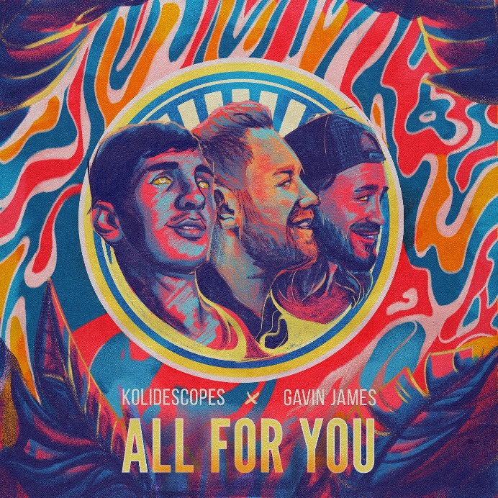
DOWNLOAD ARTWORK HERE

Rising intercontinental electronic duo KOLIDESCOPES teamed up with Irish singer-songwriter Gavin James for their irresistible new single “All For You.” The track, co-written by KOLIDESCOPES and James, is available now HERE and accompanied by a lyric video streaming now HERE.

About the collaboration, KOLIDESCOPES and Gavin James shared: “Met for pints of Guinness and wrote 3 songs, we had been friends for years so it made sense to write some music. The song is about finding yourself again through someone else, wondering how you’ve found them, and that you’ll do anything to keep that person around.”

“All For You” sees KOLIDESCOPES joining forces with Gavin James, an award-winning singer-songwriter who has accumulated over 1.5 billion streams. The soulful track marks the latest release from KOLIDESCOPES, following last summer’s euphoric label debut, “Torn.” Hailed by Variance as an “entrancing new single,” “Torn” is joined by an equally energetic companion video, streaming now HERE.

KOLIDESCOPES ascended to the top of singles charts around the world last year as co-writers and co-producers of the #1 global hit, Joel Corry’s “Head & Heart (Feat. MNEK).” The track proved a sensation upon its July 2020 release, spending six consecutive weeks atop the UK Singles Chart while also reaching #1 in such far-flung countries as Belgium, Czech Republic, Hungary, Ireland, Israel, Serbia, Scotland, and the Netherlands. Here in the United States, the track climbed to the top 3 on Billboard’s “Hot Dance/Electronic Songs” chart, simultaneously arriving on the overall “Hot 100” as well as the top 25 on Billboard’s “Mainstream Top 40.” What’s more, “Head & Heart” – which has received platinum certification in the UK, Australia, and New Zealand, as well as gold certification in Austria, Belgium, Canada, Germany, and Italy – is joined by a hugely popular companion video, now with over 137 million views on YouTube alone.

ABOUT KOLIDESCOPES:
KOLIDESCOPES is an ambitious, adventurous international duo comprised of musician/producers Johnny Courtidis and Dan Dare. Courtidis first made waves as one half of Melbourne, Australia-based indie-house duo Parachute Youth, whose 2012 single “Can’t Get Better Than This” reached #1 in nine countries, earning platinum sales and more than 50 million streams. Meanwhile, London-based Dan Dare also proved an in-demand songwriter and producer, collaborating with Charli XCX, Marina & The Diamonds, and Giggs, to name but a few.

Upon meeting at Matrix, Courtidis and Dare each immediately recognized a kindred spirit and quickly bonded over their tough childhoods and shared love of music. Together they have created a series of spectacular songs – sumptuously melodic, synth-led soundtracks tinged with a touch of sorrow hinting at their past lives. Tracks such as “Focus,” “All My Love,” and “Foundations” proved worldwide club favorites while also drawing acclaim from the likes of Earmilk, which raved, “KOLIDESCOPES bring sophisticated production and big city lights energy to our day…No matter what season we’re in, KOLIDESCOPES’ feel good vibes will always be welcome in our house.”

“Our mission,” say KOLIDESCOPES, “is for us to write meaningful songs that people can dance to. It’s music for day and nighttime. Everything we write comes from an organic place. It’s dance music we’re writing, but it isn’t put-your-hands-in-the-air-and-go-fucking-mad dance music. We want to put our soul into what we’re doing.”

ABOUT GAVIN JAMES:
With over 1.5 billion streams, Gavin James has achieved phenomenal global success by simply letting his songs speak for themselves. These past years have been non-stop for James, from rising busking on Dublin’s Grafton Street to playing shows with Niall Horan, Ed Sheeran and Sam Smith to selling-out his own world tour including two headline shows at the 15,000 capacity 3Arena.
His growing international impact, with 22 Platinum records across the world including No.1 radio singles in Ireland, Switzerland, Portugal, Brazil, Holland and top 10 in France as well as his collaborations with Alan Walker which has also reached platinum sales around the globe.

CONNECT WITH KOLIDESCOPES
INSTAGRAM | FACEBOOK | TWITTER | SOUNDCLOUD | YOUTUBE

CONNECT WITH GAVIN JAMES
WEBSITE | INSTAGRAM | FACEBOOK | TWITTER | YOUTUBE

For press inquiries, please contact:
Jessica Nall // Jessica.Nall@atlanticrecords.com

