FOR IMMEDIATE RELEASE

SEPTEMBER 3, 2020

KOLIDESCOPES RELEASED OFFICIAL VIDEO FOR EUPHORIC SINGLE “TORN”

ACCLAIMED WRITERS AND PRODUCERS OF UK #1 SINGLE “HEAD & HEART”
RELEASE GRIPPING NEW VIDEO TO LATEST RELEASE

WATCH THE VIDEO HERE
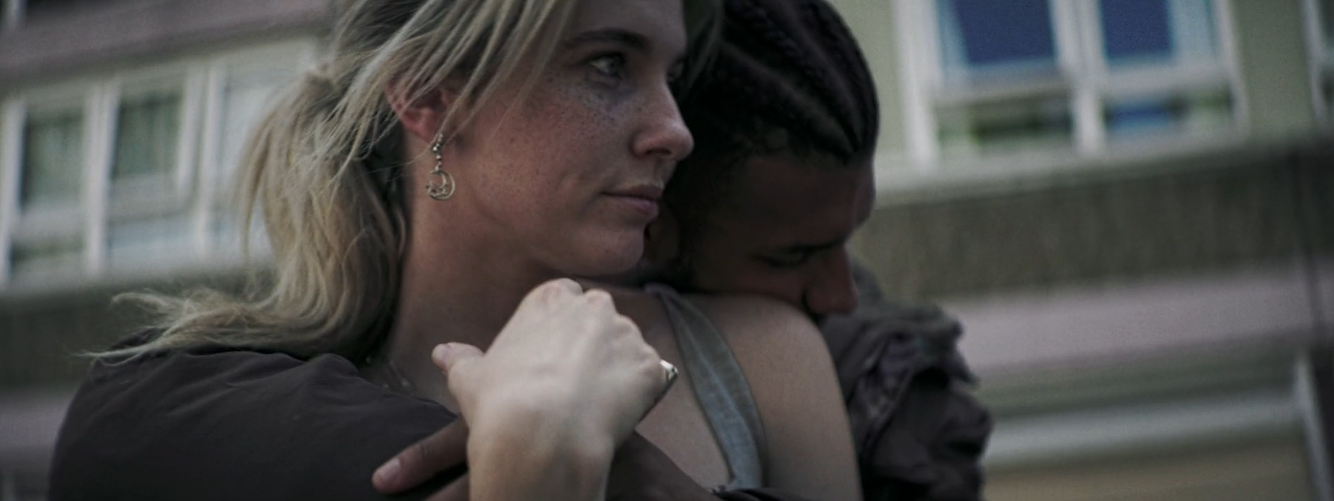

Rising intercontinental electronic duo KOLIDESCOPES made waves with their debut label release “Torn” earlier this year. Today, the acclaimed producers have released the real and gripping companion video for the euphoric track; streaming now on their official YouTube channel HERE.

“We wanted the music video to feel really British, inspired by the movies ‘Snatch’ and ‘Lock Stock and Two Smoking Barrels,’” the duo shares. “We shot the video the week when everyone was able to come out of lockdown and so we got together a load of our friends to take part. The story plays on the idea of love lost and being Torn between two different lives. We hope our fans will enjoy watching it as much as we enjoyed shooting it”

“Torn” was released fresh on the heels the KOLIDESCOPES written and produced, UK #1 single - Joel Corry & MNEK’s “Head & Heart” and offered an ideal introduction to the rising duo’s ambitious artistic approach, blending richly textured melancholia with a euphoric positivity and shimmering energy equally suited for sweltering summer days and long dark nights.

KOLIDESCOPES is acclaimed made up of musician/producers Johnny Courtidis and Dan Dare. Courtidis first made waves a one half of Melbourne, Australia-based indie-house duo Parachute Youth, whose 2012 single “Can’t Get Better Than This” reached #1 in nine countries, earning platinum sales and more than 50 million streams. Meanwhile, London-based Dan Dare also proved an in-demand songwriter and producer, collaborating with Charli XCX, Marina & The Diamonds, and Giggs, to name but a few.

Upon meeting at Matrix, Courtidis and Dare each immediately recognized a kindred spirit and quickly bonded over their tough childhoods and shared love of music. Together they have created series of spectacular songs, sumptuously melodic, synth-led soundtracks tinged with a touch of sorrow hinting at their past lives. Tracks such as “Focus,” “All My Love,” and “Foundations” proved worldwide club favorites while also drawing acclaim from the likes of Earmilk, which raved, “KOLIDESCOPES bring sophisticated production and big city lights energy to our day…No matter what season we’re in, KOLIDESCOPES’ feel good vibes will always be welcome in our house.”

DOWNLOAD PRESS PHOTO

CONNECT WITH KOLIDESCOPES
INSTAGRAM | FACEBOOK | TWITTER | SOUNDCLOUD | YOUTUBE

For press inquiries, please contact:
Jessica Nall // Jessica.Nall@atlanticrecords.com

