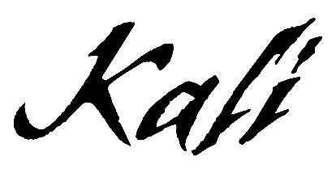

Confidence spreads like wildfire. With unapologetic bars, undeniable melodies, and unrestrained spirit, Kali bosses up the moment she wraps her fingers around the microphone. Empowered with style, swagger, and substance, the buzzing rapper quietly set social media ablaze with a sound just as perfect for the streets. In under a year, she has already posted up tens of millions of views and inspired nearly 400K videos on TikTok with massive plugs by superstars such as Charli D’Amelio, Gabrielle Union, Rico Nasty, Nessa Barrett, and many more.
In 2021, she presents a knockout sound of her own on a series of singles and more to come.
“You can’t tell me nothing,” she confesses. “I just do what I want. By living like that, I built my confidence up. When I started doing music, I was learning and going through a lot with my family. I realized I had to have my own back more than anybody else. Now, I feel like my sound is ‘Pretty Gangsta B’. Don’t play with me,” she warns.
Growing up on the north side of Atlanta, she discovered music through her producer parent. She often listened to him make beats and shared her journals with him. At the same time, she constantly spun the likes of Missy Elliott and Nicki Minaj, developing a deep reverence for the art of hip-hop. Mom kept her busy with soccer, which she played from the age of seven through college. At 19-years-old, she lost the passion for the sport admitting, “It just wasn’t fun anymore, because my parents turned it into a job.” So, Kali started to record songs of her own.
Simultaneously, she bounced around the country from California to Indiana to Texas. During 2019, she made an appearance on NETFLIX’s Rhythm + Flow. Despite the judges missing the episode, the atmosphere and experience inspired her to go hard once she returned home. After making waves with “MAMI,” She dropped “OOP” and regularly hosted her own “Freestyle Friday” on Instagram, sharpening her technique.
At the end of 2020, she relocated to Atlanta to live with her best friend. Settling into a groove, she unleashed her This Why They Mad Now EP. The lead single “Do A Bitch” exploded right out of the gate. In between bass-y piano and 808s, she tears through the production with a seductively incisive flow before a menacingly catchy chorus assures, “You know I’ll do a bitch.”
It incited a flurry of activity on TikTok and racked up over 5 million streams in a month’s time as she attracted the likes of major figures in music.

“It’s about a situation with a boy—exactly like the song says,” she recalls “I almost didn’t put ‘Do A Bitch’ out, but my best friend was like, ‘You need to drop it. It’s real.’ So, I did.”
In the end, her confidence has the power to inspire.
“I make music for women especially,” she leaves off. “If you’re going through something with your boy, just keep pushing, make your money, and do you. Forget about everyone else. That’s what I want you to take away from what I’m doing. Don’t let anybody stop you.”

