BRITISH SINGER KARL BENJAMIN UNVEILS NEW SINGLE ‘FRIENDS’
LISTEN HERE

+ ANNOUNCES DEBUT EP ‘DRIST’
SET FOR RELEASE MARCH 26TH

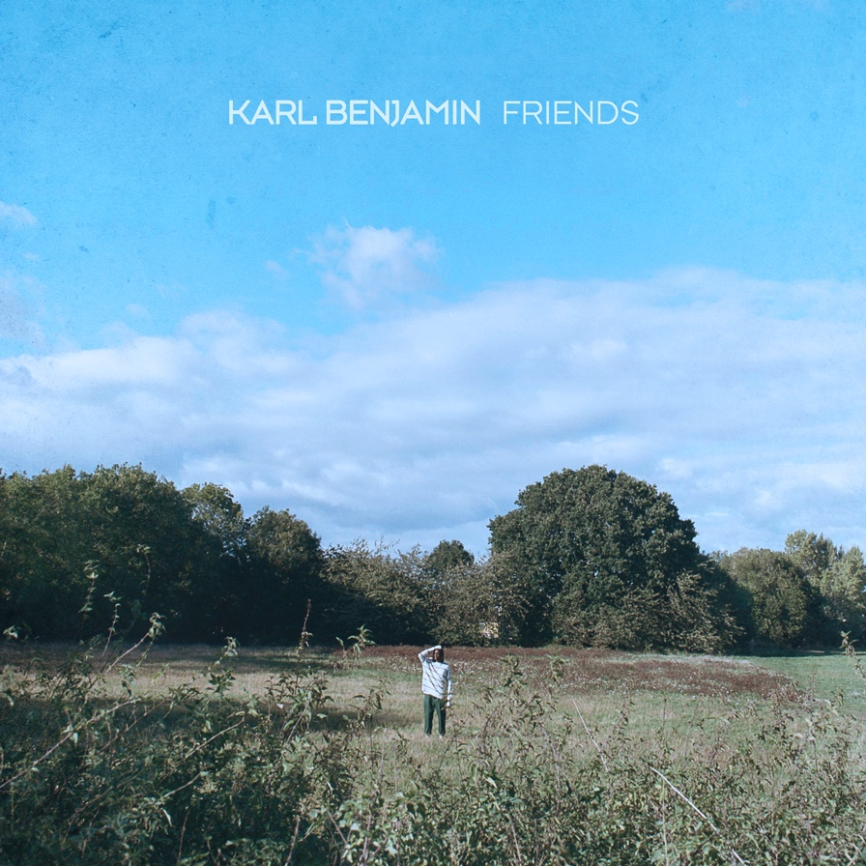

Today, British singer Karl Benjamin has unveiled his beautifully hard-hitting new single ‘Friends’ (stream here). Produced by Courage (Joseph Carson) ‘Friends’ owns a rich, velvety vocal that harks to soul roots but still feels uniquely modern and unfamiliar. Following his brilliant debut, ‘Apricot Sky’, and his February release, ’Moon’, ‘Friends’ continues to demonstrate how Karl’s taste is eclectic, broad and ambitious.

“I wrote ‘Friends’ so I could talk about one of my biggest fears. Losing the people I treasure. It’s a tribute to my late brother, Leon, and to making sure that I don’t take the people I still have around me for granted. I can be a little antisocial sometimes, so I feel like I might not appreciate their presence in my life enough. I know I do, even though I don’t show it all the time. So I hope this song lets my loved ones know, they are truly appreciated. I’m just a bit of an introvert I guess”

In addition to releasing ‘Friends’, today Karl also announces his highly-anticipated debut EP ‘DRIST.’ – an abbreviation for ‘Deep Rooted Insecurities and Shy Tendencies’. Full of honest and raw ode’s, the project speaks on the topics of love, loss and fear.

“Being trapped in the house with my own thoughts for so long has really shown me how much this word means to me.” Karl states. “I’m an antisocial extrovert that’s had the time to analyse their own DRIST, and in doing so, I’m slowly understanding myself & my cerebellum more each day. I wrote this Ep with my DRIST in mind. I hope it reaches those with similar thought patterns to mine.”

It’s fair to say Karl’s journey into music has been a while in the making. Even before he started making his own, music was always a fixture in his life. “My sister was the person that actually inspired me. She was doing her piano and I was doing my football, which I was terrible at anyway.” But when he was young, his older sister was always “belting Alicia Keys” and it encouraged him to give it a go for himself. After gaining the confidence to explore his own voice, Karl entered a singing competition and won. From there, he worked with one of his teachers on a little four-track EP. When he relocated to Brighton for university, things kicked up another notch, singing lead in a seven-piece band: “it was like an alternative funk kind of R&B soul… thing!”

Scouted by an agent while at Secret Garden Party for a gig with the ensemble, Karl then began modelling for the likes of Vivienne Westwood, Nicholas Daley, Converse and more, alongside the band. Eventually moving back up to the capital for work, things with the band slowed down but his own relationship with making music remained intact and it’s in London he realised he wanted to pursue music seriously.

With support from the likes of i-D, The Face, The Independent, Clash, Line of Best Fit and more, the year ahead will see Karl Benjamin stand at the forefront of Britain’s young and fiendishly talented singers. Stream/watch and enjoy his captivating new single ‘Friends’ below.

LISTEN TO ‘FRIENDS’ HERE

CONNECT WITH KARL BENJAMIN
INSTAGRAM
TWITTER

FOR ALL INQUIRIES, CONTACT
ARIANA.WHITE@ATLANTICRECORDS.COM

