FOR IMMEDIATE RELEASE
JANUARY 13, 2022

KOJEY RADICAL RELEASES NEW SINGLE
“PAYBACK (FEAT. KNUCKS)”

THE LATEST SINGLE FROM HIS HIGHLY ANTICIPATED DEBUT ALBUM REASON TO SMILE, RELEASED 4TH MARCH 2022 VIA ASYLUM / ATLANTIC RECORDS

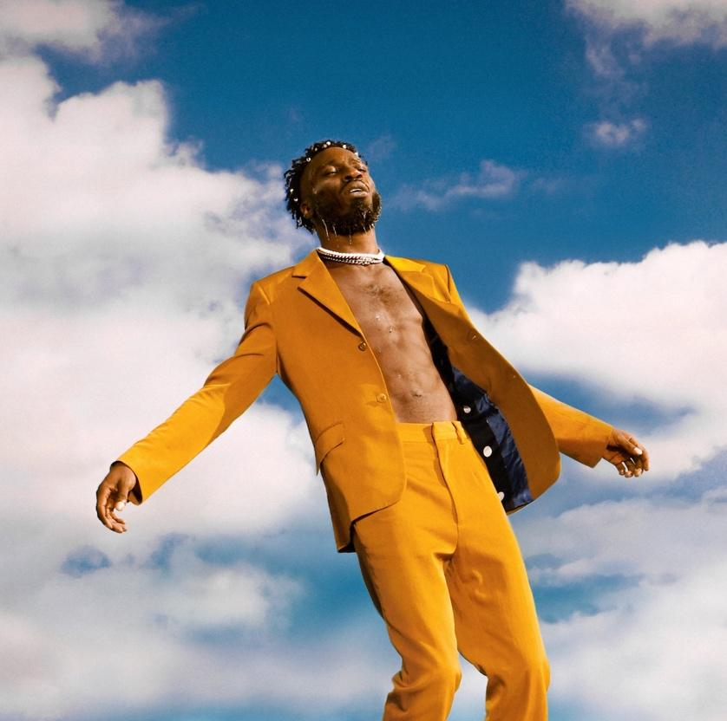
(download high-res single art here)

London’s Kojey Radical today releases the latest single from his highly anticipated Reason To Smile debut album (out 4th March via Asylum / Atlantic Records). Produced by Swindle and featuring north west London rapper Knucks, “Payback” sees Kojey Radical performing with supreme confidence, reclaiming titles, words, and identity. It’s a song – all swaggering – that’s embedded in Black cool and draws a line through generations of Black artistry. The payback of the title is internal: it comes from a recognition of self and discovering that inner joy.

“When you’ve been taught to be the victim for so long, it feels great to stand up and say, ‘No one can bully me’,” says Kojey.

“Payback” provides another enticing glimpse of what fans can expect from Reasons To Smile. The album is a love letter to the hip hop that’s influenced Kojey, littered with references, sample nods and interpolation. It’s an album about confidence, pride, and identity and features guest appearances from Tiana Major9, Masego, Shaé Universe, Cashh, Kelis, Lex Amor, Knucks, Shakka, Wretch 32, Ego Ella May and Rex Life Raj and his own mother (whose voice weaves throughout the record) alongside a who's-who of global production talent including KZ, Swindle, Jay Prince, iO, The FaNaTiX, Cadenza, 169, Venna, Ric & Thadeus, Blue Lab Beats, Emil Larbi, Mr Cutts and Ed Thomas.

Having already made such an indelible mark on British music it's hard to believe that Kojey Radical has never released an album. Over four previous EPs and writing for artists such as Mahalia, Kojey’s given people greatness; but on Reason To Smile he's striving for perfection. Defined by a sound he describes as "space and bass" and also featuring the previous singles "War Outside (ft Lex Amor)" and "Gangsta", Reason To Smile is without doubt Kojey Radical's most ambitious and complete work to date and an emphatic statement of the levels at which he operates.

Talking about the album, Kojey Radical says:

"This is the first time I've done it to the scale and ambition of what I speak. Previously it's been "I'm warming, I'm warming, I'm warming up". But I'm warm now - put me in the game"

Reasons To Smile track list:

1. Reason to Smile ft. Tiana Major9
2. Together
3. Nappy
4. Silk ft. Masego
5. Pressure ft. Shaé Universe
6. Born Feat Cash
7. Pusher Man: BWI
8. Talkin ft Kelis & Tiana Major9
9. War Outside ft Lex Amor
10. Payback ft Knucks
11. Fubu
12. Beautiful ft Shakka & Wretch 32
13. Anywhere ft Ego Ella May
14. Solo ft. Rexx Life Raj
15. Gangsta

2022 will also see Kojey Radical’s biggest ever live shows. Following a run of intimate UK in store and out-store performances the week of album release, Kojey will headline London’s legendary, 5000 capacity O2 Academy Brixton on 7th April 2022 and Manchester’s 2300 capacity Albert Hall on 6th April. For full details via https://kojeyradical.online/

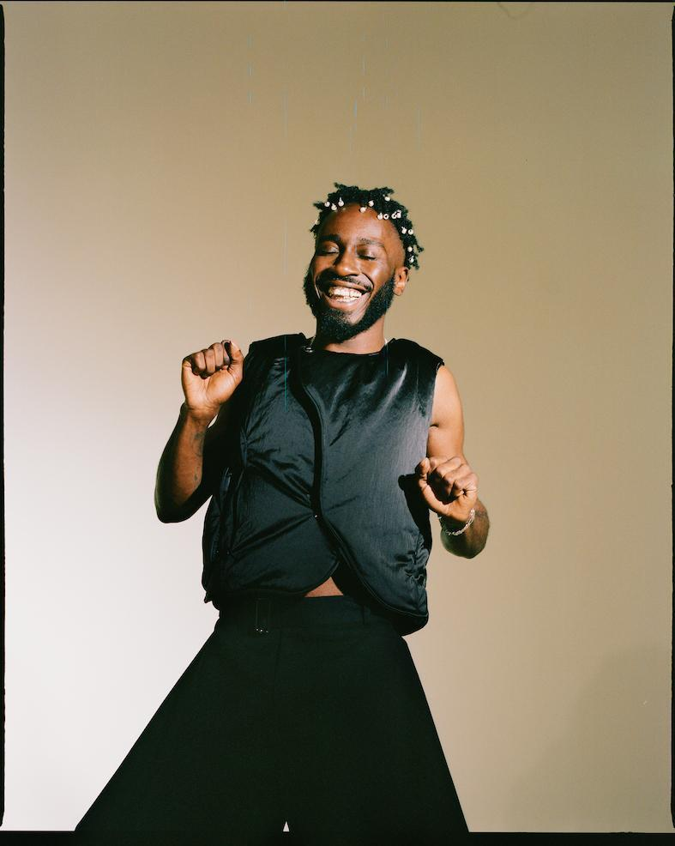
(download high-res photo here)

About Kojey Radical:

Born and raised in East London, British Ghanaian Kwadwo Adu Genfi Amponsah aka Kojey Radical is often described as a “renaissance man”. At 29 years old, he is at the forefront of a generation of young British artists who have pushed underground Black music into the mainstream over the last few years through a series of acclaimed, ambitious EPs - Dear Daisy, 23Winters, In Gods Body and Cashmere Tears - and collaborations with the likes of Mahalia, Mereba, Ghetts, Shy FX, AJ Tracey, Swindle, Wretch32 and MJ Cole. On the eve of the release of his highly anticipated debut album Reason To Smile, Kojey Radical embodies everything that makes an artist truly exciting in 2021; he’s an authentic and uncompromising creative force, constantly evolving and blurring boundaries as he moves from rap, funk, spoken word and poetry to fashion, art and film with an almost effortless fluidity.

Connect With Kojey Radical:

INSTAGRAM // SPOTIFY // YOUTUBE

More information from:

Selam Belay / Selam.belay@atlanticrecords.com

