SHARES LATEST TRACK
‘WHAT MATTERS’
FEATURING SIMON NEIL FROM BIFFY CLYRO

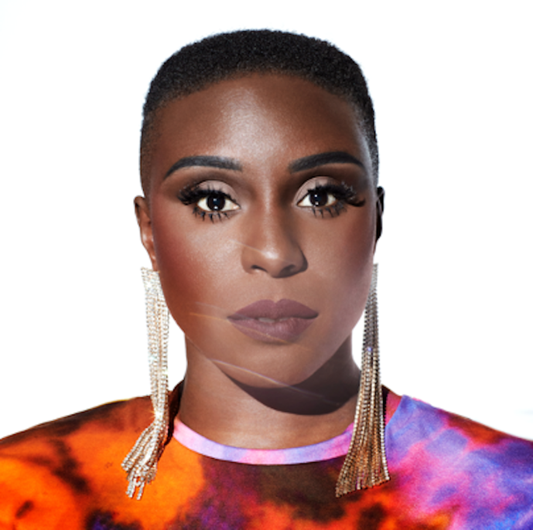

STREAM HERE | WATCH THE VIDEO HERE

NEW ALBUM ‘PINK NOISE’ OUT JULY 2ND
PRE-ORDER HERE
HEADLINING LONDON’S VILLAGE UNDERGROUND
2ND SEPTEMBER | TICKETS HERE

“A glorious immersion in 80s pop" - The Guardian
“She’s back, with her dancing shoes on” - The Sunday Times Culture
“We honestly didn't deserve Laura Mvula - talented, frank, and wise…” - CLASH
“Loud, ambitious and uplifting” - The Independent
“Buoyant, dreamlike...lush swathes of synths and drums that leap like shooting stars” -gal-dem

Laura Mvula today shares her ethereal new track ‘What Matters’, straight from her 80s pop renaissance album ‘Pink Noise’, out July 2nd on Atlantic Records. The song which will be released as an instant grat, also features Simon Neil from Biffy Clyro. Stream or watch the video for the track now.

With its synth friendly stylings, ‘What Matters’ is a track that truly harks back to the classic 80’s style of a love ballad; from the love-lorn vocals to the elegant instrumentals, to the old school veneer of the video that highlights the soul in the performance. Here, Laura collaborates with Simon Neil, best known as part of Scottish icons Biffy Clyro. Together, the pair give a performance on ‘What Matters’ that perfectly captures the essence of ‘Pink Noise’ as an album.

The track will be going live with the performance of the song by the pair from ‘Laura Mvula Presents...Under A Pink Moon’ - The Livestream, which streamed in February and is now available to watch on demand. The performance truly marked a stand out moment in her career as her first live performance in three years. Now, as it’s released to the world to experience again, fans can get a taste of what to expect from her London Village Underground on September 2nd.
‘Pink Noise’ is a battle cry and stark reminder of the sheer talent of the critically acclaimed artist. This is Laura in a new found light - still reflecting her distinctive signature sound but showing the progression of an artist who has come into her own. It's an album borne out of both intense struggles and the positive realisations that come when you emerge reborn on the other side. Lyrically it touches on ideas around break-ups – both personal and professional – but also a hard won appreciation. Pink Noise marks a shift from the more experimental, baroque soul of her first two albums, 2013's Sing to the Moon and 2016's The Dreaming Room, both of which were Mercury nominated. While Dreaming Room also won album of the year award at the prestigious Ivor Novello awards, suddenly she had time to look back on how she was perceived to look at the bigger picture.

About the album Laura says, “This is the album I always wanted to make. Every corner is made warm with sunset tones of the 80s. I was born in 1986. I came out of the womb wearing shoulder pads. I absorbed the dynamism of the 80s aesthetic right from my first moments on this planet.” She also tells us how “Making ‘Pink Noise’ felt like the most violent of emotional wrestling matches. It took 3 years of waiting and waiting and fighting and dying and nothingness and then finally an explosion of sound. As if it was always here this record is my most honest and unapologetic flying of the freedom flag. I can’t wait to play this album live.”
It’s been a stellar 2021 for Laura. Earlier this year, her partnership with Pantone Color Institute gave us the vibrant Pink Noise by Laura Mvula colour. Inspired by the romance of a Southern California sunset, ‘Pink Noise by Laura Mvula’ is an undeniable and unapologetic shade of fuchsia pink bursting with a captivating charisma that intrigues and sparks the imagination. The colour conveys a bold confidence and spirited message of optimism that characterises the metamorphosis undertaken by Laura as she embarked on her own transformative journey - a journey which is beautifully unveiled throughout the new album.

As one of the most exciting musical talents to come out of the UK, Laura has previously won an Ivor Novello Award for Best Album, has been nominated for the Mercury Prize (not once but twice), BBC Sound Poll, the BRITs Critics Choice Award, two BRIT Awards in 2014 (British Female Solo Artist and British Breakthrough Act) and won an incredible two MOBO’s in 2013 (Best Female and Best R&B/Soul).
Having caught the attention of her musical hero Prince while performing for the first of two times on the Pyramid Stage at Glastonbury, Laura has gone on to travel the world, selling out shows and captivating crowds at every destination. Crowned “Queen of the Prom” and given a five star review from the Evening Standard for her Proms 2014 Late Night performance at the Royal Albert Hall, Laura’s critically acclaimed career has led her to work with real-life inspirations Nile Rodgers and touring with David Byrne.
Pink Noise tracklisting:
- Safe Passage
- Conditional
- Church Girl
- Remedy
- Magical
- Pink Noise
- Golden Ashes
- What Matters
- Got Me
- Before The Dawn

LAURA MVULA ON SOCIAL MEDIA
INSTAGRAM | FACEBOOK | TWITTER
For more information please contact:
Ariana.white@atlanticrecords.com

