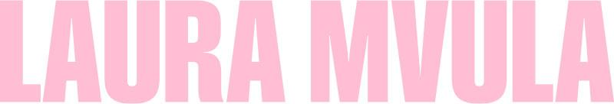
SHARES CINEMATIC OFFICIAL MUSIC VIDEO FOR ‘GOT ME’
WATCH HERE | STREAM THE SINGLE HERE

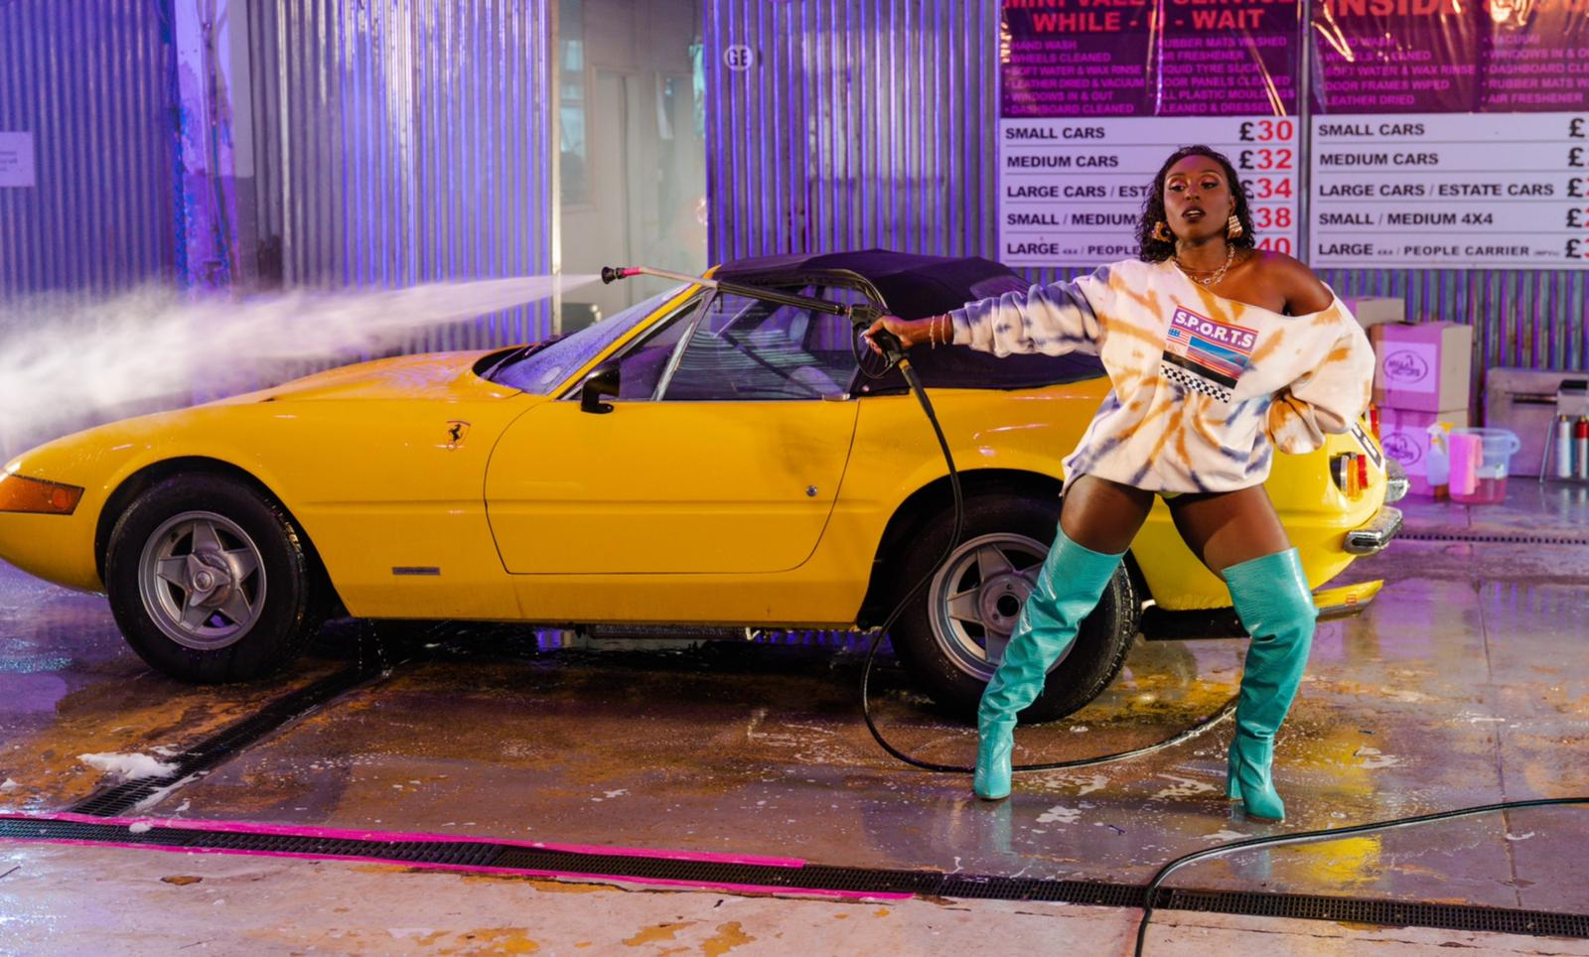

NEW ALBUM ‘PINK NOISE’ OUT JULY 2ND
PRE-ORDER HERE
“A glorious immersion in 80s pop" - The Guardian
“She’s back, with her dancing shoes on” - The Sunday Times Culture
“We honestly didn't deserve Laura Mvula - talented, frank, and wise…” - CLASH
“Loud, ambitious and uplifting” - The Independent
“Buoyant, dreamlike...lush swathes of synths and drums that leap like shooting stars” -gal-dem

“When it comes to music, I want to be able to be all that I am without hiding, without fighting with myself. We’re already in what feels like some kind of global claustrophobia – we’re locked in and we need to come out and we need to break out. That’s what this music is to me and I just want to share it. I want people to feel free.” - Laura Mvula 2021

Laura Mvula has shared the cinematic official music video for her latest single ‘Got Me’, directed by Samuel Douek. Watch here and stream the single here. The track is taken from her 80s pop inspired new album ‘Pink Noise’, due for release on July 2nd via Atlantic Records.

Described by CLASH as an “exuberant slice of 80s inspired electro-pop” and “thrilling” by The Times, with Independent praising the track’s “juddering hook”; the official music video for ‘Got Me’ follows the sonic triumphant suit. Transporting you to an 80s style flick, the visuals star Laura and her friends, freeing their inhibitions at a car wash and drenched in dynamic neon and block colours.

Speaking further about the video director Samuel Douek says, “‘Got Me’ was inspired by the neon synth aesthetic of Laura’s ‘Pink Noise’ era, as well as iconic music videos like Michael Jackson's ‘The Way You Make Me Feel’. We wanted to transport you to the retro future where Laura and her badass entourage run a car wash and take no prisoners. We watch Laura as she seduces an unsuspecting customer into the waiting room and then runs off with his yellow Ferrari. It's a fun, empowering video about women in charge.”
‘Pink Noise’ explores a side of Laura previously uncharted. As triumphant as ever, the album is a battle cry and stark reminder of the sheer talent of the critically acclaimed artist. This is Laura in a new found light - still reflecting her distinctive signature sound but showing the progression of an artist who has come into her own. It's an album borne out of both intense struggles and the positive realisations that come when you emerge reborn the other side. Lyrically it touches on ideas around break-ups – both personal and professional – but also a hard won appreciation.
It's all there on the album's delicious lead single, Church Girl, an 80s-era Whitney Houston-esque slice of effortlessly euphoric pop that turns the spotlight inwards while careening towards the dancefloor. “I was the original pop head in my family, I'm obsessed with pop,” she says, acknowledging the shift from the more experimental, baroque soul of her first two albums, 2013's Sing to the Moon and 2016's The Dreaming Room, both of which were Mercury nominated. “For some reason when I made Sing to The Moon that sound became permanently attached to me in people's heads. Like having the same hairstyle for the rest of your life, which for me is unthinkable. So this album was such a release.”
Dreaming Room won the coveted album of the year award at the prestigious Ivor Novello awards, an accolade that gave Birmingham-born Laura – a classically trained musician, hope for her future in music. Suddenly she had time to look back on how she was perceived, and to look at the bigger picture. “Growing up my parents always said to me and my siblings that as young black people we were going to have to work a hundred times harder just to get in the room, and that for me meant literally attempting to create a new genre of music,” she says. “So if I was going to do this thing I was going to have to invent something to go 'hey, I'm here'. I was learning that I was perceived as this artist who was very 'special' and it was 'pop but it's not pop, it's jazz but it's not jazz, it's classical but it's not classical, it's black but it's not black'. I realised that a lot of this game was about justifying being in the room in the first place. Because I was doing something that couldn't be neatly boxed. With this new album there is something hugely relieving about leaning heavily into a style of music – that 80s cosmic landscape – that has always been in my spirit.”
Contrasting confessional lyricism with compelling and infectious synth pop, ‘Pink Noise’ feels completely and uniquely Laura. Her artistic prowess knows no limits - take the neo-soul meets art pop of ‘Remedy’ for example, or the darker, pulsating ‘Conditional’ that injects bombastic funk into indietronica. She feels rejuvenated too, especially on electro pop stunners ‘Magical’ and ‘Before The Dawn’. This is Laura Mvula at her most ambitious to date, leaving no stone left unturned in this cosmic new realm.

Laura says, “This is the album I always wanted to make. Every corner is made warm with sunset tones of the 80s. I was born in 1986. I came out of the womb wearing shoulder pads. I absorbed the dynamism of the 80s aesthetic right from my first moments on this planet. Wrestling with identity seems to be one of the rites of passage of the established artist. Making ‘Pink Noise’ felt like the most violent of emotional wrestling matches. It took 3 years of waiting and waiting and fighting and dying and nothingness and then finally an explosion of sound. As if it was always here this record is my most honest and unapologetic flying of the freedom flag. In my adult years I had forgotten how important dance was to me as a vital tool of my creative expression. I brought it back, just for me, so I could find my delight in dance again. And now I can’t stop dancing. I can’t wait to play this album live.”
The official music video for ‘Got Me’ follows the announcement of Laura’s partnership with Pantone Color Institute to create the empowering Pink Noise by Laura Mvula colour. Inspired by the romance of a Southern California sunset, ‘Pink Noise by Laura Mvula’ is an undeniable and unapologetic shade of fuchsia pink bursting with a captivating charisma that intrigues and sparks the imagination. The colour conveys a bold confidence and spirited message of optimism that characterises the metamorphosis undertaken by Laura as she embarked on her own transformative journey - a journey which is beautifully unveiled throughout the new album.

As one of the most exciting musical talents to come out of the UK, Laura has previously won an Ivor Novello Award for Best Album, has been nominated for the Mercury Prize (not once but twice), BBC Sound Poll, the BRITs Critics Choice Award, two BRIT Awards in 2014 (British Female Solo Artist and British Breakthrough Act) and won an incredible two MOBO’s in 2013 (Best Female and Best R&B/Soul).
Having caught the attention of her musical hero Prince while performing for the first of two times on the Pyramid Stage at Glastonbury, Laura has gone on to travel the world, selling out shows and captivating crowds at every destination. Crowned “Queen of the Prom” and given a five star review from the Evening Standard for her Proms 2014 Late Night performance at the Royal Albert Hall, Laura’s critically acclaimed career has led her to work with real-life inspirations Nile Rodgers and touring with David Byrne.
Pink Noise tracklisting:
- Safe Passage
- Conditional
- Church Girl
- Remedy
- Magical
- Pink Noise
- Golden Ashes
- What Matters
- Got Me
- Before The Dawn
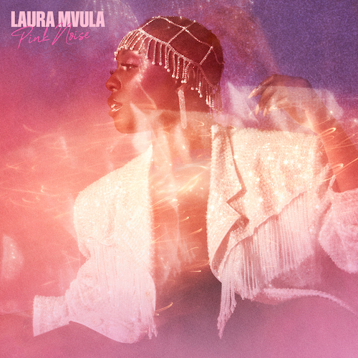

LAURA MVULA ON SOCIAL MEDIA
INSTAGRAM | FACEBOOK | TWITTER
For more information please contact:
Ariana.white@atlanticrecords.com

