LAURA MVULA
SHARES NEW TRACK ‘SAFE PASSAGE’
STREAM HERE
WATCH HERE

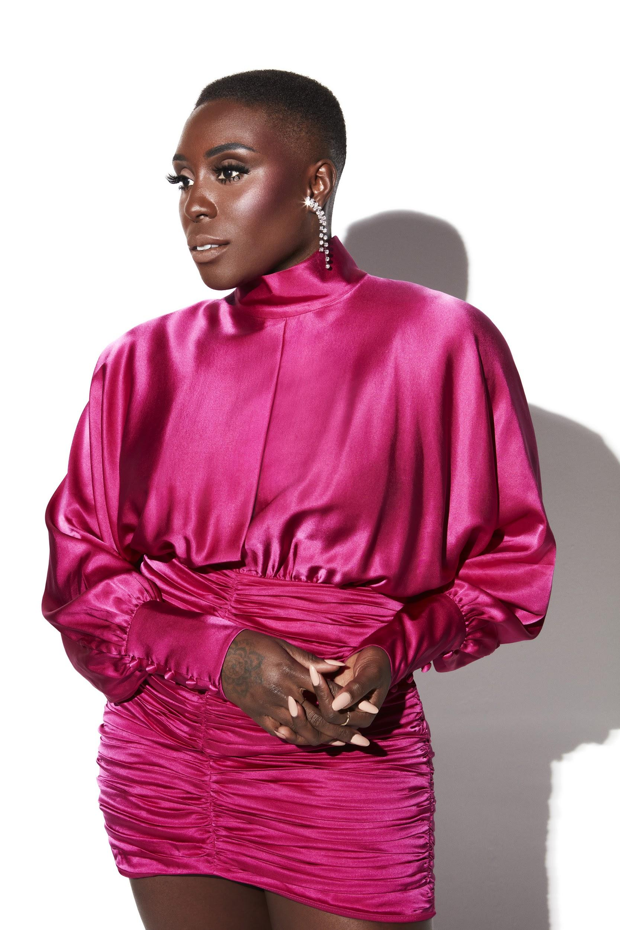
IMAGE CREDIT - Danny Kasirye
HI-RES ARTWORK HERE

“We honestly didn't deserve Laura Mvula - talented, frank, and wise…” - CLASH

“What a comeback.” - The i

“When it comes to music, I want to be able to be all that I am without hiding, without fighting with myself. We’re already in what feels like some kind of global claustrophobia – we’re locked in and we need to come out and we need to break out. That’s what this music is to me and I just want to share it. I want people to feel free.” - Laura Mvula 2021

Today Laura Mvula has shared a new track ‘Safe Passage’, the first taste of what’s to come from Laura this year and her first original music to be released via Atlantic Records. Stream here.

The official video for ‘Safe Passage’ (watch here) is taken from Laura’s special one-off Under A Pink Moon live performance last week, her first in over 3 years which The i described in their 5* review as Laura showing “her rejuvenated and ready to take on the pop world...what a comeback”.

Steeped in demanding beats and sparkling 80’s synth pop vibes, ‘Safe Passage’ draws the listener into celestial escapism. About the new track Laura says, “‘Safe Passage’ is a poem about the vehicle that takes us all from the space where we feel like we're drowning, and we're trapped to the promised land, which actually exists. It's not a dream, it's not a fictional place. We can go there. We can go there like right now. We just have to tap into ourselves to our love relationships. ‘Safe Passage’ evokes that feeling in me. It reminds me of a time when feeling positive emotions was much simpler, much less complicated.”

She continues, “Writing the song was a struggle because I had to really dig for it. But as it revealed itself to me, it struck me down like lightning on the Damascus Road, and I was grateful for it. I was so scared of letting myself down. And I was so exhausted of caring only about pleasing people and things around me. And I wanted and needed release from that. That's what ‘Safe Passage’ is.”

‘Safe Passage’ follows the release of Laura’s 1/f EP, showcasing her hit singles reimagined to a stellar new dynamic sonic direction, inspired by cosmic 80s sounds (stream here).

As one of the most exciting musical talents to come out of the UK, Laura has previously won an Ivor Novello Award for Best Album, has been nominated for the Mercury Prize (not once but twice), BBC Sound Poll, the BRITs Critics Choice Award, two BRIT Awards in 2014 (British Female Solo Artist and British Breakthrough Act) and won an incredible two MOBO’s in 2013 (Best Female and Best R&B/Soul).
Having caught the attention of her musical hero Prince while performing for the first of two times on the Pyramid Stage at Glastonbury, Laura has gone on to travel the world, selling out shows and captivating crowds at every destination. Crowned “Queen of the Prom” and given a five star review from the Evening Standard for her Proms 2014 Late Night performance at the Royal Albert Hall, Laura’s critically acclaimed career has led her to work with real-life inspirations Nile Rodgers and touring with David Byrne.

LAURA MVULA ON SOCIAL MEDIA
INSTAGRAM | FACEBOOK | TWITTER
For more information please contact:
ARIANA.WHITE@ATLANTICRECORDS.COM

