NEW ALBUM DUE FOR RELEASE 2ND JULY 2021
PRE-ORDER HERE
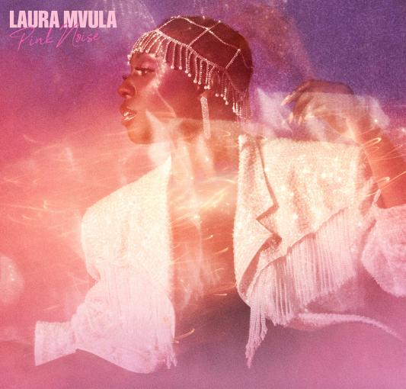
IMAGE CREDIT - Danny Kasirye

NEW SINGLE ‘CHURCH GIRL’ OUT NOW
STREAM HERE
WATCH VISUALIZER HERE

LAURA WILL BE JOINING GRAHAM NORTON ON 26TH MARCH

“We honestly didn't deserve Laura Mvula - talented, frank, and wise…” - CLASH

“What a comeback.” - The i

“When it comes to music, I want to be able to be all that I am without hiding, without fighting with myself. We’re already in what feels like some kind of global claustrophobia – we’re locked in and we need to come out and we need to break out. That’s what this music is to me and I just want to share it. I want people to feel free.” - Laura Mvula 2021

Laura Mvula today announces her highly anticipated new album ‘Pink Noise’, due for release on July 2nd via Atlantic Records. Along with the album announcement, Laura has shared her defiant new single ‘Church Girl’ which is out now. Stream here and pre-order the album here.

About her new single Laura says, “I am not my story. For so long I identified as the things that happen in my life, the things I do, good or bad. I’m letting go of this mind-made ‘me’. I’m coming home to myself beyond the realm of form. I am not the thoughts in my head, or the things I achieve, or the shape of my haircut. I no longer ‘dance with the devil’ on my back. I’m basking in the light of knowing my true self, the deeper ‘I’.”

Church Girl
Who do you think you are?
You don’t write the story baby
Wanna be some kinda superstar
It’s just a game of let it be
Can you ever give up
Livin in this masquerade?
Singin of insanity
Cryin for the mess we made
How can you dance with the devil on your back?
How can you move, caught up
In a picture perfect
That will never last
In the deep of the night
Did I hear you call my name?
Surrender to the light

Laura says, “Three years ago I knew I’d made a promise I couldn’t keep. After two albums, I was sure I had nothing to say. I felt like ‘Sing To The Moon’ was just a happy accident anyway so I looked for teaching posts in Hackney. I began to accept that I was ‘too old to be pop’ and ‘no longer relevant enough to breakthrough’. I couldn’t be bothered publicly ‘failing again’. I sought comfort in deeply patient friends and family. I practiced feeling that feeling - the need to be safe, the need to escape. I fuelled up on my favourite music of the past and spent days, weeks, months hovered over my hardly-a-home-studio (a laptop, midi keyboard and USB mic). And then, sat in my PJ’s, on a rainy Sunday afternoon, a new chapter was born - ‘Safe Passage’ was here.”

‘Pink Noise’ explores a side of Laura previously uncharted. As triumphant as ever, the album is a battle cry and stark reminder of the sheer talent of the critically acclaimed artist. This is Laura in a new found light - still reflecting her distinctive signature sound but showing the progression of an artist who has come into her own.

“This is the album I always wanted make. Every corner is made warm with sunset tones of the 80s. I was born in 1986. I came out of the womb wearing shoulder pads. I absorbed the dynamism of the 80s aesthetic right from my first moments on this planet. Wrestling with identity seems to be one of the rites of passage of the established artist. Making ‘Pink Noise’ felt like the most violent of emotional wrestling matches. It took 3 years of waiting and waiting and fighting and dying and nothingness and then finally an explosion of sound. As if it was always here this record is my most honest and unapologetic flying of the freedom flag. In my adult years I had forgotten how important dance was to me as a vital tool of my creative expression. I brought it back, just for me, so I could find my delight in dance again. And now I can’t stop dancing. I can’t wait to play this album live.”

Contrasting confessional lyricism with compelling and infectious synth pop, ‘Pink Noise’ feels completely and uniquely Laura. Her artistic prowess knows no limits - take the neo-soul meets art pop of ‘Remedy’ for example, or the darker, pulsating ‘Conditional’ that injects bombastic funk into indietronica. She feels rejuvenated too, especially on electro pop stunners ‘Magical’ and ‘Before The Dawn’. This is Laura Mvula at her most ambitious to date, leaving no stone left unturned in this cosmic new realm.

New single ‘Church Girl’ follows the release of ‘Safe Passage’ earlier this month, which The Independent described as “ambitious and uplifting”, alongside gal-dem who said “her vocal is powerfully refined over lush swathes of synths and drums that leap like shooting stars”. Both tracks exemplify Laura’s euphoric and ethereal synth -pop inspired sound, and feature on her first album in 6 years.

Last week Laura showcased her stellar new material with an appearance on Later With Jools Holland, and she will also be performing her new single on The Graham Norton Show on 26th March.

As one of the most exciting musical talents to come out of the UK, Laura has previously won an Ivor Novello Award for Best Album, has been nominated for the Mercury Prize (not once but twice), BBC Sound Poll, the BRITs Critics Choice Award, two BRIT Awards in 2014 (British Female Solo Artist and British Breakthrough Act) and won an incredible two MOBO’s in 2013 (Best Female and Best R&B/Soul).
Having caught the attention of her musical hero Prince while performing for the first of two times on the Pyramid Stage at Glastonbury, Laura has gone on to travel the world, selling out shows and captivating crowds at every destination. Crowned “Queen of the Prom” and given a five star review from the Evening Standard for her Proms 2014 Late Night performance at the Royal Albert Hall, Laura’s critically acclaimed career has led her to work with real-life inspirations Nile Rodgers and touring with David Byrne.
Pink Noise tracklisting:
- Safe Passage
- Conditional
- Church Girl
- Remedy
- Magical
- Pink Noise
- Golden Ashes
- What Matters
- Got Me
- Before The Dawn

LAURA MVULA ON SOCIAL MEDIA
INSTAGRAM | FACEBOOK | TWITTER
For more information please contact:
ARIANA.WHITE@ATLANTICRECORDS.COM

