Deem Spencer and the booyah! kids rework NYC collective MICHELLE’s “SUNRISE”

WATCH LIVE PERFORMANCE SESSION HERE
BUY/STREAM HERE

BUY/STREAM “SUNRISE” HERE

“the collective’s contagious charm and versatile creative approach is worth our attention”
– Pigeons & Planes “Best New Artists”

“NYC-based musical collective… who make pop music so catchy that they've been picked up by Canvasback Music with one breezy LP behind them.”
– The FADER

“The six-member collective is riding at the forefront of New York’s energetic music scene… multi-talented singers, songwriters and musicians blend a vast range of genres to deliver a fresh sound”
– V Magazine

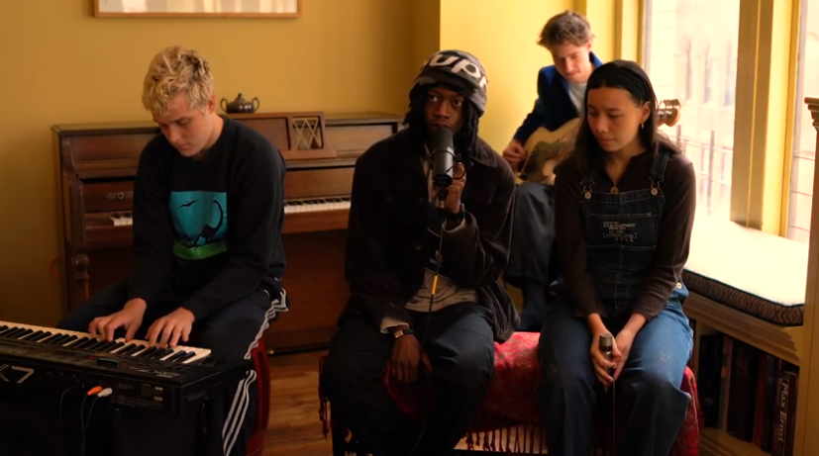

Queens rapper Deem Spencer becomes the latest artist to lend his voice to NYC collective MICHELLE’s “SUNRISE,” adding a verse to the booyah! kids’ remix of the track – listen here. Today’s release comes accompanied by an intimate live performance session – watch HERE.

Alongside the rework, MICHELLE shared:

Today we are sending our final iteration of SUNRISE to you. This last go at the song is especially rewarding to share, as we hold the people who created this rework close to us. The first few shows we’ve ever played have been with the booyah! kids, and Deem Spencer opened for us at our first headline show this past winter. We’ve been listening to their music all the while, and it’s beautiful to hear them listen and transform our work today. Thank you for responding to SUNRISE, eyes peeled ears open for something new soon.

Today’s remix comes on the heels of a rework of “SUNRISE” courtesy of British poet and singer Arlo Parks – listen here – released earlier this month to acclaim from NME, DIY, and Consequence of Sound who declared: “The New York City-based collective and the British bedroom pop artist start the day with magic… This new collaboration doubles down on the feel-good warmth of the original track, breezy, sunbaked melodies and all.”

In August, the band was named to Pigeons & Planes “Best New Artists,” with the outlet heralding: “With its forward-thinking production and alchemization of genres—from synth-pop melding to R&B—there’s an undeniable allure to the group. Encapsulating the diverse experience of a New York upbringing and its dynamic music scene, each member adds something distinctive to the project… the collective’s contagious charm and versatile creative approach is worth our attention.”

SUNRISE, released in July, marked the first new single from the NYC-based collective since their self-released 2018 debut album HEATWAVE, and their first original release with Canvasback/Transgressive. It was met with praise from V Magazine, Dork, NME, and more. Uproxx highlighted the track in their “Best New Indie Music of the Week,” declaring “One of the more exciting tracks I’ve heard in a long time, ‘SUNRISE’ combines elements of indie pop, funk, and R&B to create something truly unique and modern.”

MICHELLE’s debut album HEATWAVE – a streets-and-skylines homage to their hometown – was created in just 2 weeks and self-released in 2018, seamlessly weaving together R&B-inflected pop, sleek synths, plush harmonies, and buoyant groove. Heralded by stand-out track “THE BOTTOM,” HEATWAVE amassed millions of streams, led to shows for sold-out NYC crowds at Baby’s All Right and Webster Hall, and has earned critical acclaim from The Fader, NME and more, as well as airplay from BBC Radio 1 and 6 Music.

Born-and-bred New Yorkers, MICHELLE is refreshingly comprised of predominately POC + queer members. The collective references equally diverse influences — Noname, Led Zeppelin, Sly and the Family Stone, Orion Sun, My Chemical Romance, SZA — all of which distill to create a cohesively diverse sound.

The group's unique stylings are the result of songwriting from Sofia D’Angelo, Julian Kaufman, Charlie Kilgore, Layla Ku, Emma Lee and Jamee Lockard with production from Kaufman and Kilgore.

Website | YouTube | Instagram | Twitter| Facebook

