NYC collective MICHELLE release “UNBOUND”

OFFICIAL MUSIC VIDEO PREMIERED ON THE FADER FOLLOWING
ANNIE MAC HOTTEST RECORD IN THE WORLD AUDIO DEBUT

WATCH “UNBOUND” OFFICIAL VIDEO HERE
BUY/STREAM HERE

“…plush R&B pop that feels wholly indebted to the flexuous city that surrounds them…”
“…a Brooklyn fantasy that feels as though it could have been plucked from the nineties…”
– The FADER

“the collective’s contagious charm and versatile creative approach is worth our attention”
– Pigeons & Planes “Best New Artists”

“The six-member collective is riding at the forefront of New York’s energetic music scene… multi-talented singers, songwriters and musicians blend a vast range of genres to deliver a fresh sound”
– V Magazine

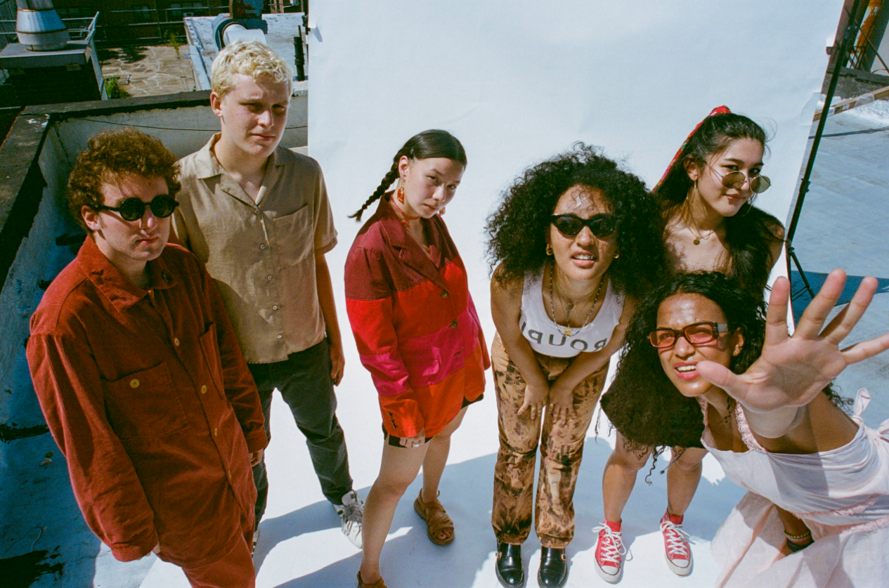
download hi-res press image

NYC collective MICHELLE announces the release of “UNBOUND,” following the track’s debut as Annie Mac’s Hottest Record in the World yesterday on BBC Radio 1. The official video for the new single also premiered yesterday via The FADER, with the outlet praising the band’s “plush R&B pop that feels wholly indebted to the flexuous city that surrounds them.”

Directed by Madeline Leshner and styled by Clara Perlmutter, the visual stars the group in a lust-filled dreamscape - “a Brooklyn fantasy that feels as though it could have been plucked from the nineties.”

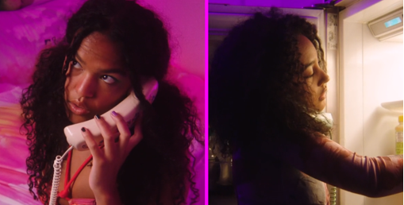

Speaking on the track, the band shared:

“UNBOUND came alive really fast. It’s about desire: the kind that oozes for the person you do want and the kind that evaporates for the person you don’t. We wanted to make something groovy and colorful, that could access nostalgia while also giving our listeners something new and danceable in a way we haven’t before.”

“UNBOUND” is the second single to be released by the band this year and follows “SUNRISE,” released in July to praise from V Magazine, NME, Dork, The Line of Best Fit and more. Uproxx highlighted the track in their “Best New Indie Music of the Week,” declaring “‘SUNRISE’ combines elements of indie pop, funk, and R&B to create something truly unique and modern.”

The track has since been remixed by the likes of Leven Kali, Deem Spencer x the booyah! kids, and Arlo Parks, the latter of which garnered acclaim from Consequence of Sound, NME, and DIY, among others.

In August, the band was named to Pigeons & Planes “Best New Artists,” with the outlet heralding: “With its forward-thinking production and alchemization of genres—from synth-pop melding to R&B—there’s an undeniable allure to the group. Encapsulating the diverse experience of a New York upbringing and its dynamic music scene, each member adds something distinctive to the project… the collective’s contagious charm and versatile creative approach is worth our attention.”

SUNRISE marked the first new single from the NYC-based collective since their self-released 2018 debut album HEATWAVE. That album – a streets-and-skylines homage to their hometown – was created in just 2 weeks and self-released in 2018, seamlessly weaving together R&B-inflected pop, sleek synths, plush harmonies, and buoyant groove. Heralded by stand-out track “THE BOTTOM,” HEATWAVE amassed millions of streams, led to shows for sold-out NYC crowds at Baby’s All Right and Webster Hall, and has earned critical acclaim from The Fader, NME and more, as well as airplay from BBC Radio 1 and 6 Music.

Born-and-bred New Yorkers, MICHELLE is refreshingly comprised of predominately POC + queer members. The collective references equally diverse influences — Noname, Led Zeppelin, Sly and the Family Stone, Orion Sun, My Chemical Romance, SZA — all of which distill to create a cohesively diverse sound.

The group's unique stylings are the result of songwriting from Sofia D’Angelo, Julian Kaufman, Charlie Kilgore, Layla Ku, Emma Lee and Jamee Lockard with production from Kaufman and Kilgore.

Website | YouTube | Instagram | Twitter| Facebook

