RISING NASHVILLE SONGWRITER MUNN SHARES “I LOST MYSELF,”
HIS GORGEOUS SINGLE + DEBUT MUSIC VIDEO RELEASED WITH ATLANTIC RECORDS

LISTEN HERE: https://youtu.be/iTuuFESejls

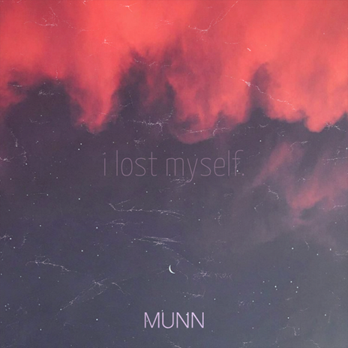

Nashville songwriters watch out: there’s a new guy in town, and he is a force. Please introduce yourselves to MUNN, a native Midwesterner with a devastatingly gorgeous voice, and an intricate fingerpicking guitar style to match. After self-releasing a stream of singles beginning with 2018’s “I Tried,” the prolific, young songwriter caught the attention of Ian Hunter at Atlantic Records, thanks to his tender 2019 single “I Lost Myself,” produced by his longtime songwriting partner and manager Dylan Stiles. Today, Atlantic Records is thrilled to welcome MUNN for the re-release of “I Lost Myself” along with its cinematic, heart-wrenching new music video directed by Jake Heidecker, both of which are officially out today - LISTEN HERE!

Born in rural Nebraska and raised in Indiana, MUNN and Stiles took a road trip to Nashville in 2019 to explore the area, and found themselves signing a lease on a house they couldn’t afford on the second day of the trip - something neither of them had remotely planned, but when it’s time to pursue a dream, it’s time to pursue a dream. After having his heart broken by his fiancé during his sophomore year of college, MUNN lost all interest in school, and struggled to figure out what was next. It was this emotional revelation that opened up his creative floodgates, and led him to pen his debut single “I Tried.” He had finally found a way to heal, and, from then on, creating music was the only thing on his mind.

Having met Dylan Stiles in 2017, a self-taught producer who had begun toying with production when he was 14, Stiles began sending MUNN beats he’d created between classes. Thus began a process that, despite a 12 hour drive separating them, led the two to begin creating songs using only an Xbox headset and GarageBand. Before they knew it, they’d amassed a trove of songs written together virtually, and met up between semesters in early 2019 for a proper marathon 36 hour recording session.

The result was MUNN’s debut EP, Garden of My Mind. One of its songs, “Sad Kids,” wound up picking up traction, leading the two to continue writing and recording in the pursuit of their next release. After their follow-up, 2019’s In Search of Divine Intervention failed to capture the attention they’d hoped, the two sat down to figure out a new way to release their music moving forward, opting to trickle out tracks in rapid succession, until one caught on. The only problem was, they’d just released all the songs they had to date - the only bones of a song MUNN had was a demo of “I Lost Myself,” a song he’d written three nights before his fateful move to Nashville.

The two recognized the song’s potential and wound up diverting all their attention to finishing it right. The song came out on September 6, 2019 and over the course of the next seven months, MUNN kept releasing new songs every few weeks; during that time, “I Lost Myself” kept doubling in popularity month after month, with MUNN and Stiles quickly realizing that this was the direction MUNNs music needed to go.

With over a million streams on Spotify alone, “I Lost Myself” is a passionate song that anyone who’s ever suffered through heartbreak can empathize with. And now with the backing of Atlantic Records, the song is finally getting the proper release it deserves. With MUNN busy writing a new collection of songs and an Atlantic singles deal in his back pocket, it’s safe to say we’ll be hearing a lot more from MUNN in the very near future.

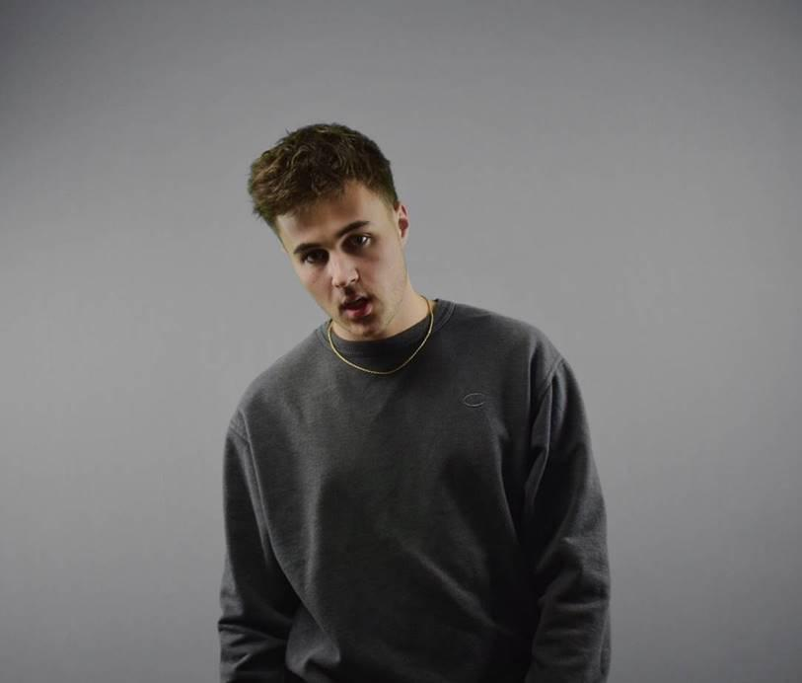

CONNECT WITH MUNN:
Instagram | Facebook | Twitter | Spotify

FOR MORE INFORMATION:
Paige Rosoff – Big Beat Records
Paige.Rosoff@atlanticrecords.com

