FOR IMMEDIATE RELEASE
OCTOBER 22, 2021

LATIN SENSATION MALÚ TREVEJO RELEASES DEBUT SINGLE AND VIDEO FOR
“COMPLICADO” FEATURING LUAR LA L

LISTEN HERE
WATCH HERE

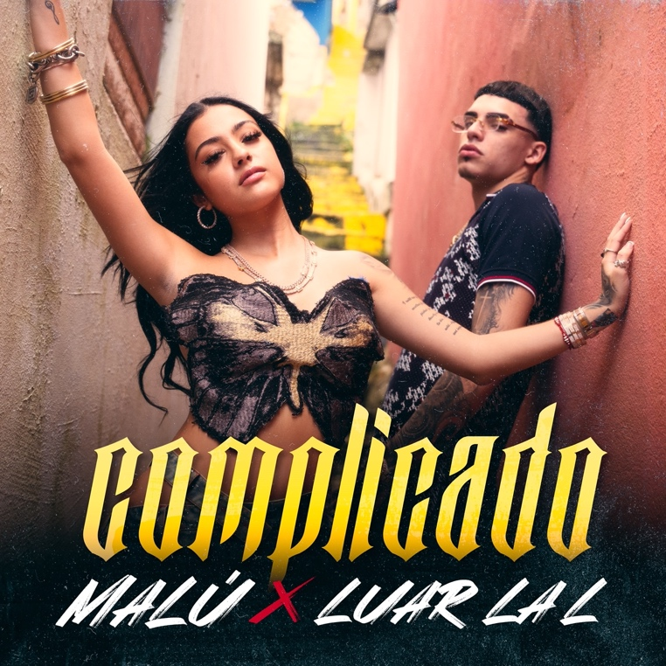

19-year old Latin sensation Malu Trevejo has signed with Atlantic Records and released her first single today, “Complicado” featuring Luar La L. Of Cuban and Spanish descent, the Miami-based multiplatinum singer, performer, personality, and actress has already reached platinum status and amassed a significant following that exceeds 35 million+ across social media platforms, with more than 10 Million on Instagram alone.

Trevejo reached levels of unprecedented success all before her 18th birthday. She initially exploded with the RIAA Latin platinum-certified breakout “Lune Lluna,” paving the way for collaborations with the likes of superstar duo Gente de Zona, Haraca Kiko, and Jeon as well as packed shows across the United States, Spain, and Latin America. She also graced the bill of Lollapalooza as one of the first Latinas on the Chicago stage with the likes of J Balvin and Rosalía.

Now, the single “Complicado” kicks off her next chapter. Over a shadowy and simmering beat, her voice flutters from melodic verses into a hovering hook punctuated by stoned and sultry delivery. Meanwhile, Puerto Rican rap phenomenon Luar La L pulls up with a focused and fiery flow that melts into the chorus.

“It’s a relationship song,” Trevejo explains. “It talks about when you want to be with someone. However, this person is like, ‘But’. You turn it around now, and you’re the one saying, ‘But’, to the other person. You’re taking control.”

While nurturing her budding music career, Trevejo is also making her big screen debut in the forthcoming feature film, Wolf Mountain.

# # #

For more information on Malu contact:
Juliana Plotkin, JPLA Media / juliana@jplamedia.com
Ariana White, Atlantic Records / Ariana.White@atlanticrecords.com

