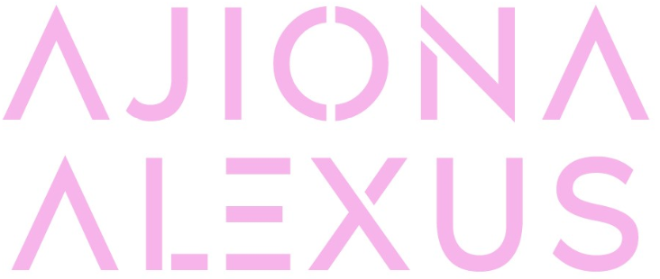
OFFICIAL BIO | UPDATED MAY 2021

True talent translates to any arena. Ajiona Alexus shines as a singer, songwriter, dancer, and actress, establishing herself as an all-around entertainer in classic form with modern swagger. Whether she’s on screen in zeitgeist-defining series such as 13 Reasons Why and EMPIRE or in the studio with GRAMMY® Award-winning collaborators like Brody Brown [Bruno Mars], the Alabama-born and Los Angeles-based multi-hyphenate confidently and charismatically holds her own. However, she introduces audiences to every side of herself on a series of singles for Atlantic Records in 2021.

“I can make you smile, I can make you cry, I can make you think, and I can make you laugh,” she says. “My goal is to be the best entertainer across the board. With music, I feel like I’m really showing everyone who I am. I was always so determined to be on that stage. I want my music to be timeless and motivating. I’m trying to take the fire I have for music and give it to the world.”

Born in Tuskegee and raised in Birmingham, Ajiona recognized the power of that fire early on. She watched family members sing at church and during holidays, while her big brother listened to hip-hop, dad enjoyed 90’s R&B and mom played old school favorites a la Anita Baker and Etta James. After excelling in basketball and soccer at the local YMCA, at 8 years old, her dad recognized her talents and introduced her to performing arts then eventually began managing her career professionally. She was accepted into the Alabama School of Fine Arts in the 7th grade. She belted out Broadway staples during productions of The Three Musketeers and more, but primarily describes her younger self as “a bathroom singer.”

“I was always singing in the bathroom,” she laughs. “I didn’t go to many school parties. I was just singing all day and night, trying so hard to develop my voice.”

In 2012, She made a mixtape and spent weeks choreographing her own stage performance. She wound up opening for the likes of Diggy, OMG Girlz, IYAZ, and MANN when they rolled through Birmingham. However, her big break came after she nailed the audition for The Ricky Smiley Show. She was cast as, De’Anna, a series regular and after three seasons on the show, she launched a successful film and television career, landing roles in the NETFLIX smash 13 Reasons Why, Hulu’s Runaways, Light As A Feather, and FOX’s EMPIRE as Young Cookie in addition to starring in films such as Tyler Perry’s Acrimony and Will Packer’s Breaking In. At the same time, she never stopped writing music, often crafting song ideas while on set.

In 2020, her demos caught the attention of Atlantic Records, and she signed to the label alongside a partnership with BAB Music Entertainment and Block Entertainment. Inspired by the likes of Beyoncé, Drake, Aaliyah, Rihanna, Michael Jackson, Janet Jackson, and more, she brought a fresh energy to throwback R&B.

“Music allows me to say how I feel and move how I want,” she explains. “Acting is a skillset God has given me to bring words to life, and I love it with all my heart. As much as I’m telling stories on camera, I tell my story through music. It’s the ultimate representation of who I am.”

As such, her debut single “Same Mistakes” came right from the heart. Over guitar by Dave “Uncle Dave” Foreman [Aaliyah], she poured her soul out in the studio, vibing and bringing the song to life on the spot. Finger-snaps peak through the evocative riff as her voice flutters from intimate verses into a fierce bridge punctuated by raw emotion and a little attitude.

“The song is about learning how to grow, so you don’t make the same mistakes over and over again,” she reveals. “I was speaking on everything I went through at the time. It’s really meant to be relatable.”

Simultaneously, she gives back at every turn. Passionate about anti-bullying and mental health awareness, she actively supports the American Foundation For Suicide Prevention and encourages the youth in her community to have a positive self-esteem and build self-worth.

In the end, Ajiona never stops pushing herself. “I do everything with purpose and meaning,” she leaves off. “I’m moving, I’m growing, and I’m trying to help others grow. Now, I just want to share this light.”

Ajiona Alexus is managed by Earn B. Management.

