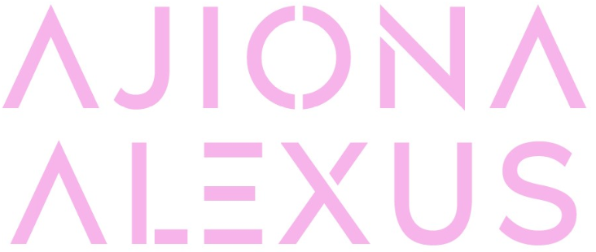
OFFICIAL BOILERPLATE | UPDATED MAY 2021

Ajiona Alexus shines as a singer, songwriter, dancer, and actress, establishing herself as an all-around entertainer in classic form with modern swagger. Whether she’s on screen in zeitgeist-defining series such as 13 Reasons Why and EMPIRE or in the studio with GRAMMY® Award-winning collaborators like Brody Brown [Bruno Mars], the Alabama-born and Los Angeles-based multi-hyphenate confidently and charismatically holds her own. After excelling in basketball and soccer, at the local YMCA, she attended Alabama School of Fine Arts magnet school. She belted out Broadway staples during productions of The Three Musketeers and more. Making a mixtape, she wound up opening for the likes of Diggy, OMG Girlz, IYAZ, and MANN when they rolled through Birmingham. However, her big break came after she nailed the audition for The Ricky Smiley Show. She was cast as De’Anna, a series regular and after three seasons on the show, she launched a successful film and television career with roles in the NETFLIX smash 13 Reasons Why, Hulu’s Runaways, Light As A Feather, and FOX’s EMPIRE as Young Cookie in addition to starring in films such as Tyler Perry’s Acrimony and Will Packer’s Breaking In. At the same time, she never stopped writing music, often crafting song ideas on set. In 2020, her demos caught the attention of Atlantic Records, and she signed to the label in partnership with BAB Music Entertainment and Block Entertainment. However, she introduces audiences to every side of herself on a series of singles for Atlantic Records in 2021 led by “Same Mistakes.” Ajiona Alexus is managed by Earn B. Management.

