**NIKO RUBIO RELEASES “BED”**

**THE SEXY, ROCK-DRIVEN ANTHEM IS THE LATEST SONG RELEASED FROM THE SINGER/SONGWRITER’S FORTHCOMING EP DUE OUT THIS SUMMER**

[**DOWNLOAD/STREAM: “Bed”**](https://nam04.safelinks.protection.outlook.com/?url=https%3A%2F%2Fnikorubio.lnk.to%2FBed&data=04%7C01%7CBrian.Sommer%40atlanticrecords.com%7C89c6e4fdf6c1478ed1b108d92c320c3d%7C8367939002ec4ba1ad3d69da3fdd637e%7C0%7C0%7C637589415724961916%7CUnknown%7CTWFpbGZsb3d8eyJWIjoiMC4wLjAwMDAiLCJQIjoiV2luMzIiLCJBTiI6Ik1haWwiLCJXVCI6Mn0%3D%7C1000&sdata=a%2Ft6MWXPpCtXbrrQx0avSxj7fPtlOSb72vRAcpiyyvM%3D&reserved=0)

*Written by Niko Rubio; Produced by Andy Seltzer*

[**WATCH THE STUNNING MUSIC VIDEO FOR “YOU COULD BE THE ONE”**](https://nikorubio.lnk.to/BedVisualizer)

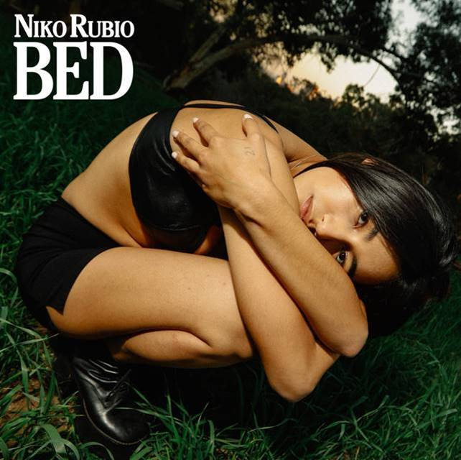

[DOWNLOAD ARTWORK HERE](https://nam04.safelinks.protection.outlook.com/?url=http%3A%2F%2Fpress.atlanticrecords.com%2Fniko-rubio%2F&data=04%7C01%7CBrian.Sommer%40atlanticrecords.com%7C89c6e4fdf6c1478ed1b108d92c320c3d%7C8367939002ec4ba1ad3d69da3fdd637e%7C0%7C0%7C637589415724971910%7CUnknown%7CTWFpbGZsb3d8eyJWIjoiMC4wLjAwMDAiLCJQIjoiV2luMzIiLCJBTiI6Ik1haWwiLCJXVCI6Mn0%3D%7C1000&sdata=SSL%2F94z5YDmrppu%2BMSRGJJC4OerwOwrSz0bqRV4B3n0%3D&reserved=0)

**New York, NY – June 11, 2021 –** Emerging singer/songwriter **Niko Rubio** is back with another stunning single titled **“Bed,”** available now – [LISTEN HERE](https://nam04.safelinks.protection.outlook.com/?url=https%3A%2F%2Fnikorubio.lnk.to%2FBed&data=04%7C01%7CBrian.Sommer%40atlanticrecords.com%7C89c6e4fdf6c1478ed1b108d92c320c3d%7C8367939002ec4ba1ad3d69da3fdd637e%7C0%7C0%7C637589415724971910%7CUnknown%7CTWFpbGZsb3d8eyJWIjoiMC4wLjAwMDAiLCJQIjoiV2luMzIiLCJBTiI6Ik1haWwiLCJXVCI6Mn0%3D%7C1000&sdata=zITGmPtBuCLkWk7vdmUmUYHXe%2BVv%2BEISi0HksyhupeE%3D&reserved=0). Accompanied today by an equally captivating visualizer – [WATCH HERE](https://nikorubio.lnk.to/BedVisualizer) – the sultry new single penned by Rubio and produced by Andy Seltzer contains an alluring chorus complimented by echoing electric guitars, and is the second release from the California-native’s forthcoming EP, due out this Summer.

**“**Bed,” follows Rubio’s major label debut single, [“You Could Be The One,”](https://nam04.safelinks.protection.outlook.com/?url=https%3A%2F%2Fwww.youtube.com%2Fwatch%3Fv%3Dbm337OC4Nc4&data=04%7C01%7CBrian.Sommer%40atlanticrecords.com%7C89c6e4fdf6c1478ed1b108d92c320c3d%7C8367939002ec4ba1ad3d69da3fdd637e%7C0%7C0%7C637589415724981907%7CUnknown%7CTWFpbGZsb3d8eyJWIjoiMC4wLjAwMDAiLCJQIjoiV2luMzIiLCJBTiI6Ik1haWwiLCJXVCI6Mn0%3D%7C1000&sdata=n2EHmWSqi21pO6ozxXHkIyJM5fZjMt8ofxgq5jR8tsc%3D&reserved=0) released in late April to critical acclaim, with ***Billboard*** praising the rising artist’s entrance as a, *“captivating showcase for the newcomer,”* adding that, *“the kicky pop-rock track allows Rubio’s tone to sink down low and soar skyward.”*

* * *

**ABOUT NIKO RUBIO:**

When creating her debut project, 20-year-old singer/songwriter Niko Rubio found a never-ending muse in the Pacific Coast Highway: the iconic stretch of road that runs along the ocean for nearly the entire length of California, including the Southern California South Bay area where she grew up. Expansive and euphoric, Niko’s radiant form of songwriting perfectly echoes the pure sense of possibility that accompanies driving down the PCH.  Drawing inspiration from the collage of artists she’s come to admire throughout her life including Vampire Weekend, Lana Del Rey, Erykah Badu & twenty one pilots, as well as the mariachi & banda music her grandparents played at home, Niko’s music is an amalgamation of these influences, but unique in its effervescent melodies and unpredictable textures. Using cinematically detailed references and her effortlessly untamed vocals, Niko is ready to take those who listen to her songs “You Could Be The One” and “Bed,” as well as her forthcoming EP on a sonic road trip along the highway where they became a possibility.

**Press Contact:** Jason Davis – [jason.davis@atlanticrecords.com](mailto:jason.davis@atlanticrecords.com)

* * *

**APPROVED PRESS IMAGE:**

Photo Credit: Lauren Dunn



**CONNECT WITH NIKO RUBIO:**

[INSTAGRAM](https://nam04.safelinks.protection.outlook.com/?url=https%3A%2F%2Fwww.instagram.com%2Fholanikorubio%2F%3Fhl%3Den&data=04%7C01%7CBrian.Sommer%40atlanticrecords.com%7C89c6e4fdf6c1478ed1b108d92c320c3d%7C8367939002ec4ba1ad3d69da3fdd637e%7C0%7C0%7C637589415724991898%7CUnknown%7CTWFpbGZsb3d8eyJWIjoiMC4wLjAwMDAiLCJQIjoiV2luMzIiLCJBTiI6Ik1haWwiLCJXVCI6Mn0%3D%7C1000&sdata=rN4%2BqzmGi11TUthAt%2FsdUGj33jK7K49FExOC3a1O%2BBg%3D&reserved=0) | [FACEBOOK](https://nam04.safelinks.protection.outlook.com/?url=https%3A%2F%2Fwww.facebook.com%2Fholanikorubio&data=04%7C01%7CBrian.Sommer%40atlanticrecords.com%7C89c6e4fdf6c1478ed1b108d92c320c3d%7C8367939002ec4ba1ad3d69da3fdd637e%7C0%7C0%7C637589415724991898%7CUnknown%7CTWFpbGZsb3d8eyJWIjoiMC4wLjAwMDAiLCJQIjoiV2luMzIiLCJBTiI6Ik1haWwiLCJXVCI6Mn0%3D%7C1000&sdata=bXWKs0p1LXd6KoOGXr4X2Hm3muN8fhZg%2BjVc1xrkgEI%3D&reserved=0) | [YOUTUBE](https://nam04.safelinks.protection.outlook.com/?url=https%3A%2F%2Fwww.youtube.com%2Fchannel%2FUCxKEF6kdZr_lysTAVBxboSA&data=04%7C01%7CBrian.Sommer%40atlanticrecords.com%7C89c6e4fdf6c1478ed1b108d92c320c3d%7C8367939002ec4ba1ad3d69da3fdd637e%7C0%7C0%7C637589415725001891%7CUnknown%7CTWFpbGZsb3d8eyJWIjoiMC4wLjAwMDAiLCJQIjoiV2luMzIiLCJBTiI6Ik1haWwiLCJXVCI6Mn0%3D%7C1000&sdata=BePcr%2BXKEFpdTFy2hkmYQTt2MRQWhMU%2B7HveZLE7Yls%3D&reserved=0) | [PRESS SITE](https://nam04.safelinks.protection.outlook.com/?url=http%3A%2F%2Fpress.atlanticrecords.com%2Fniko-rubio%2F&data=04%7C01%7CBrian.Sommer%40atlanticrecords.com%7C89c6e4fdf6c1478ed1b108d92c320c3d%7C8367939002ec4ba1ad3d69da3fdd637e%7C0%7C0%7C637589415725011889%7CUnknown%7CTWFpbGZsb3d8eyJWIjoiMC4wLjAwMDAiLCJQIjoiV2luMzIiLCJBTiI6Ik1haWwiLCJXVCI6Mn0%3D%7C1000&sdata=MT32093%2FpLv6bDEr7pO1C4Yt72qlHSKyZWoHUgMS%2FtU%3D&reserved=0)

# # #